Abstract: Active participation in orientation is thought to increase understanding and use of library resources and services beyond the effect of tours or welcome lectures. Timed scavenger hunts have been used to orient undergraduate and medical students to academic libraries. This report describes the planning, execution and evaluation of an untimed iPod-documented scavenger hunt in 2012 for first-year graduate veterinary students, and the modification and execution of the hunt for new students in 2013. Findings in terms of student participation, staff experiences, and student and staff perceptions of the hunt’s utility as a learning opportunity suggest the characteristics of a scavenger hunt that facilitates hands-on learning in the library while placing reasonable demands on library staff.
Introduction:
Orientation for new students at any level helps them acclimate to the physical space of their campus and the support services provided. Planned library involvement in orientation provides library staff a unique opportunity to briefly engage every member of a new class and introduce resources available early in academic study. Orientation methods employed include lecture, classroom hands-on sessions, guided tours, and self-directed print or digital tours. However, few libraries report assessment of whether knowledge of library resources and services was gained or retained during orientation. As universities look for libraries to demonstrate active learning with progress towards concrete objectives, such as students learning to use specific resources or equipment, the idea of having the students find and use spaces and resources on their own resonates.¹ (Burke, 2013)
Using a scavenger hunt as the basis to explore the library encourages active participation. It also helps foster a sense of camaraderie and a shared experience among the new students. To succeed in a scavenger hunt, participants answer a list of questions prepared in advance by the hunt organizers in which students may physically collect objects, take pictures of actions or objects, or record their answers during the discovery process. To determine a winner, scavenger hunts are generally either timed or scored based on a points-per-question system with the most points going to the questions that the organizers deem most difficult to answer. It is possible to remove the competitive aspect of the exercise in order to shift the focus from beating other teams to purely completing the tasks—what effect this modification has on enjoyment is not known. While scavenger hunts may be completed individually, they are most often undertaken as a team in order to maximize the sharing of knowledge and entertainment value.
Literature Review:
Academic libraries that have used scavenger hunts during freshmen orientation with the intent of reducing library anxiety and familiarizing incoming students with the library’s resources and physical layouts report varying degrees of success. In some cases, such as at the Holon Institute of Technology in Israel, the small group activities were used as a complement rather than a focal point of library orientation.² (Langley, 2007). The few studies that focused solely on scavenger hunts as an orientation method primarily mention orienting freshman students on university campuses of various sizes and governance, though there have been some reports from community colleges and smaller private schools.³ (McCain, 2007)
Partnering with other student services is one strategy for creating and evaluating orientation. Librarians at the Queensborough Community College partnered with the college counseling center to create a non-credit course that would be mandatory for all incoming freshman, which included information literacy and library tours done in the traditional model. Students appeared disengaged, unresponsive, and would sometimes leave the class early as no penalties or grades were given.⁴ (Marcus, 2003) In response, QCC chose to use a mystery-style game that used the same premise of orienting students to the physical space of the library while introducing them to library resources. They were unique in evaluating the effectiveness of this model versus the standard tours; using a control group of students who completed the tour while a second group completed the hunt, librarians administered an exit survey regarding the intended learning outcomes of the orientation to determine which strategy was more effective. The results indicated an overwhelmingly positive response to the new active-learning model from both students and counselors.⁵ (Marcus, 2003)
Positive engagement and entertainment were part of several programs. A pirate-themed library exercise used at the University of Notre Dame equated information literacy and searching a database to discovering buried treasure. It supplemented the traditional tour during the class with active-learning methods such as crossword puzzles, word jumbles, and riddles to keep the class engaged and to reinforce concepts. Prizes were awarded to all participants at the end of the session to maintain a positive atmosphere.⁶ (Smith, 2007) When Niagra University restructured their mandatory first-year library orientation, the librarians included themselves as part of the game to increase student-librarian interaction and assist them in answering the clues. The new mystery hunt was designed with specific goals in mind, including services offered by the library as well as the physical layout and resources provided for student use. While a standard scavenger hunt involved answering a list of predetermined questions, the Niagra mystery hunt involved searching for clues related to the fictional missing valet of a famous author. The students used clues that led them to different parts of the library, where the answers at each station helped discover who the author was in order to track down the missing valet. Winners were determined based on time and accuracy, though everyone was awarded some sort of prize.⁷ (Kasbohm, 2006)
Levels of control range from self-guided voluntary, to required, to graded participation. Planned activities in the self-guided treasure hunt developed for the Bachelors in Oral Health program at the University of Otago, New Zealand included stops to gather clues from both social and academic locations, with students working together in a 90 minute simultaneous session.⁸ (Thompson, 2008) In 2012, the NCSU Libraries had developed an award-winning iPod/Evernote-based scavenger hunt for in-class introduction to the Libraries used for undergraduate English and communications courses. The developers tested several mobile device applications before selecting Evernote for its free platform and ease of use. The hunt was timed in addition to being scored by hand. Students were given 25 minutes to complete the hunt, but several later responded that they did not feel familiar enough with the library at the outset to complete the hunt under such a constraint.⁹ (Burke, 2013) At Australian Catholic University, grades were assigned as part of the mandatory nursing student orientation. Their treasure hunt focused on finding the skills and resources used in nursing school, and optimized the time students spent by including only the most important information needed in the library. As their international students have a range of cultural backgrounds, English skills, and computer literacy, the orientation also includes an introduction to several popular search engines that may not be available in their home countries'.¹⁰ (Telford, 2006)
Few published reports on graduate professional student scavenger hunts are available, but there is one longitudinal evaluation of a medical school orientation program for classes of 100 first year medical students at the Weill Cornell Medical Library which began in 2006.¹¹ (Mongelia, 2007) Learning objectives involved being able to locate journal issues in the stacks, current issues and online, check out a laptop, refill a copy card, learn the library hours and send a comment from the library website.¹² (Mongelia, 2007) Evaluation immediately post-hunt was a key component; students responded on a nine-point Likert scale from uncomfortable to confident to express how they felt using the library’s physical spaces and online resources. They were also asked to name two things they learned and to provide an overall assessment of the hunt experience ranging from awful to outstanding on a 9-point scale. In a summative evaluation of several years of data, students felt they learned the most about finding physical resources and the online catalog.¹³ (Merlo, 2011) The print treasure map and clues were replaced by an iPad-based hunt with QR code clues in 2012.¹⁴ (Epstein, 2011)
Pitfalls and negative experiences on the management end of some academic library scavenger hunts included overtaxing the library staff due to the sheer number of students who needed help navigating the resources. Positive responses of the students and their professors outweighed the negative remarks from staff. In her review of scavenger hunt assignments, McCain reported that using a scavenger hunt for library orientation resulting in some resistance from staff simply for the idea being new and innovative.¹⁵ (McCain, 2007)
Background:
The College of Veterinary Medicine at a large southeastern land-grant university was increasing its doctor of veterinary medicine (DVM) student enrollment from eighty students per class to one hundred students for the fall of 2012. The Veterinary Medicine Library (VML) had traditionally provided mandatory library staff-led tours of 20-30 minutes during lunchtime to groups of ten students—eight groups over two days. Approximately 10 minutes of the Library director’s orientation welcome lecture prior to the tours was also devoted to physical spaces and resources. Interactions with new students at the service desk demonstrated little recall of information from the tours. Almost half the incoming students (n=41, 41% in 2012) had earned a prior degree at NCSU and were assumed to be familiar with the Libraries’ online resources, however those specific to veterinary medicine were thought to be unique to all. No DVM students had previously completed the NCSU undergraduate scavenger hunt which was implemented two years prior.
Learning Objectives:
The main objective was to create an active, self-directed and effective orientation with hands-on experience for all 100 DVM students that created a shared level of competency with NCSU Libraries resources, technologies, and services that could be managed with limited staff to observe the various activities. The learning goals of the hunt were for students to become familiar with the VML staff and spaces, practice using resources relevant to their first year coursework, and to prepare for future knowledge-seeking needs. Consequently, the 30-minute orientation lecture could focus on finding and evaluating high-quality animal health information after briefly introducing the scavenger hunt, rather than having to cover the technology and services. Specific learning objectives addressed by one or more questions on the hunt included: locating known-item veterinary resources (online book, print journal, print course reserve book, and print non-reserve book), interacting with the VML staff to check out a tech lending item, using the overhead scanner, registering for the Tripsaver interlibrary loan/campus delivery service, and finding directional information on hours and printing costs which are different for VML than the other NCSU Libraries. Handheld technology (iPod Touch) was employed so that groups could document their experiences more quickly using cameras and screenshots rather than requiring printouts or real-time staff observations.
Methods:
Planning
VML staff attended one of two Staff Scavenger Hunt overviews presented April 11 and April 24, 2012 by Adrienne Lai, Anne Burke, and Adam Rogers. These were intended to introduce all NCSU Libraries staff to the scavenger hunt process, and they allowed VML staff to experience the hunt themselves, use the iPods, and decide whether the hunt might appropriately substitute for orientation tours. Major differences included the size of the library and the size and time constraints of the target student population. VML is a single level library with 181 seats compared to the ten-story main library. DVM students are oriented over the course of a week in a cohort of 100 students, versus single classes of 10-30 undergraduate students completing the hunt in a 50 minute session. In July 2012, VML staff met with the developers to consider where to deviate from the undergraduate NCSU Libraries hunt structure for an experience more conducive to graduate students. We removed the time and scoring aspects to foster collaborative exploration rather than competition, and provide more time for students to spend creating relationships with their classmates and the library staff.
The content of the hunt for DVM students could be more in-depth since the participants were not constrained by a 50-minute class period. We needed to cover the spatial awareness aspect normally provided by the tour, and the common questions that we normally observed being problematic early in the semester, but we also wanted to retain some of the sense of fun and exploration of the library that we had seen in the undergraduate hunt. Table 1 shows which components of the veterinary student question sheet were modified from the undergraduate hunt, and which were added to fit the unique needs of the students and the VML. Many of these items were similar to those used by the Weill Cornell Medical Library. The specific items used in each question were chosen based on resources that the students might use in their first year and were based on the top five search results for each topic in the Libraries catalog, with a preference for eye-catching resources that looked interesting. VML does not maintain iPod Touches in its technology lending pool, so we borrowed 10 from the main library.
TABLE 1. Learning concepts used through the Hunt creation process.
Questions | New? | Modified? | Included in 2013?
- Use the Online Catalog to find an eBook
- Find Library Hours
- Locate a Book in the VETS Collection
- Locate a Book in the Stacks
- Locate a Specific Journal Article in the Stacks
- Locate a DVD in the Media Collection
- Name Two Tech Lending Items
- Locate/Interpret an Entry in the Room Scheduler Website
- Checkout a Reserve Book and Flash Drive
- Locate and Use the Zeutschel Overhead Scanner
- Register for Tripsaver Account
- Find Cost of Printing
Bonus Question: Meet the Staff

The cohort effect of the group made choosing and scheduling times challenging—we needed to keep it manageable for having only ten iPods, but also allow for their choices in group creation and timing. The scavenger hunt was described in the orientation materials (Figure 1) to seem like it was expected, but we intentionally did not state it was mandatory in an effort to encourage participation. It was replacing mandatory tours where time and effort was spent to ensure attendance by all students and we wanted to see how many students would participate voluntarily.
FIGURE 1. Fall 2012 Orientation schedule describing the scavenger hunt

Preparation and Creation
As a team exercise with the smallest group size being two participants, we created fifty Google mail and Evernote team accounts named with animal group names. Google limits on creating email accounts provided a challenge, as did the lack of experience with iPods and Evernote. To avoid creating traffic jams in the small library, the places and order of the questions needed to vary. A total of fifty question sheets were printed, which varied in groups of ten. Different sources were used for three questions, which asked for students to take a screen shot of an online citation, take a picture of a specific monograph on the shelf, and to take a picture of a specific journal article in the journal stacks, respectively. Appendix 1 provides one version of the Question Sheet from the 2012 hunt. The 2013 hunt sheet is shown in Appendix 2. Students also had some options for self-determination as they were invited to choose what topic within dermatology to look up, and which course reserve book and technology lending item to borrow. A display case on the service desk counter showcased the smaller technology lending items so students could see the items available to borrow.
Using the instructional Power Point created for the undergraduate scavenger hunt as a template, we modified the screenshots of the iPod touch to give step-by-step instructions on how the iPod touch operates, including turning it off and on, taking pictures, screenshots, and browsing the mobile catalog. Staff also learned the procedure for signing each group up on paper, as students were able to choose their own group members and a group name from the list provided. Students received an overview document with instructions on Evernote and the iPod, and VML staff logged each group into Evernote based on the chosen team name. Although we encouraged students to record their answers as notes in Evernote, we accepted responses written on the sheet and we reviewed the device camera rolls for photo responses that had not been linked up with Evernote. As a final optional activity on the hunt, the students could have a library staff member take their photo by the group study tent. This was intended to help them meet a staff member, and gave us a group photo to share with them as a memory of the event. When students returned the iPod and question sheet, they received a reward of healthy fruit snacks to reinforce their positive experiences and demonstrate that the library was food-friendly.
Results:
Participation
Group sizes in 2012 ranged from one to four participants, with a median and a most common size of two, and completion progress was outlined on the VML blog over the course of the week from August 6-10. Several students completed the hunt independently with permission—this accommodated student preference to work alone, and some very difficult schedules. Several students questioned whether it was mandatory, and we followed up with those who had not completed the hunt to encourage their participation. After a few email reminders, ninety-two students completed the scavenger hunt for a final completion rate of 92%. Figure 2 shows that the completion progress was marked by several periods of intense activity.
In 2013, group sizes ranged from one to six participants, with a median of 3 and a mode of 2. Larger groups were the norm and there were five groups of 5-6. As the wording was strengthened to indicate the hunt was mandatory, the final rate of participation after one email reminder was 99%.

FIGURE 2. Percentage of total students completing the hunt each day in 2012 and 2013.

Time Spent and Success Rates
For process evaluation and future planning in 2012, we captured completion time data on six of the early groups, where time to completion ranged from thirty-eight to fifty-seven minutes, with a mean time of forty-six minutes (SD=7 minutes). Of the thirty-six groups completing the hunt, twelve (33%) groups had one or more errors in their ten responses. We did not have sufficient staff to check responses and follow up in real time with the groups as they turned in their sheets and iPods. We did record all the responses before logging out of the Evernote accounts to be able to turn over the iPod to the next group of participants.
Most did not know the names of their textbooks at the point they participated in the scavenger hunt, so we pulled a selection of the first year texts out during the busiest times. The most common errors in responses were underestimating the weekend hours on a specific day (n=9) and listing the price of printing in the main library rather than the cheaper price at the VML (n=7) Infrequent problems included looking in the journal stacks for monographs (n=2), being unable to determine the time due for course reserve materials (n=2), or register for a Tripsaver account (n=1). We did not observe how these errors were made, what students searched or browsed, or what aspects of our materials were unclear though we have some ideas based on the nature of the responses. The Library director corrected errors in responses via email to the groups as she thanked them for completing the hunt and shared group photos if they had been taken. Twenty-six (72%) of the groups took a group photo. It is not clear whether these emails were read, though some students did reply thanking us for the photos. Figure 3 shows an email highlighting the type of language and examples used to correct erroneous information responses.
FIGURE 3. Sample of email feedback sent to students completing the hunt with errors.
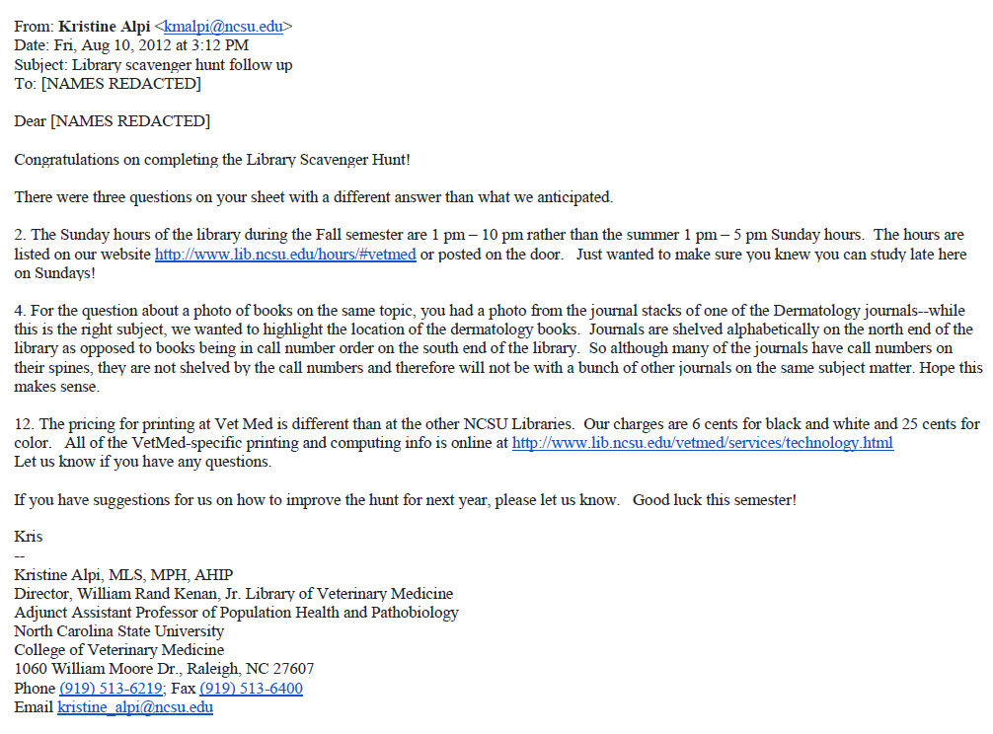
Based on areas of confusion in the 2012 hunt and suggestions, we modified the questions and activities for the next year’s hunt. In 2013, time to completion was captured for eleven of the 32 groups and the mean completion time was 34 minutes (SD-12 minutes) with the fastest recorded time being 18 minutes and the longest taking 53 minutes. Half (n=16) of the groups had no errors. Several groups had errors they were invited to correct in real-time as they turned in their score sheets. The most common errors remained branch weekend hours (n=9). A few groups missed the main library hours (n=3), room scheduler lookup (n=3) and reserve book loan periods (n=3). The confusing about printing pricing was improved from the previous year by writing a more specific question. Email corrections were made for those sheets not scored in real-time and some resubmitted scans for missing items. Finally, fifteen (47%) groups took a group photo.
Post-Event Evaluation
Orientation programming is evaluated annually by its coordinator, the College of Veterinary Medicine’s counseling psychologist. Two questions provided by the library were included on the web-based orientation evaluation survey which was sent to all of the students on October 24, 2012. By the closing date of November 1, there were thirty-nine responses to the library-provided question on use of the knowledge or skills gained in the hunt, which represented approximately 42% of the scavenger hunt participants. Table 2 shows that more than half of the respondents (n=21) had used library resources or services in the eleven weeks between the hunt and the evaluation. Another 15% (n=6) thought they would by the end of the semester.
TABLE 2. Evaluation survey responses
Have you used any of the knowledge or skills you gained during the Library Scavenger Hunt?
2012 (n=39) | Number of responses | Percentage of responses
Yes | 21 | 53.85%
Not yet, but I think I will this semester | 6 | 15.38%
No, and I don’t think I will this semester | 12 | 30.77%
Did not participate in the scavenger hunt | 0 | 0.00%

Have you used any of the knowledge or skills you gained during the Library Scavenger Hunt component of Orientation?
2013 (n=35) | Number of responses | Percentage of responses
Yes | 14** | 40.00%
Not yet, but I think I will this semester | 17** | 48.57%
No, and I don’t think I will this semester | 3 | 8.57%
Not applicable: Did not participate in the scavenger hunt | 1 | 2.86%
** Orientation evaluation sent out immediately after orientation before most classes had started.

Since the evaluation was intended for quality improvement of the orientation and not IRB-approved research, we are not sharing the comments from the eleven students who gave more insight into their experiences with the scavenger hunt as a library orientation method. There were a range of comments regarding the hunt’s usefulness ranging from extremely positive to neutral to a few negative or unnecessary. The remaining comments suggested aspects of using the library that should be more emphasized, such as certain collections, or navigating the online catalog.
For the second year of the program, in response to a suggestion from the 2012 orientation program students, the evaluation was distributed immediately after orientation. The response rate of 35% was similar, but the change in timing likely affected the rate of responses for those who had already used the resources, down from 54% to 40%. Seventeen (49%) said they would use the resources by the end of the semester. The hunt had been modified to be more relevant to the fall semester coursework, so the reduction from 12 (38%) to only 3 (9%) thinking they would not use the information showed movement in the right direction. Three of the ten comments suggested covering the printing account system. Interestingly, one of the comments suggested that small group tours might be preferable to the scavenger hunt because they reported their group basically asked where everything was and was therefore staff directed rather than self-directed.
Discussion and Conclusions:
Student Experiences
We did not use a time limit and competition component in the hunt since we wanted to encourage the students to spend extra time getting to know each other, working together, and exploring the resources. We were aware that previous studies indicated that some groups divided up in order to increase their speed, and not all the group members learned at the various stations.¹⁶ (Mongelia, 2007) Although limiting group size might have resolved the occasional freeloading that took place, we felt adult students would prefer autonomy to establish their own group operating norms. Many completed the hunt in between their classes later in the orientation week. A few lunchtime groups had to return to the library a second time because they did not have enough time to complete the hunt on breaks between sessions. During the hunt, we found that 1-2 dedicated staff members were needed to help during the peak times between 4-6 pm and at lunchtime, as many of the students needed help with the overhead scanner and with checking out Reserve materials which are held at the service desk. Some students also needed hands-on assistance with Evernote or the iPod. Several students chose not to do the bonus group picture at the end of the hunt, perhaps due to staff seeming unavailable at the time to take the picture. Students expressed confusion regarding whether or not the scavenger hunt was a mandatory orientation activity, and so some did not complete it until the very end because they did not realize they needed to do it. For the 2013 hunt, we revised the wording of the initial invitation to make it clear that the hunt is required, though no penalties were given if it is not completed
Staffing Challenges and Unanticipated Effects
We had a staff of four full-time personnel and one intern. All had received brief training on iPods and Evernote and reviewed the questions, but only three were sufficiently familiar to handle the time pressures of getting the devices signed out, checked in, and made available again quickly. During the time, the staff also needed to help regular clients, check out the materials for the scavenger hunt, photograph the groups away from the service desk, and help troubleshoot/demo some of the larger technologies. We were unable to grade the completed scavenger hunt questionnaires while the groups were still in the library, but since we had removed the competitive component, the students did not need to stay to hear their results. The staff was often busy with new groups when the groups that were finished came to be checked in. In order to give thoughtful feedback, we informed them that they would receive a follow-up email addressing any problems in their responses and sending them their group photo if they took one. As we do not know whether feedback emails were read, finding a way to provide real-time feedback before the students leave the library is an area we revisited. In 2013, we improved on staff availability but were still unable to provide real-time feedback in all situations especially for those completing the hunt in the late evening.
Many groups had questions and needed some help using the iPod Touch in the first year. Our service desk area has two staff workstations and one public machine, and these were insufficient to handle the largest surge period. More staff trained on the technologies and the process will be required at the peak times. For 2013, we eliminated the technological demands of the Evernote application by allowing students to choose how to document their hunt answers. In 2012’s evaluation, students suggested they would prefer to have the opportunity to experience library tools and resources on their own devices which they are more likely to use in the future. This allowed library staff more time to focus on answering student questions and assisting in using the library’s technology.
We gained a better sense of the busiest times and can try to staff accordingly, bringing in student workers to cover regular operations, while having all full time personnel at the desk to help and meet the students completing the hunt. Unfortunately, the hunt did not yield the hoped-for effect in efficiency. If we had retained the traditional tour strategy, we would have invested thirty minutes in each of ten tour groups for a total of five hours of contact time, plus the time to schedule and follow up with those groups. The engagement with the scavenger hunt itself (not counting the creation and staff training time) took about double the time, nine hours, mostly spent checking out reserve books and technology, helping with scanning or Tripsaver questions, and photographing the groups. On the plus side, the participating staff met students individually and saw their names with their faces at several points during the hunt, giving us a head start in getting to know the new students. The time investment was reduced in 2013 due to eliminating the iPod Touch technology, the unanticipated fewer numbers of groups, and having a veterinary student who had completed the previous year’s hunt as a student worker during the 2013 hunt.
Unanticipated effects in 2012 included a few students getting overdue notices on reserve books and technology lending items that did not get discharged in a timely fashion during the busiest periods of the hunt. We took correction action for 2013 of checking the status on the Reserve books and flash drives used at the end of each surge. We needed to remind ourselves upon viewing the August circulation statistics of reserve books and lending technology that a large number of the significantly increased uses were generated by the scavenger hunt—we needed to account for this in the locally reported VML statistics. These numbers were miniscule in the larger NCSU Libraries circulation data. We also created a surge in the workload of the Interlibrary Services/Document Delivery staff that processed ninety-two Tripsaver registrations over the five days of the hunt, which was during the summer on main campus. In evaluating our questions following the hunt, we wanted to determine whether the Tripsaver question was worth the time and effort by determining whether students had used the service during their first year. VML staff was able to check in the ILLiad system to see if the class of students that completed the hunt used their Tripsaver accounts more than the previous year’s class, which had not been required to register for Tripsaver. During the first year, three students (3%) used Tripsaver compared to four students (5%) in the previous class. Early registration for Tripsaver does not appear to impact usage of ILL services by first year students and so we eliminated the Tripsaver registration component of the hunt for 2013.
Technology and the Future of the Scavenger Hunt
Many students had never used iPod Touches or programs like Evernote, and so this choice of technologies raised questions from the students about whether these were programs and devices they were going to need to use in the curriculum, and, if not, why they had to use them for this project. We used iPods only because they had been used to implement the undergraduate hunt—they are not in the curriculum or VML technology pool. The iPods were cleaned and returned to main campus when orientation was complete, so there was little opportunity for staff or the DVM students to use the technology at VML after orientation. Using the iPod touches worked well, but if enough iPads were available, this may be a better option due to the screen size. A few students complained about the difficulty of searching the library catalog on the small screen. The iPad could use the same applications and interface with a much larger screen. Having copies of the training sheet that was used for the staff also available for the students would have been advisable, because it showed details on using the iPod which may have helped those unfamiliar with the device. Many of these technology concerns were eliminated by allowing the students to use a combination of their own devices and the workstations around the library for those who preferred larger screens.
For the 2013 event, library staff practiced doing the hunt using the available lending technologies such as iPads and discovered that the early model iPad did not have a built-in camera. Having completed the scavenger hunt individually better prepared us for answering questions that arose when the students came to complete it. It would also have been beneficial to have found a time to meet with the student workers who usually work nights because they received the training instructions second hand through a staff member. The student workers would also be asked to run the scavenger hunt and to report back with problems or suggestions. This would have provided a better cross-section of technological knowledge, as many of the student workers already knew how to use an iPod Touch. We would continue to use the instruction sheet as a backup reference because we felt that it was a thorough resource, and do a short hands-on training session with the staff before asking them to complete the hunt on their own.
As more of the NCSU undergraduate population completes the iPod scavenger hunt, it is likely that more of our incoming DVM students will have experience with this type of activity. We will need to stay in close contact with the development and content changes in that process to ensure that our scavenger hunt remains unique enough to add value to those students during their DVM orientation. There are enough differences between the VML and main library to warrant orientation to physical aspects of the library and we focused the examples on locating and using books and videos with content relevant to their the DVM first year clinical problem solving course which often meets in library meeting spaces. Based on our experience, we recommend the scavenger hunt as an orientation strategy for professional students. It contributed to the VML goal of getting to know our student population better, and fits with our view of active learning through its hands-on approach which will hopefully provide better retention of the information. It gave the students practice with library skills and equipment we believe they will need during their first year, and it offered them the opportunity to explore and ask questions while not under the time constraints of a graded assignment.
Acknowledgements
The authors would like to thank their colleagues at the Veterinary Medicine Library Elisabeth Whitman, Jacqueline Gadison, and Carol Vreeland for assisting in the management and execution of the VML scavenger hunt in August 2012 and 2013. Dr. Betsy Taylor promoted and evaluated the hunt as part of orientation programming. We would also like to thank Anne Burke, Adrienne Lai, and Adam Rogers, who spearheaded the original scavenger hunt in D.H. Hill Library. We would also like to thank Anne and Adrienne, as well as our anonymous peer reviewers, for reviewing the manuscript.

Notes
- Anne Burke, Adrienne Lai, and Adam Rogers, “The North Carolina State University Libraries’ Mobile Scavenger Hunt: A Case Study,” Mobile Library Services: Best Practices (Scarecrow Press, Inc., 2013), 65-78.
- Dorothy Langley, “Treasure Hunt in the Library: An Exercise in Academic Literacy.” Proceedings of the 2007 Informing Science and IT Education Joint Conference. Ljubljana, Slovenia, 22–25 June 2007. http://www.proceedings.informingscience.org/InSITE2007/InSITE07p065-070Lang320.pdf
- Cheryl McCain, “Scavenger Hunt Assignments in Academic Libraries: Viewpoints versus Reality,” College and Undergraduate Libraries 28, no. 1 (2007): 19-31.
- Sandra Marcus and Sheila Beck, “A Library Adventure: Comparing a Treasure Hunt with a Traditional Orientation Tour.” College and Research Libraries 64 (2003): 23-44.
- Marcus and Beck, “Library Adventure,” 23-44.
- F. A. Smith, “The Pirate-Teacher.” Journal of Academic Librarianship 33 (2007): 276–88.
- Kristine E. Kasbohm, David Schoen, Michelle Dubaj, “Launching the Library Mystery Tour: A Library Component for the ‘First-Year Experience.’” College & Undergraduate Libraries 13, no. 2 (2006): 35-46.
- Kate Thompson, Rosemary Kardos, and Lynne Knapp, “From Tourist to Treasure Hunter: A Self-guided Orientation Programme for First-year Students,” Health Information and Libraries Journal 25 (2008): 69–73.
- Burke, Lai, and Rogers, “Case Study,” 65-78.
- Janette Telford, “Treasure Hunting: Information Literacy for International Nursing Students,” LIANZA (Library and Information Association of New Zealand Aotearoa) Conference, Wellington, 8–11 October 2006. Available from: http://www.lianza.org.nz/sites/lianza.org.nz/files/treasurehunting_jtelford.pdf
- Pattie Mongelia and Helen-Ann Brown [sic], “Millennials Find Treasure in the Library!” Medical Library Association Annual Meeting, May 2007. Available from: http://hdl.handle.net/1813/7620
- Mongelia and Brown, “Millennials Find Treasure,” 2007.
- Loretta Merlo, et al. “ReThink: Weill Cornell Medical Library's Treasure Hunts,” Medical Library Association Annual Meeting, May 17, 2011.
- Helen-Ann Brown Epstein, Sherisse Brown, Loretta Merlo, and Sarah Reinbold. “iPads Added to the Weill Cornell Medical Library Treasure Hunt,” Medical Library Association Annual Meeting, May 6, 2013.
- McCain, “Scavenger Hunt Assignments,” 19-31.
- Mongelia and Brown, “Millennials Find Treasure,” 2007.
Appendix A. 2012 Sample Scavenger Hunt Hint Sheet
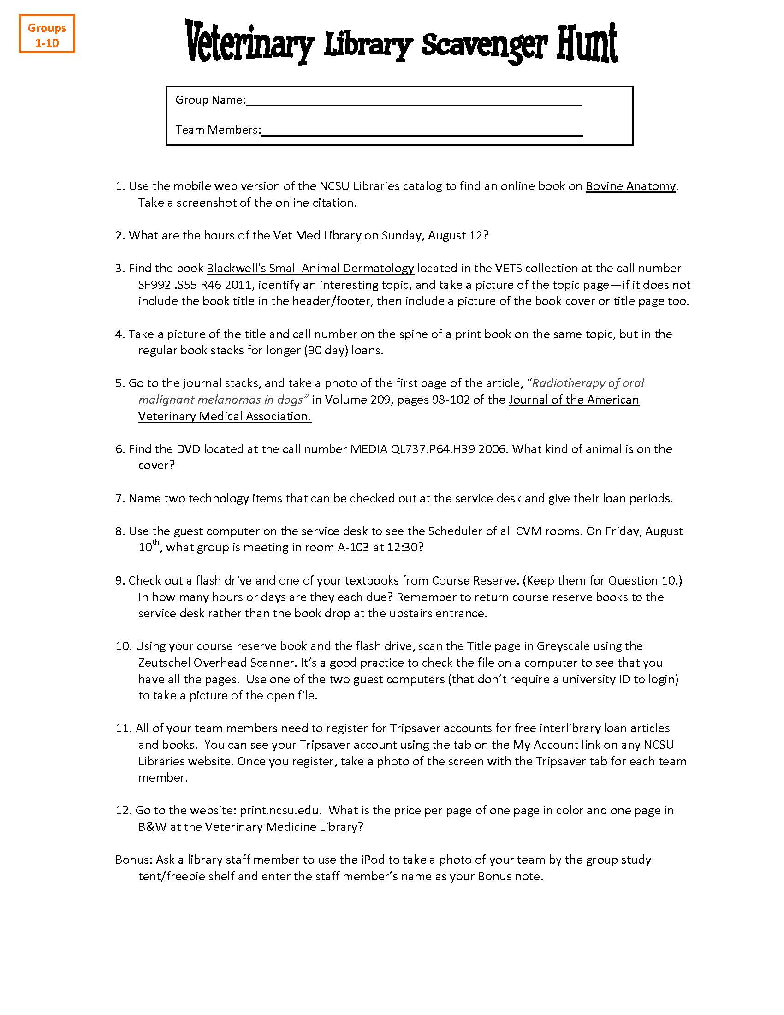
Appendix B. 2013 Sample Scavenger Hunt Hint Sheet
