Supporting Academic Success: Development of Resources to Optimize the Effectiveness of a Preschool Sensory Room

Ella Clayton, OTS
Dr. Annie DeRolf, Capstone Coordinator
Dr. Lori Breeden, Faculty Mentor
Department of Occupational Therapy, Indiana University

Author’s Note
The author has no known conflicts of interest to report.
Correspondence concerning this article should be addressed to Ella Clayton, Indiana University Department of Occupational Therapy. 1050 Wishard Boulevard, Indianapolis, IN 46202. Email: ellmclay@iu.edu

Table of Contents
Acknowledgements | 4
Abstract | 5
Introduction | 6
Needs Assessment  Needs Assessment Process  Community Profile  Site Interview | 7  7  8  8
Gap Analysis  Current State  Identified Gap(s)  Desired State  Gap Analysis Conclusion | 9  9  9  10  10
Guiding Model/ Theory | 10
Literature Review  Sensory Processing and Integration  Sensory Processing Disorder and Difficulties  Evidence-Based Sensory Interventions  School Based Occupational Therapy  Sensory Integration in Schools  Motor performance  Handwriting  Sensory rooms  Capstone Implications  Capstone Project Plan and Process  Project Goals and Objectives  Capstone Process  Capstone Project Implementation  Advancement of Clinical Skills  Initial Site Survey  Sensory Room Refurbishment  Creation of Sensory Resources  Creation of Educational Materials  Post Implementation Survey  Evaluation  Discussion and Impact  Limitations  Sustainability Plan  Conclusion  References  Appendix A | 12  12  13  15  17  19  20  20  22  23  24  24  25  26  26  27  28  29  30  30  31  32  32  32  33  35  43
Appendix B  Appendix C  Appendix D  Appendix E  Appendix F  Appendix G  Appendix H | 45  46  49  50  52  53  54

Acknowledgements
I would like to take a moment to express my gratitude to everyone who has contributed to making this project possible and supported me over the past three years. It would not have been possible without you all.
A special thank you to Tammy Brown my site mentor, for welcoming me to Pleasant View Elementary with open arms. It has been a privilege to be mentored by someone with so much experience and passion for school based occupational therapy.
I would also like to thank my classmates and professors at Indiana University’s occupational therapy program. This program has challenged me and provided invaluable experiences that would not have been possible without your support. Thank you to my faculty mentor Dr. Lori Breeden for your guidance and support while writing this doctoral capstone report.
Finally, a huge thank you to the people I love the most —my friends and family. To my friends, thank you for cheering me on and believing in me. To my partner Ian Hall, thank you for being there through every high and low of my graduate school journey. I truly could not have done it without you.
To my parents, Jeff, and Kara Clayton — the best physical therapists I know and my inspiration for becoming an occupational therapist. Thank you for the unconditional love and support you give to me every day. I owe everything to you both, and I strive every day to make you proud.

Abstract
Sensory processing challenges can significantly impact a student’s functional participation in educational activities, highlighting the importance of sensory rooms as therapeutic environments where sensory input can be modulated to support individual needs. This doctoral capstone project aimed to enhance the effectiveness of Pleasant View Elementary’s (PVE) preschool sensory room by providing education and resources to help educators adapt sensory input to students’ individual needs. To achieve this goal, the doctoral capstone student developed and implemented sensory resources, modified the sensory room layout and equipment, and provided staff education on sensory topics. Project efficacy was evaluated through pre- and post-surveys completed by preschool educators at PVE. Despite a limited survey response rate, results indicated that educators’ knowledge and confidence in supporting student’ sensory needs were increased after the sensory informational session. Additionally, educator responses and feedback indicated an overall increase in the perceived effectiveness of the sensory room in meeting students’ emotional and sensory regulation after the implementation of the doctoral capstone project. The outcomes of this project support the value of structured sensory environments and staff training in effectively supporting students with sensory processing challenges.

Keywords: occupational therapy, sensory processing disorder, sensory differences, preschool

Supporting Academic Success: Development of Resources to Optimize the Effectiveness of a Preschool Sensory Room
For children who struggle with sensory processing, a day at preschool can feel overwhelming. Their typical day may include a variety of demands, such as peer interactions, structured activities, unstructured play time, and multiple transitions between tasks and environments (Martinelli, 2016). When these demands become too extensive for their sensory systems they may experience a sensory mismatch, where the sensory input they receive does not align with their needs (Mulligan et al., 2021). In these cases, sensory rooms can be an effective tool for regulating sensory systems and increasing focus on learning activities (Unwin et al., 2024).
Sensory processing is the way individuals organize sensory information from the body and the environment which influences how they interact with their physical and social surroundings (Passarello et al., 2022). Current studies estimate that 5% to 16.5% of the general population have symptoms associated with sensory processing challenges. In clinical populations such as autism spectrum disorder, (ASD) and attention deficit hyperactivity disorder (ADHD), these estimates are much higher (Miller et al., 2017). When children experience sensory processing difficulties in the classroom, their behavior may include verbal and physical aggression, elopement, and noncompliance with adult demands (Pietro, 2016). These behaviors impact student learning and create an unsafe environment for all students in the classroom (Jones et al., 2020).
When these behaviors occur at Pleasant View Elementary School (PVE), the preschool sensory room is available to provide a space away from the classroom for sensory regulation. Sensory rooms, also known as multi-sensory environments (MSE), are spaces with equipment designed to provide sensory stimulation tailored to the user’s needs (Stephenson & Carter, 2011). The terms sensory room(s) and MSE(s) will be used interchangeably throughout this report. Sensory rooms address the sensory needs of the user by reducing or stimulating the sensory modalities to meet the user’s needs (Unwin et al., 2021). For example, a sensory swing may be used in a linear motion to calm overstimulated students, and a spinning chair may be used for students who require increased sensory input. Common equipment utilized in school sensory rooms includes sensory bins, swings, crash pads, ball pits, varying textured objects, music players, body socks, and weighted blankets.
One of the most important resources in a sensory room is the educator who works closely with the student. As Unwin et al. (2021) explains, the educators’ knowledge of the environment, equipment, and the students’ needs is essential for creating an effective and supportive sensory room. To create an optimal sensory room for enhanced learning, educators must be confident in their ability to effectively use the equipment and tailor the resources to their students’ needs (Unwin et al., 2021). This doctoral capstone project aimed to develop comprehensive training materials (e.g. sensory room guide and practical strategies) to equip educators with the skills and confidence necessary to meet the sensory needs of each student.
Needs Assessment
Needs Assessment Process
To determine the needs of PVE in Zionsville, Indiana, the needs assessment included a community profile, gap analysis, stakeholder interviews, and literature review. Literature searches were conducted on PubMed, and Google Scholar, using search terms related to sensory processing and integration and school-based occupational therapy. Based on the literature review and relevant needs of the site, a proposed evidence-based plan to address the identified gap in sensory room resources and education was developed in collaboration with occupational therapists at PVE.
Community Profile
The Zionsville Community School System (ZCS) consists of nine schools with a total of 7,784 students. ZCS ranks in the top five percent of Indiana school districts and has an overall graduation rate of 97% (National Center for Education Statistics n.d.). Of the six elementary schools in the district, PVE is the only with two additional preschool and transitional pre-k classrooms. The transitional classrooms are integrated programs where typically developing students and students who require additional support are placed together in the same educational environment. These classrooms allow typically developing students to serve as positive role models for their peers by demonstrating skills that the educators and therapists are teaching (Zionsville Community Schools [ZCS], n.d.). In addition to these classrooms, there are also developmental preschool programs for children who have a speech delay or other academic, social, or physical needs. The preschool classrooms include different enrollment options depending on the student’s needs. These options include a five-day full-time program, five-day partial-time program, three-day full-time program, three-day partial-time program, two-day full-time program, and two-day partial-time program (ZCS, n.d.).
Site Interview
A site interview with an occupational therapist at PVE, Tammy Brown OTR/L, was completed on March 15th, 2024. The interview started with a brief tour of the entire building with special focus on their therapy room, and sensory rooms. Several questions were asked to gain a better sense of the site and needs of their staff and students. Questions were centered around the challenges at the site and both the needs of the students and occupational therapists. The complete list of interview questions can be found in Appendix A. The occupational therapist indicated a desire to reorganize and restructure the sensory rooms through the distribution of evidence-based resources. These resources would allow teachers to maximize the effectiveness of the sensory room and prioritize the sensory needs of each student. This became the primary objective of the doctoral capstone project.
Gap Analysis
Current State
PVE serves the largest preschool population of all the elementary schools in the Zionsville School District. The preschool classrooms are all located in the same hallway, which also houses the preschool sensory room. The sensory room is often utilized when students are having behaviors and are unable to regulate within the classroom environment. These sensory behaviors can be viewed as disruptive to their peers, which prevents optimal learning from occurring. The sensory room has a variety of resources and tools for occupational therapists, educators, and students, but a lack of organization, intentionality, and accessibility of the resources themselves creates barriers to usage. Currently, there are no resources for educators to match students’ sensory needs to appropriate activities, which results in the ineffective utilization of the sensory room.
Identified Gap
Due to the imbalance of available staff and high caseload volume, the occupational therapists do not have the capability to develop intentional resources in the sensory room to reduce the current barriers. Along with the occupational therapists, the educators also do not have time in their day to modify the sensory room due to their high work demands. Outdated materials prevent the implementation of best practice strategies for the regulation of student behaviors. Additionally, current resources in the sensory room lack direction on modifications to find the best fit for each student which prevents the sensory rooms from having an ideal calming atmosphere that is beneficial for students.
Desired State
The occupational therapists at PVE expressed a desire to improve the intentional use of. The sensory room by creating evidence-based resources that can be more efficiently matched to the sensory needs of the students. These changes to the sensory room would be identified and implemented through collaboration with occupational therapists and educators at PVE and would align with current best practice. The resources designed for the program will individualize the sensory options and improve sensory regulation for students at PVE.
Gap Analysis Conclusion
While the preschool sensory room at PVE does currently provide a space outside the classroom for students to regulate, the effectiveness could be increased by the presence of modifiable, evidence-based resources. The sensory room is well equipped with resources suitable for preschoolers, but educators lack training on how to utilize them to meet the individual needs of their students. To reach the site’s desired state, the doctoral capstone project utilized best practice principles gathered from the literature to guide the development of sensory room resources. With these resources, staff at PVE would be able to tailor the sensory room experience to the individual needs of each student.
Guiding Model/Theory
The development of the doctoral capstone project was guided by the Person-Environment-Occupation (PEO) model, which acknowledges that occupational performance is cultivated through the constant interaction between person, environment, and occupation (Law et al., 1996). The person is defined as a unique being simultaneously assuming various dynamic roles (Law et al., 1996). The person consists of mind, body, and spirit and brings an individualized set of attributes and life experiences that influence occupational performance. The environment includes cultural, socioeconomic, institutional, physical, and social considerations (Law et al., 1996). The last component, occupation, is defined as self-directed functional tasks and activities that an individual partakes in over their lifetime (Law et al., 1996). Occupational performance is shaped by person, environment, and occupation. When there is harmony among the three components of the PEO model, the resulting outcome is optimal occupational performance. A barrier or disruption in one of the three components may lead to inhibited occupational performance.
The person of this doctoral capstone project includes both the preschool students who benefit from the sensory room and the educators at PVE who support these students by utilizing the resources. Each child shares the role of a preschool student but brings their unique experiences and sensory processing patterns, which influence how they interact with their school environment (Passarello et al., 2022). Knowing each student’s unique sensory processing pattern allows educators to analyze if a barrier is present due to a sensory mismatch (Unwin et al., 2021). Environmental factors in the school setting are reflective of the PEO Model as sensory stimuli in the classroom are dynamic throughout the school day. The sensory room aims to create a positive environmental setting to promote sensory regulation for students. The environmental factors must be both diverse and modifiable to meet the unique needs of each student. The occupation component requires activities in the sensory room to be enjoyable and meaningful for the student to facilitate a match between sensory input and sensory needs. Activities must also be based on evidence to facilitate best sensory regulation outcomes. The doctoral capstone project aims to tailor the use of the sensory room to each child's needs, balancing their personal, environmental, and occupation factors to support their success.
Literature Review
Sensory Processing and Integration
Sensory processing and sensory integration are multifaceted concepts that have been interpreted and described by various models and theories. In general, sensory processing refers to the ability to use the seven senses to take in, process, and give meaning to sensory stimuli from the environment. Sensory integration typically refers to the neurological process that organizes and provides meaning to sensory stimuli, allowing an individual to respond appropriately (Children's Hospital of Philadelphia, 2016).
Dunn’s Model of Sensory Processing explains that a person’s behavioral response to sensory stimuli reflects a particular neurological threshold they may have (Dunn, 1997). Neurological threshold refers to the amount of sensory stimuli required for the brain to notice and respond to sensory events. Responses occur in two main ways–responding in accordance to sensory stimuli or responding to counteract the sensory stimuli (Dunn, 1997; Ismael et al., 2018). The neurological thresholds can be high or low, and self-regulation or responding strategies can be passive or active. The four patterns of sensory processing highlighted in Dunn’s model include low registration, sensory seeking, sensory sensitivity, and sensory avoiding (Dunn, 1997; Ismael et al., 2018). The low registration pattern represents a high threshold and passive regulation strategies. Individuals with this sensory pattern do not recognize or process all incoming sensory information (Dunn, 1997; Ismael et al., 2018). Associated behaviors include lack of interest and inattention to surroundings. Sensory seeking characteristics include high thresholds and active behaviors to counteract the sensory stimuli. Sensory seekers may add movement, touch, sound, and visual stimuli to every experience (Dunn, 1997; Ismael et al., 2018). The sensory sensitivity pattern includes a low threshold and passive self-regulation strategies. Individuals with sensory sensitivity are often hyperactive or very distracted, presenting as irritable or uncomfortable in highly stimulating environments (Dunn, 1997; Ismael et al., 2018). Sensory avoiding individuals have a low threshold and active self-regulation strategies. Resulting behaviors of this pattern include limiting sensory events and creating rituals for daily routines (Dunn, 1997; Ismael et al., 2018). In schools, sensory avoiders may cover their ears in loud classrooms or avoid touching certain textures like paint or sand.
Sensory Processing Disorder and Difficulties
Sensory processing difficulties are often seen in individuals with ASD and are included as features of ASD in the Diagnostic and Statistical Manual of Mental Disorders, Fifth Edition (DSM-5) (Galiana-Simal et al., 2020). Sensory processing difficulties can result in atypical responses to sensory stimuli including hypersensitivity, hyposensitivity, or distorted perceptions (Patil & Kaple, 2023). Individuals with ASD may experience sensory processing difficulties due to changes in neural connections, gating dysfunction, or atypical modulation (Patil & Kaple, 2023). Although sensory processing disorder (SPD) is not recognized in the DSM-5, it is included in the Diagnostic Classification of Mental Health and Developmental Disorders of Infancy and Early Childhood-Revised. SPD is diagnosed when an infant/child demonstrates behaviors rooted in abnormalities with regulating sensory input (DC: 0-5: Diagnostic Classification of Mental Health and Developmental Disorders of Infancy and Early Childhood, 2016). SPD affects individuals through infancy and early childhood, and related behaviors cause distress or impair the child’s ability to participate in daily activities (DC: 0-5: Diagnostic Classification of Mental Health and Developmental Disorders of Infancy and Early Childhood, 2016). SPD has been historically difficult to diagnose and understand because one or more of the sensory systems including visual, auditory, tactile, smell, taste, vestibular, proprioception, and interoception can be affected (Galiana-Simal et al., 2020). According to Ben-Sasson et al. (2009), 5-13% of children aged four to six years old are affected by sensory disorders and suffer debilitating social and emotional consequences.
SPD can be subclassified into three types: sensory modulation disorder (SMD), sensory-based motor disorder (SBMD), and sensory discrimination disorder (SDD) (Miller et al., 2009). Modulation within SMD refers to the ability to notice, react, regulate, adapt, and grade sensory responses that are appropriate to daily sensory experiences (Mulligan et al., 2021). The three subtypes of SMD include sensory over-responsivity (SOR), sensory under-responsivity (SUR), and sensory cravings (SC). Example behaviors associated with SOR are intense, exaggerated responses to sensory events that most children do not react negatively to (Mulligan et al., 2021). Individuals with SUR may exhibit lethargy, indifference, and muted or slowed behaviors in response to sensory experiences. Behavior associated with SC includes seeking more intense sensory input resulting in inappropriate, disruptive, disorganized, and risky actions (Mulligan et al., 2021).
SBMD includes challenges with motor skills due to difficulty processing and integrating sensory information. The two subtypes of SBMD are postural disorder and dyspraxia. Postural disorder includes issues with stabilization of the body during movement or at rest and decreased motor strength balance and coordination (Mulligan et al., 2021). Dyspraxia manifests in difficulties with sequencing motor planning and performing new motor activities (Mulligan et al., 2021). SDD involves problems with accurately perceiving and interpreting sensory information coming in or from the sensory systems (Mulligan et al., 2021). Sensory discrimination allows individuals to distinguish between different sensory information and interpret its meaning. Individuals with SDD can register sensory stimuli but are unable to distinguish the qualities of the sensory stimuli (Mulligan et al., 2021).
Evidence-Based Sensory Interventions
Challenges with sensory processing and integration can affect children’s participation in daily activities including education, self-care, play activities, and social participation (Costa-Lopez et al., 2021; Jones et al., 2020). Occupational therapists have historically been the leading professionals in evaluating and treating sensory processing and integration difficulties (Bodison & Parham, 2018). Occupational therapy sensory interventions can be classified into two main categories: Ayres' Sensory Integration (ASI) and sensory-based interventions (SBI) (Bodison & Parham, 2018; Watling & Hauer, 2015; Case-Smith et al., 2015).
ASI, developed by Dr. A. Jean Ayres, is a play-based method that utilizes active engagement in sensory-rich environments to elicit adaptive responses and improve a child’s ability to successfully perform and meet environmental demands (Watling & Hauer, 2015). Goals for ASI are rooted in changing internal neurophysiological processing of sensation to promote observable change in functional behavior and sensory responsiveness (Watling & Hauer, 2015). Ten elements based on a Fidelity Measure by Parham et al. (2011) are required for interventions to be classified as ASI. They are as follows:
Ensuring physical safety; Presenting a range of sensory opportunities (specifically, tactile, vestibular, and proprioceptive); Using activity and arranging the environment to help the child maintain self-regulation and alertness; Challenging postural, ocular, oral, or bilateral motor control; Challenging praxis and organization of behavior; Collaborating with the child on activity choices; Tailoring activities to present the just-right challenge; Ensuring that activities are successful; Supporting the child’s intrinsic motivation to play; and Establishing a therapeutic alliance with the child. (Parham et al. 2011)
A systematic review by Watling & Hauer (2015) concluded that ASI interventions that adhere to the aforementioned elements show significant improvement in “individualized student goals, improved sleep, decreased ‘autism mannerisms’ and reduced caregiver burden” (p.6). A recent call to action by the American Journal of Occupational Therapy (AJOT) emphasizes the importance of utilizing ASI in school-based practice (Whiting et al., 2025). Guiding principles of ASI should be used to create sensory-rich environments and activities in schools that produce adaptive responses and support learning (Whiting et al., 2025).
The other category of interventions, SBI, differs from ASI in that it consists of applying adult-directed sensory modalities to the child with the goal of producing short-term effects on self-regulation, attention, or behavioral organization (Watling & Hauer, 2015). Three distinct categories of SBI exist - multisensory, single-sensory, and environmental considerations (Watling & Hauer, 2015). Multisensory SBI includes client engagement in activities that provide two or more distinct sensory stimuli. In a systematic review of five studies that examined frequent and active participation in multisensory interventions, outcomes showed improvement in “‘autism symptoms’, cognitive functions, motor performance, sensory integration function, and focus” (Watling & Hauer, 2015, p. 8). Single-sensory SBI involves participation in an activity that provides singular sensory input. Examples of single-sensory SBI include weighted vests, dynamic seating options, sound therapies, and vestibular input. According to Watling and Hauer (2015), single-sensory SBI produced small effects or no effects while vestibular input produced the most significant outcomes, indicating this method may be useful before academic instruction for some students.
Environmental modifications are physical changes to the environment that support the successful functioning of children with sensory processing challenges. Research on the outcomes of environmental modifications in school-based settings are limited. Watling and Hauer, (2015) were unable to draw conclusions regarding environmental modifications due to limited studies available. According to Kinnealey et al. (2012), classroom environmental modifications for students with ASD through sound reduction proved to be beneficial, especially for those with sensory hypersensitivity. These implications demonstrated improved attention and engagement within the classroom among these students as well (Kinnealey et al., 2012).
School-Based Occupational Therapy
About 25% of occupational therapists work in early intervention and school settings, to help children and adolescents participate in meaningful occupations (American Occupational Therapy Association [AOTA], 2017). Students in the public education system are entitled to receive occupational therapy services under Part C of the Individuals with Disabilities Education Improvement Act (IDEA) and Every Student Succeeds Act of 2015 (ESSA) (AOTA, 2017; Individuals with Disabilities Education Act [IDEA], 2004; Every Student Succeeds Act, 2015 [ESSA]). IDEA requires eligible students to receive an Individualized Education Program (IEP) that includes measurable annual goals (academic goals and functional goals) (IDEA, 2004). Through these acts of legislation, eligible children can receive occupational therapy services for their IEP goals and personal growth.
Through the use of occupation, school-based occupational therapists promote student academic success. Occupational therapy plays a crucial role in education as school-based occupational therapists integrate their interventions into various school settings, such as the classroom, lunchroom, and recess. (Cahill & Beisbier, 2020). Sensory integration methods are utilized by school-based occupational therapists to increase the accessibility of the general education curriculum and academic activities (Roley et al., 2009). Clinical reasoning behind the use of sensory integration methods is based on professional training, evidence, and expertise. School-based occupational therapists utilize their clinical reasoning to help students whose sensory challenges are interfering with access to the curriculum and affecting participation in activities at school (Roley et al., 2009).
To provide the best quality of care for their students, occupational therapists must utilize evidence-based practices to guide their clinical decision making to ensure the effectiveness of their interventions (AOTA, 2017). Principle two of the Occupational Therapy Code of Ethics, nonmaleficence, highlights the importance of refraining from harmful actions as a practicing occupational therapist (AOTA, 2020). Occupational therapists have an ethical obligation to utilize best practice materials to avoid potential harm caused by inadequate or outdated interventions. Effective occupational therapy starts with a comprehensive evaluation. This process involves screening all areas of meaningful occupations for a student, reviewing student records, observing the student in their natural routine, and using applicable subjective and objective assessment tools (Clark et al., 2019). Proper evaluations provide a strong foundation for developing individualized treatment plans. The school-based occupational therapist should then work with the educators to identify the student’s needs and create collaborative IEP goals (Clark et al., 2019). Interventions provided should reflect the distinct value of occupational therapy in school settings (Clark et al., 2019). Frequent gathering of quantitative data is essential in school-based occupational therapy to closely monitor the effectiveness of the intervention (Clark et al., 2019). In relation to sensory integration, school-based occupational therapists must ensure student’s needs are linked to sensory processing difficulties before using a sensory approach for interventions (AOTA, 2023).
Sensory Integration in Schools
Sensory integration is commonly used in schools with children who have sensory challenges that affect their participation in the school environment (Roley et al., 2009). Sensory-based interventions are commonly utilized with children diagnosed with ASD and/or ADHD. A large majority of school-based occupational therapists have reported that they believe sensory-based interventions are appropriate within the school setting (Roach et al., 2017). Of the surveyed school-based occupational therapists, 100% reported that their caseload included children with a diagnosis of ASD, and 71% reported their caseload included children with ADHD (Roach et al., 2017). The use of sensory-based interventions in the school setting has shown improvement in student performance areas including attention, self-regulation, learning, and overall educational participation (Roach et al., 2017). A study from Whiting et al. (2023) concluded that sensory integration interventions with consultation can improve school performance and performance for students with sensory integration challenges.
One challenge in using sensory integration within the school setting is the contextual limitations of the environment which may include limited physical space and resources, administrative policies, and insufficient support from other staff members (Roach et al., 2017). Another challenge is ensuring that all professional team members are knowledgeable about sensory-based interventions, which is crucial for promoting awareness and facilitating carryover (Roach et al., 2017). Interprofessional collaboration can promote shared knowledge, but limited time for these interactions is a barrier that may restrict communication and coordination among team members (Rose & Seruya, 2020). To combat these challenges, school-based occupational therapists must be creative when incorporating sensory-based interventions in the school environment (Roach et al., 2017). Hubbard and Friedman (2020) concluded that a four-month interprofessional training and coaching sequence is an effective way to increase communication skills among educators and school-based occupational therapists.
Motor Performance
Sensory processing plays a role in motor development as the process is largely dependent on experiences–in particular active trial and error experiences (Hadders-Algra, 2018). In motor development theoretical frameworks, it is believed that both life experiences and correct sensory processing are paramount for motor development (Takahashi et al., 2020). Addressing gross and fine motor skills to promote student’s participation in ADLs, education, play, self-care, and social participation is in the scope of practice for school-based occupational therapists (Tanner et al., 2020). Interventions focusing on motor development aim to remediate motor impairments, minimize developmental delays, and support family functioning through the development of routines (Tanner et al., 2020). The utilization of evidence-based interventions to develop fine and gross motor skills directly affects student performance outcomes. Tanner et al. (2020) indicates that video games, preschool programs that target fine motor and visual-motor skills, and movement breaks are all beneficial interventions for fostering the development of motor skills in preschool-aged children. Other studies echo the benefits of addressing motor skills in schools and indicate interventions based on motor learning theory increase functional performance for preschool students with ASD (Jin et al., 2023).
Handwriting
A major determining factor for academic success is handwriting (Bonneton-Botté et al., 2023). The foundation for these skills is built in the preschool and pre-k classrooms. Writing is a complex task that intertwines lower-level motor skills, higher-order cognitive processes, and the environmental context (Bonneton-Botté et al., 2023). The ability to write allows students to engage in key academic areas including reading, spelling, and mathematics. A study by Donica et al. (2024) that explored the relationship between sensory integration and handwriting in elementary students found sensory integration may play a role in handwriting skills. Additional findings from the same study suggest occupational therapy practitioners should evaluate underlying sensory integration skills to understand their possible impact on handwriting skills (Donica et al., 2024). Another study by Diamant and Nealon (2018) showed a statistically significant relationship between auditory sensory systems and motor coordination in children with ASD impacting handwriting skills.
Difficulties in handwriting lead to an increased risk of problems in the classroom, and potentially low self-esteem (Bonneton-Botté et al., 2023). To promote success in handwriting interventions, school-based occupational therapists should work with students on handwriting skills often, be task-specific, utilize explicit instruction, provide intrinsic and extrinsic feedback, introduce variability, and create a motivating and supportive learning environment (Bonneton-Botté et al., 2023). These guidelines align with the concepts of motor learning and emphasize the importance of personalized handwriting instruction.
For elementary school-aged children, several strategies are applicable for the development of handwriting skills. Typically developing children may benefit from the use of gross motor skills to improve the construction of the motor representations of letters (Bonneton-Botté et al., 2023). Self-evaluation techniques, motor imagery, trace deletion during letter training for feedback provision, and watching video sequences of letter formation are evidence-based strategies for handwriting interventions for this population (Bonneton-Botté et al., 2023).
Sensory Rooms
Sensory rooms were first used in the Netherlands under the name ‘snoezelen’ (Hogg & J. Cavet, 2013, pp. 67–68). Original snoezelen rooms were developed for individuals with profound and multiple disabilities as a space for relaxation and pleasure (Hogg & J. Cavet, 2013, pp. 67–68). The concept of sensory rooms has since evolved, and today the use of sensory rooms is widespread throughout various settings including hospitals, community centers, therapy clinics, residential care facilities, and schools. Occupational therapists play a critical role as navigators through the sensory landscape, and craft tailored sensory interventions and therapeutic sensory environments for their clients (Land, 2024).
In a study by Unwin et al. (2021), qualitative interviews with 10 practitioners revealed key themes about MSEs for autistic children. MSEs were found to improve behavior, attention, and mood, with those benefits enhanced by factors like student motivation, control, a comfortable sensory environment, and strong practitioner-student relationships. Practitioners emphasized the importance of tailoring MSE use to each child's needs, playing an active role as an educator, and using MSEs for teaching. The most pivotal factor for MSE success was identified as educators who understand students’ needs and adapt MSE use accordingly (Unwin, et al., 2021).
Thompson (2011) supported the use of MSEs and the incorporation of multi-sensory experiences for students with developmental disabilities. A significant increase in sustained focus and reduction in self-injurious behaviors was reported after time spent in a MSE (Thompson, 2011). Additionally, an increase in observed student happiness, relaxation, and engagement was noted after the utilization of a MSE. African American students’ average sustained focus after the MSE was far greater than their Caucasian peers (Thompson, 2011).
A rapid review conducted by AJOT analyzed 61 articles that focused on recommendations for supporting students with sensory processing challenges (Unwin et al., 2024). Six of the studies focused on MSEs and their ability to enhance learning and minimize distress for students with sensory processing challenges. Three studies reported that MSEs were effective in reducing anxiety, distress, and challenging behavior. Findings also concluded that when students were given the opportunity to have control over aspects of the sensory room, a reduction in “repetitive motor behaviors, sensory behaviors, and stereotyped vocalizations were present” (Unwin et al., 2024, p.6). Additional findings suggest an increase in attention as well (Unwin et al., 2024).
Capstone Implications
Occupational therapists help students achieve their academic potential by eliminating barriers to participation through the use of occupation. Sensory processing issues can impose barriers to student academic performance and other education-related activities, including motor performance and handwriting skills. When evaluations reveal sensory processing challenges, school-based occupational therapists can enhance student educational outcomes by implementing sensory integration strategies. By using evidence-based interventions customized to each student’s needs, they can support improved occupational performance and foster positive results. Sensory rooms in schools have great potential to be optimized through the use of sensory processing knowledge, frameworks, and evidence-based interventions. As the doctoral capstone student worked to create sensory room resources for educator and student use, evidence-based practice was critical for ethical considerations and student success outcomes. Current literature on sensory processing and evidence-based sensory interventions in schools guided the development of the doctoral capstone project to benefit educators and students at PVE.
Capstone Project Plan and Process
In collaboration with the site mentor, and educators at PVE the primary goal of the project was determined to be creation of resources and training materials about sensory processing and the sensory room for educators. Information gathered through the needs assessment, literature review, and the initial educator survey piloted the creation of goals and objectives for resource and training material creation. The plan for evaluation of the capstone project included assessing if goals and objectives were met, and analysis of educator surveys to assess satisfaction with the provided resources and training materials.
Project Goals and Objectives
By the end of the capstone project, the student aimed to accomplish the following goals and objectives:
Project Goal 1: The student will develop sensory activity resources to promote sensory regulation among preschool students who utilize the sensory room at PVE.
Objective 1: The student will collaborate with the educators to learn more about current sensory protocols in place at PVE.
Objective 2: The student will review and utilize evidence-based information/protocols to develop the sensory activity resources.
Objective 3: The student will collect feedback regarding the use of sensory activity usage to make adjustments as needed throughout the capstone project
Project Goal 2: The student will facilitate sustainability of the implementation of sensory room resources by current and future staff at PVE.
Objective 1: The student will designate accessible physical and digital locations for staff members to retrieve and utilize the sensory room resources.
Objective 2: The student will develop educational materials to explain and orient current and new staff to sensory processing, and the purpose and use of the sensory room resources.
Project Goal 3: The student will gain advanced clinical knowledge and skills within the school-based setting.
Objective 1: The student will conduct occupational therapy sessions under the supervision of the site mentor to practice and apply therapeutic interventions with the student population at PVE.
Objective 2: The student will engage in student evaluations to develop competency with the Peabody Developmental Motor Scales, Third Edition (PDMS-3).
Objective 3: The student will observe and actively participate in IEP meetings to gain a thorough understanding of the IEP process and collaborate with the interdisciplinary team.
Capstone Process
The capstone project began with an off-site needs assessment, gap analysis and initial literature review to determine purpose and direction for the capstone project. Once on-site, the student developed an outline for the capstone project development and implementation across the fourteen-week time frame (see Appendix B). The initial three weeks onsite were spent observing and assisting with occupational therapy sessions, developing, and refining the project plan and process, revising the needs assessment and literature review, and creating and sending out the initial educator survey. Weeks four, five, and six were spent reviewing educator survey responses and in-person suggestions, developing sensory activity resources, changing the layout of the sensory room, removing unused equipment, and adding in new equipment. In addition, the doctoral capstone student routinely participated in evaluations, IEP meetings, push-in occupational therapy sessions in the classrooms, and motor group sessions in the therapy room. Weeks seven through ten were spent developing the educator training presentation and conducting the educator in-service session. Hands-on experience was continued, as well as collecting feedback on the sensory room resources and changes. During the final four weeks, the student created and administered the post-survey to educators, analyzed results of the post-survey, implemented changes based on educator feedback, completed sustainability measures, and finalized the doctoral capstone report.
Capstone Project Implementation
Prior to the onsite implementation of the capstone project, the doctoral capstone student submitted project plans to the institutional review board (IRB). The capstone project was deemed not human subjects research indicating that the capstone project did not require further review and could proceed as planned.
Advancement of Clinical Skills
Throughout the capstone project experience, the capstone student engaged in a variety of hands-on activities and experienced significant growth in clinical and professional skills. Conducting push-in occupational therapy sessions allowed the capstone student to refine the ability to adapt interventions in real-time, ensuring they were meaningful and relevant in a school environment. This skill proved to be important as the capstone student learned to incorporate student’s individual sensory needs into their educational goals. Conducting and contributing to IEP meetings deepened the capstone student’s communication and advocacy skills, particularly with articulating the importance of sensory strategies for students with sensory processing difficulties. The capstone student developed a deeper understanding of effective collaboration within an interdisciplinary team, including related services team members and educators, to create holistic interventions to address student’s sensory, motor, and academic needs.
Through administering and scoring the PDMS-3 the capstone student developed skills related to evaluation and interpreting developmental milestones, as well as using data to inform and guide individualized intervention planning. Additionally, the capstone student gained proficiency in documenting student progress with accuracy and detail, which contributed to comprehensive student progress reports and goal planning. Overall, the capstone experience significantly enhanced the capstone student’s clinical skills and fostered a well-rounded approach to school-based occupational therapy. The capstone student gained greater confidence as an advocate for sensory and motor needs within the educational setting and developed a stronger sense of how to create collaborative, evidence-based interventions that are responsive to the complex needs of students.
Initial Site-Survey
The doctoral capstone student in collaboration with the site mentor created an initial survey for the preschool educators at PVE to help determine current perceptions and concerns related to the usage of the sensory room. The survey included six questions, comprised of open ended, multi-select, and five-point Likert scale formats. One additional open-ended question allowed educators to expand on additional thoughts, concerns, and suggestions regarding the sensory room. A full list of initial site-survey questions and responses can be found in Appendix C. This survey was emailed to the preschool educators during week two of the capstone project and three responses were received.
Two-thirds of the educators surveyed reported their students utilized the sensory room several times a week. Results of the surveys indicated that emotional regulation was the primary reason for using the sensory room, additionally sensory overload, calming/relaxation, breaks from classroom tasks and difficulty focusing were also noted as reasons for sensory room use. The top three most utilized equipment from eight options were the sensory swing, crash pad, and steamroller. All the surveyed educators had a different perception of the current effectiveness of the sensory room ranging from neutral, effective, and very effective. Survey responses along with in-person discussions with educators revealed a lack of intentional activities and guidance for instructional aides who routinely work with the students in the sensory room.
Sensory Room Refurbishment
The doctoral capstone site mentor indicated a need to alter aspects of the sensory room to create a calming atmosphere. Based on principles of ASI, physical features of a sensory rich environment include flexibility of arrangement and an array of available sensory resources (Parham et al. 2011) Initially, the sensory room had the swing in the middle of the room, limiting space for activities. Several pieces of equipment were damaged and worn through, and the sensory room was lacking potentially valuable sensory materials. A prospective room layout was drawn up in collaboration with the site mentor (see Appendix D), and an inventory of sensory room equipment was completed. On week five of the doctoral capstone experience, the doctoral capstone student and site mentor began sensory room refurbishment. The storage cabinet was relocated near the entrance to provide quick access to sensory tools. The swing was moved to a corner to provide more space in the middle of the room, allowing for flexible arrangement of equipment. The crash pad was relocated near the storage cabinet to provide a sectioned off calming area.
The doctoral capstone student and site mentor discussed equipment that were unused or damaged to potentially remove from the sensory room. After consulting the preschool educators, selected equipment was removed from the sensory room and put in storage or thrown away. A list of needed equipment was developed based on student needs, and equipment was sourced from the therapy room and other locations in the building. All equipment selected for the sensory room was designed to be incorporated in meaningful, playful, and goal-directed activities based on ASI principles (Watling & Hauer, 2015). Various lighting options including a mutli-colored lamp, projector, and wall lights were added to provide modifiable visual stimuli and improve attention and engagement for students with visual hypersensitivity based on findings from (Kinnealey et al., 2012). The site mentor purchased wall decals that were placed on three walls of the sensory room to contribute to the calming atmosphere.
Creation of Sensory Resources
Results from educator surveys and discussions revealed a lack of resources in the sensory room intended to guide educators on activities to meet student’s sensory needs. To meet this need, the doctoral capstone student developed evidence-based sensory activity resources centered on concepts from ASI (see Appendix E). Activities were divided into three categories: calming, alerting, and organizing. An overview sheet was created to describe the purpose of each category of activity, and the importance of tailoring activities to student’s interests and sensory needs (see Appendix F). Additional easy-reference sheets were created for each activity category to increase access and usage of the sensory resources. An informational overview sheet on sensory circuits, using the three sensory categories in succession, was created based on educator feedback (see Appendix G). These resources were laminated and placed near the entrance of the sensory room for easy accessibility.
Creation of Educational Materials
PVE instructional assistants do not receive training on sensory processing or guidance on the effective use of the sensory room. This led to the creation of an informational presentation which covered the topics: what is sensory processing, the eight sensory systems, sensory processing difficulties, Dunn’s Four Quadrant Model, what are sensory rooms, and utilizing the sensory room. The doctoral capstone student provided an in-service during the eighth week which all preschool staff were invited to attend. During the in-service session the doctoral capstone student reviewed the listed concepts, addressed questions concerning sensory processing and use of the provided sensory resources and equipment. Four preschool educators, one instructional assistant, and a preschool SLP, PT, and OT attended the presentation. In addition to the in-person education a VoiceThread of the session was created and a link was made available to those unable to attend and future staff members.
Post Implementation Survey
To assess the effectiveness of the doctoral capstone project a post implementation survey was developed and distributed to the five preschool educators at PVE. Of the five educators, three responses were returned. 100% of educators surveyed indicated they felt better equipped to support students with sensory processing challenges after attending the informational session. 100% of educators indicated the sensory activity resources created by the doctoral capstone student were very useful in supporting student’s sensory needs. Two responses indicated the sensory room was very effective in helping students regulate their emotions and sensory needs, one response indicated the sensory room was effective. All responses indicated that the doctoral capstone project had a positive impact on student engagement, focus, and behavior. A full list of post implementation survey questions and responses can be found in Appendix H.
Evaluation
Prior to implementation of the doctoral capstone project, three preschool educators completed the pre-survey which evaluated perceptions and concerns related to the usage of the sensory room. After project implementation, the post-survey was disseminated to evaluate the effectiveness of the sensory information session, and sensory resources. Throughout implementation of the doctoral capstone project, the capstone student gathered qualitative feedback from educators and support staff to continually alter and improve sensory resources to fit the needs of PVE’s staff and students.
Both the pre- and post-surveys asked respondents to rate the effectiveness of the sensory room in helping students regulate their emotions and sensory needs on a five-point Likert scale. The pre-survey responses were evenly distributed with 33.3% of respondents selecting neutral, 33.3% selecting effective, and 33.3% selecting very effective. In contrast, the post-survey showed a notable shift, with 66.7% of respondents selecting very effective and 33.3% of respondents selecting effective. This shift suggests an overall increase in the perceived effectiveness of the sensory room in meeting students’ emotional and sensory regulation after the implementation of the doctoral capstone project.
Qualitative data from the post-survey, along with in-person feedback highlighted the layout change of the sensory room as a key-factor in the success of the doctoral capstone project. Both educators and students noted that the open layout allowed more flexible use of the space and improved organization of resources. Increased lighting options were also a key-factor, creating a more inviting and adaptable environment to better meet the diverse sensory needs of students. Additionally, feedback on sensory activity materials indicated that the calming activities, and the compression sensory swing were particularly beneficial to students.
Discussion and Impact
Both quantitative and qualitative results indicated that the doctoral capstone project enhanced the effectiveness of the PVE preschool sensory room. Additionally, the findings suggested that the sensory informational session contributed to increased educator confidence and knowledge in supporting students with sensory processing challenges. Though the implementation of this project, the capstone student also deepened their understanding of sensory processing and school-based occupational therapy while building meaningful relationships with both staff and students. All goals and corresponding objectives for the doctoral capstone project were successfully met. Goals included developing sensory activity resources, implementation of sensory resources, and gaining advanced clinical knowledge and skills in the school-based setting. The results of this project highlight the importance of structured sensory environments paired with staff education to enhance participation and success for students with sensory processing challenges.
Limitations
Several potential limiting factors may have influenced the results and findings of this doctoral capstone project. A small sample size of survey participants limits the generalizability of findings. Lack of funding restricted the scope of materials and resources that could be incorporated into the sensory room, potentially affecting the overall impact of the sensory resources. School policies and restrictions limited the types of equipment and materials that could be used in the sensory room, further narrowing the available options. Schedule constraints within the school setting created additional challenges, as time for staff informational sessions, student use of the sensory room, and data collection was limited.

Sustainability Plan
To ensure project sustainability, the capstone student shared both hard copies and digital files of the created sensory resources with the capstone site mentor. Digital files were put into a singular One Note folder for simplicity. This will allow the related service team members and educators continued access to resources if the hard copies in the sensory room become damaged. In addition, the capstone student recorded the sensory informational session via VoiceThread. The capstone site mentor indicated that they would use this recording for future staff members during their orientation period. Continued implementation of the sensory room resources, and recorded informational session ensures that the knowledge and tools needed to support student’s sensory needs are readily accessible, fostering on-going staff development and promoting long-term benefits for students.
Conclusion
Between 40% to 88% of children with various neurodevelopmental diagnoses, including ASD, exhibit sensory progressing challenges (Pfeiffer et al., 2018). The high prevalence of sensory processing challenges in school-aged children highlights the critical need for adaptable sensory environments and strategies in educational settings. The doctoral capstone project was designed to improve the effectiveness of PVE’s sensory room to better regulate students with sensory processing difficulties. Throughout the fourteen-week doctoral capstone experience, the doctoral capstone student developed sensory resources, implemented sensory room refurbishment, led a sensory informational session, and engaged in the school-based occupational therapy process. Results from the post-survey and verbal feedback indicated the doctoral capstone project resulted in a positive impact on the capstone site. Educators indicated they felt more confident in meeting the sensory needs of their students after attending the informational session. As a result of the doctoral capstone project, PVE is now equipped with the resources and tools necessary to individualize and structure sensory room use to meet the diverse needs of its students.

References
American Occupational Therapy Association. (2020). Occupational Therapy Code of Ethics. American Journal of Occupational Therapy, Vol. 74(Supplement_3), 7413410005p1–7413410005p13. https://doi.org/10.5014/ajot.2020.74S3006
American Occupational Therapy Association. (2017). Guidelines for occupational therapy services in early intervention and schools. American Journal of Occupational Therapy, 71(Supplement 2), Article 7112410010p1. https://doi.org/10.5014/ajot.2017.716s01
American Occupational Therapy Association. (2023). Sensory integration approaches for children and youth in occupational therapy practice. American Journal of Occupational Therapy, 77(Supplement 3), 7713410230. https://doi.org/10.5014/ajot.2023.77S3004
Ben-Sasson, A., Carter, A. S., & Briggs-Gowan, M. J. (2009). Sensory over-responsivity in elementary school: Prevalence and social-emotional correlates. Journal of Abnormal Child Psychology, 37(5), 705–716. https://doi.org/10.1007/s10802-008-9295-8
Bodison, S. C., & Parham, L. D. (2018). Specific sensory techniques and sensory environmental modifications for children and youth with sensory integration difficulties: A systematic review. American Journal of Occupational Therapy, 72(1), 7201190040p1–7201190040p11. https://doi.org/10.5014/ajot.2018.029413
Bonneton-Botté, N., Ludovic Miramand, Bailly, R., & Pons, C. (2023). Teaching and rehabilitation of handwriting for children in the digital age: Issues and challenges. Children (Basel), 10(7), 1096–1096. https://doi.org/10.3390/children10071096
Cahill, S. M., & Beisbier, S. (2020). Occupational Therapy Practice Guidelines for Children and Youth Ages 5–21 Years. American Journal of Occupational Therapy, 74(4), 7404397010p1. https://doi.org/10.5014/ajot.2020.744001
Case-Smith, J., Weaver, L. L., & Fristad, M. A. (2015). A systematic review of sensory processing interventions for children with autism spectrum disorders. Autism: The International Journal of Research and Practice, 19(2), 133–148. https://doi.org/10.1177/1362361313517762
Children's Hospital of Philadelphia. (2016). Sensory processing and sensory integration in individuals with ASD. Children's Hospital of Philadelphia. https://www.research.chop.edu/car-autism-roadmap/sensory-processing-and-sensory-integration-in-individuals-with-asd
Clark, G. F., Watling, R., Parham, L. D., & Schaaf, R. (2019). Occupational therapy interventions for children and youth with challenges in sensory integration and sensory processing: A school-based practice case example. American Journal of Occupational Therapy, 73(3), 7303390010p1. https://doi.org/10.5014/ajot.2019.733001
Costa-López, B., Ferrer-Cascales, R., Ruiz-Robledillo, N., Albaladejo-Blázquez, N., & Baryła-Matejczuk, M. (2021). Relationship between sensory processing and quality of life: A systematic review. Journal of Clinical Medicine, 10(17), 3961. https://doi.org/10.3390/jcm10173961
DC: 0-5: diagnostic classification of mental health and developmental disorders of infancy and early childhood. (2016). Zero to Three.
Diamant, R., & Nealon, B. (2018). Relationships among visual–perceptual–motor skills, sensory processing behaviors and handwriting in school-age children with autism. American Journal of Occupational Therapy, 72(4_Supplement_1), 7211500070p1. https://doi.org/10.5014/ajot.2018.72S1-PO8009
Donica, D. K., Beck, L., & Hill, K. (2024). Exploring the relationship between sensory integration and handwriting in elementary students. American Journal of Occupational Therapy, 78(Supplement 2), 7811500023p1. https://doi.org/10.5014/ajot.2024.78S2-PO23
Dunn, W., Brown, C., & McGuigan, A. (1994). The ecology of human performance: A framework for considering the effect of context. American Journal of Occupational Therapy, 48(7), 595–607. https://doi.org/10.5014/ajot.48.7.595
Dunn, W. (1997). The impact of sensory processing abilities on the daily lives of young children and their families: A conceptual model. Infants & Young Children, 9(4), 23-35.
Every Student Succeeds Act of 2015, Pub. L. 114–195, 114 Stat. 1177.
Galiana-Simal, A., Vela-Romero, M., Romero-Vela, V. M., Oliver-Tercero, N., García-Olmo, V., Benito-Castellanos, P. J., Muñoz-Martinez, V., & Beato-Fernandez, L. (2020). Sensory processing disorder: Key points of a frequent alteration in neurodevelopmental Disorders. Cogent Medicine, 7(1). https://doi.org/10.1080/2331205x.2020.1736829
Gillen, G., Hunter, E. G., Lieberman, D., & Stutzbach, M. (2019). AOTA’s top 5 choosing wisely® recommendations. American Journal of Occupational Therapy, 73(2), 7302420010p1–7302420010p9. https://doi.org/10.5014/ajot.2019.732001
Hadders-Algra M. (2018). Early human motor development: From variation to the ability to vary and adapt. Neuroscience and biobehavioral reviews, 90, 411–427. https://doi.org/10.1016/j.neubiorev.2018.05.009
Hogg, J., & J. Cavet. (2013). Multisensory Environments. Making Leisure Provision for People with Profound Learning and Multiple Disabilities (pp. 67–68). Springer.
Hubbard, K., & Friedman, Z. (2020). Interprofessional Collaboration Among Teachers and School-Based OTs. American Journal of Occupational Therapy, 74(4_Supplement_1), 7411505115p1. https://doi.org/10.5014/ajot.2020.74s1-po3317
Individuals with Disabilities Education Act of 2004. Pub. L. No. 108-446, 118 Stat. 2647 (2004).
Ismael, N., Lawson, L. M., & Hartwell, J. (2018). Relationship Between Sensory Processing and Participation in Daily Occupations for Children with Autism Spectrum Disorder: A Systematic Review of Studies That Used Dunn’s Sensory Processing Framework. American Journal of Occupational Therapy, 72(3), 7203205030p1. https://doi.org/10.5014/ajot.2018.024075
Jin, Y., Sung, Y.-S., Koh, C.-L., Shin Ying Chu, Yang, H.-C., & Lin, L.-Y. (2023). Efficacy of Motor Interventions on Functional Performance Among Preschool Children with Autism Spectrum Disorder: A Pilot Randomized Controlled Trial. American Journal of Occupational Therapy, 77(6). https://doi.org/10.5014/ajot.2023.050283
Jones, E. K., Hanley, M., & Riby, D. M. (2020). Distraction, distress, and diversity: Exploring the impact of sensory processing differences on learning and school life for pupils with autism spectrum disorders. Research in Autism Spectrum Disorders, 72, 101515. https://doi.org/ 10.1016/j.rasd.2020.101515
Kinnealey, M., Pfeiffer, B., Miller, J., Roan, C., Shoener, R., & Ellner, M. L. (2012). Effect of classroom modification on attention and engagement of students with autism or dyspraxia. American Journal of Occupational Therapy, 66(5), 511–519. https://doi.org/10.5014/ajot.2012.004010
Lane, S. J., Mailloux, Z., Schoen, S., Bundy, A., May-Benson, T. A., Parham, L. D., Smith Roley, S., & Schaaf, R. C. (2019). Neural foundations of Ayres Sensory Integration. Brain Sciences, 9(7), 153. https://doi.org/10.3390/brainsci9070153
Land, C. (2024, January 8). Sensory Integration Therapy and its Role in Occupational Therapy. St. Louis College of Health Careers. https://slchc.edu/uncategorized/blogs/sensory-integration-therapys-role-in-occupational-therapy/
Law, M., Cooper, B. A., Strong, S., Stewart, D., Rigby, P., & Letts, L. (1996). The Person-Environment-Occupation Model: A transactive approach to occupational performance. Canadian Journal of Occupational Therapy, 63(1), 9-23
Martinelli, K. (2016). Why Do Kids Have Trouble With Transitions? Child Mind Institute; Child Mind Institute. https://childmind.org/article/why-do-kids-have-trouble-with-transitions/
Miller, L. J., Nielsen, D. M., Schoen, S. A., & Brett-Green, B. A. (2009). Perspectives on sensory processing disorder: A call for translational research. Frontiers in Integrative Neuroscience, 3, 22. https://doi.org/10.3389/neuro.07.022.2009
Miller, L. J., Schoen, S. A., Mulligan, S., & Sullivan, J. (2017). Identification of sensory processing and integration symptom clusters: A preliminary study. Occupational Therapy International, 2876080. https://doi.org/10.1155/2017/2876080
Mulligan, S., Douglas, S., & Armstrong, C. (2021). Characteristics of idiopathic sensory processing disorder in young children. Frontiers in Integrative Neuroscience, 15, 647928. https://doi.org/10.3389/fnint.2021.647928
National Center for Education Statistics. (n.d.). Search for Public School Districts – District Detail for Zionsville Community Schools. Nces.ed.gov. Retrieved March 21, 2024, from https://nces.ed.gov/ccd/districtsearch/district_detail.asp?Search=2&ID2=1802830
Parham, L. D., Roley, S. S., May-Benson, T. A., Koomar, J., Brett-Green, B., Burke, J. P., Cohn, E. S., Mailloux Z, Miller L. J., & Schaaf, R. C. (2011). Development of a fidelity measure for research on the effectiveness of the Ayres Sensory Integration® intervention. The American Journal of Occupational Therapy, 65(2), 133-142. https://doi.org/10.5014/ajot.2011.000745
Passarello, N., Tarantino, V., Chirico, A., Menghini, D., Costanzo, F., Sorrentino, P., Fucà, E., Gigliotta, O., Alivernini, F., Oliveri, M., Lucidi, F., Vicari, S., Mandolesi, L., & Turriziani, P. (2022). Sensory processing disorders in children and adolescents: Taking stock of assessment and novel therapeutic tools. Brain Sciences, 12(11), 1478. https://doi.org/10.3390/brainsci12111478
Patil, O., & Kaple, M. (2023). Sensory processing differences in individuals with autism spectrum disorder: A narrative review of underlying mechanisms and sensory-based interventions. Cureus, 15(10), e48020. https://doi.org/10.7759/cureus.48020
Pfeiffer, B., May-Benson, T. A., & Bodison, S. C. (2018). State of the science of sensory integration research with children and youth. American Journal of Occupational Therapy, 72(1), 7201170010p1–7201170010p4. https://doi.org/10.5014/ajot.2018.721003
Pietro, S. (2016). How Sensory Processing Issues Affect Kids in School. Child Mind Institute. https://childmind.org/article/how-sensory-processing-issues-affect-kids-in-school/
Roach, M., Breisinger, E., & Benson, J. (2017). An exploration of the role of sensory-based theory in school-based occupational therapy. American Journal of Occupational Therapy, 71(4) Supplement 1), 7111505123p1. https://doi.org/10.5014/ajot.2017.71s1-po4060
Roley, S. S., Bissell, J., & Clark, G. F. (2009). Providing occupational therapy using sensory integration theory and methods in school-based practice. American Journal of Occupational Therapy, 63(6), 823–842. https://doi.org/10.5014/ajot.63.6.823
Rose, E., & Seruya, F. (2020). Collaboration, the Elusive Phenomenon: Perceptions of OTs in the School Setting. The American Journal of Occupational Therapy, 74(4_Supplement_1), 7411505134p1-7411505134p1. https://doi.org/10.5014/ajot.2020.74s1-po3315
Stephenson, J., & Carter, M. (2011). The use of multisensory environments in schools for students with severe disabilities: Perceptions from teachers. Journal of Developmental and Physical Disabilities, 23(4), 339–357. https://doi.org/10.1007/s10882-011-9232-6
Takahashi, E., Nitta, O., Takaki, K., & Toba, Y. (2020). Relationships between gross motor abilities and sensory processing in children aged 18 to 36 Months. Physical therapy research, 24(2), 106–111. https://doi.org/10.1298/ptr.E10051
Tanner, K., Schmidt, E., Martin, K., & Bassi, M. (2020). Interventions within the scope of occupational therapy practice to improve motor performance for children ages 0–5 years: A systematic review. American Journal of Occupational Therapy, 74(2), 7402180060p1. https://doi.org/10.5014/ajot.2020.039644
Thompson, C. J. (2011). Multi-sensory intervention observational research. International Journal of Special Education, 26(2), 202-214. https://eric.ed.gov/?id=EJ921210
Unwin, K. L., Powell, G., & Jones, C. R. G. (2021). A sequential mixed-methods approach to exploring the experiences of practitioners who have worked in multi-sensory environments with autistic children. Research in Developmental Disabilities, 118, 104061. https://doi.org/10.1016/j.ridd.2021.104061
Unwin, K., Wales, K., Johnson, T., Leonard, C., Dixon, G., English, L., & Lane, A. (2024). Evidence synthesis and clinical recommendations for supporting school students with sensory processing challenges: A rapid review. American Journal of Occupational Therapy, 78(6), 7806205010. https://doi.org/10.5014/ajot.2024.050766
Watling, R., & Hauer, S. (2015). Effectiveness of Ayres Sensory Integration® and sensory-based interventions for people with autism spectrum disorder: A systematic review. American Journal of Occupational Therapy, 69(5), 6905180030p1–6905180030p12. https://doi.org/10.5014/ajot.2015.018051
Whiting, C. C., Schoen, S. A., Bundy, A., Lane, S. J., Mailloux, Z., Roley, S. S., May Benson, T. A., & Schaaf, R. C. (2025). Occupational therapy using Ayres Sensory Integration in school-based practice: A call to action. American Journal of Occupational Therapy, 79(1), 7901347020. https://doi.org/10.5014/ajot.2025.050971
Whiting, C. C., Schoen, S. A., & Niemeyer, L. (2023). A sensory integration intervention in the school setting to support performance and participation: A multiple-baseline study. American Journal of Occupational Therapy, 77(2), 7702205060. https://doi.org/10.5014/ajot.2023.050135
ZCS. (n.d.). Universal Preschool. Www.zcs.k12.In.us. Retrieved March 21, 2024, from https://www.zcs.k12.in.us/apps/pages/universal_preschool

Appendix A: Initial Site Interview Questions
- What are the needs/specific topics/challenges you would like me to address through my doctoral capstone project?
  - What are the most important needs of the site?
  - What has been done to address these issues? What worked and what did not?
- What is the culture of the school community?
  - What are the relationships among staff like?
  - What are the relationships among the students like?
  - What do the students enjoy doing? What motivated them?
- What does a typical day look like as a school-based OT in Zionsville Community schools?
  - What are your roles and responsibilities?
  - Which schools do you frequent? Which campuses would the project focus on?
  - What hours/days are you typically working?
- What happens in a typical day for the students and staff?
  - What activities do they engage in?
  - What is the child to staff ratio?
- What does the sensory integration room currently look like?
  - Who utilizes the space?
  - What materials/resources does the room currently have?
  - Is there funding available to increase resources for the space?
- What education on sensory integration does the staff currently have?
  - Are sensory regulation tools/skills taught in the classrooms?
  - Would education about sensory integration be appropriate to provide the staff in this setting?
- Are there any constraints that you anticipate would inhibit my capstone? (Finances, time, space)?
- What do you envision the sustainability/future of my project to look like?
  - Will someone be able to upkeep the sensory room?
  - Can education about the room/sensory integration be left for the students and staff?
    - And in what forms (PowerPoint, google drive, physical handouts, etc.)?
- Are there any questions you have for me? Any questions about my education, role, background, etc.?

Appendix B: Project Timeline

Time Frame | Tasks
Weeks 1-3 | - Acclimated to capstone site  - Refined project plan and process  - Updated the needs assessment and literature review  - Observed and engaged in occupational therapy sessions  - Created and disseminated initial educator survey  - Engaged in hands-on experiences
Weeks 4-6 | - Reviewed initial educator survey responses  - Continued updating needs assessment and literature review  - Continued hands-on experience  - Cataloged sensory room equipment  - Completed sensory room refurbishment  - Developed and implemented sensory activity resources
Weeks 7-10 | - Met with site mentor at the end of week 7 to review midterm evaluation of student  - Developed educator training presentation  - Conducted educator in-service session on sensory processing and utilizing the sensory room  - Collected verbal feedback on sensory room resources and in-service session  - Continued hands-on experience
Weeks 11-14 | - Administered post-survey to preschool educators  - Analyzed results of post-survey  - Implemented changes based on educator feedback  - Met with site mentor to review final evaluation of student  - Finalized project report  - Completed sustainability measures

Appendix C: Initial Educator Survey and Results

Survey Question | Participant response
How often do your students utilize the sensory room? | Several times a week | Several times a week | Rarely
What are the primary reasons your students use the sensory room? (Select all that apply.) | Emotional Regulation, Sensory overload, Calming/relaxation | Emotional Regulation, Sensory overload, Calming/relaxation | Emotional Regulation, Break from classroom tasks, Difficulty focusing
Which sensory equipment/resources in the room do you or your students use most often? (Please select your top 3) | Sensory swing, Crash pad, Steamroller, large bouncing balls, create obstacle course with steps and squishy squares | Sensory swing, Visual aids (charts, calming images, etc), Crash pad, Steamroller | Sensory swing, Puzzles
Are there any items or equipment you feel should be added to the sensory room to better support students’ needs? | Updated calming visuals | Climbing wall, move pressure input | More sensory bins would be helpful
On a scale of 1 to 5, how effective do you find the sensory room in helping students regulate their emotions and sensory needs? | 5. Very effective | 3. Neutral | 4. Effective
How can the sensory room setup/resources be improved to better meet the needs of students? | Is there a way to have storage that is off the ground to open up space? | Intentional, labeled activities, a step by step or process to use | Some heavy-duty laminated cards designed to guide instructional assistants on what to do with a student. For example, a specific set of activities to calming, a specific set of activities for emotion regulation, a specific set of activities for focusing and what do to do for a child who is in sensory overload. This may help students use the room with a purpose.

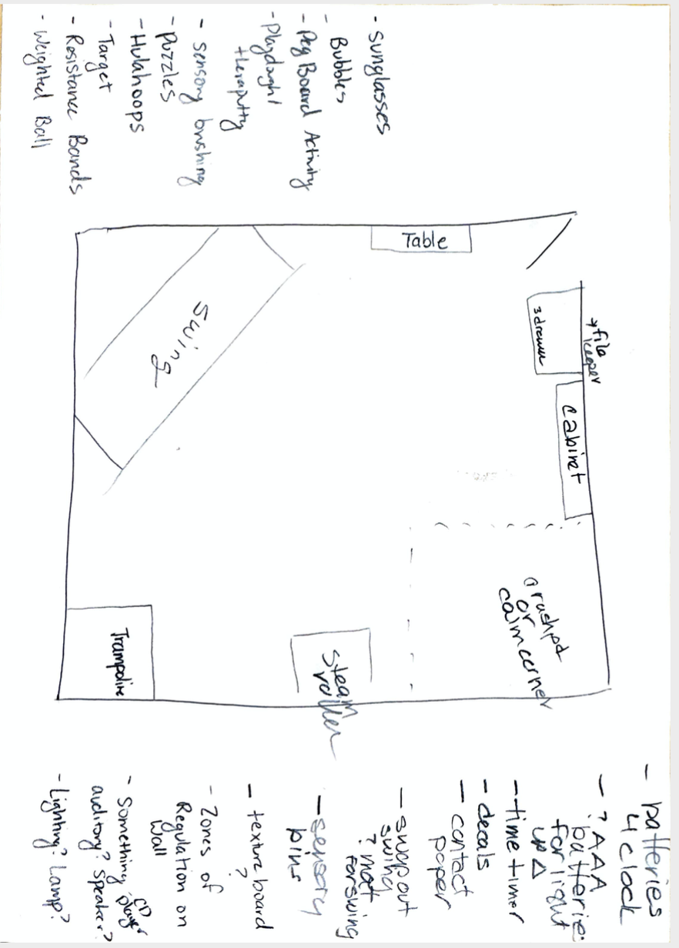
Appendix D: Prospective of Sensory Room Layout

Appendix E: Sensory Activity Examples
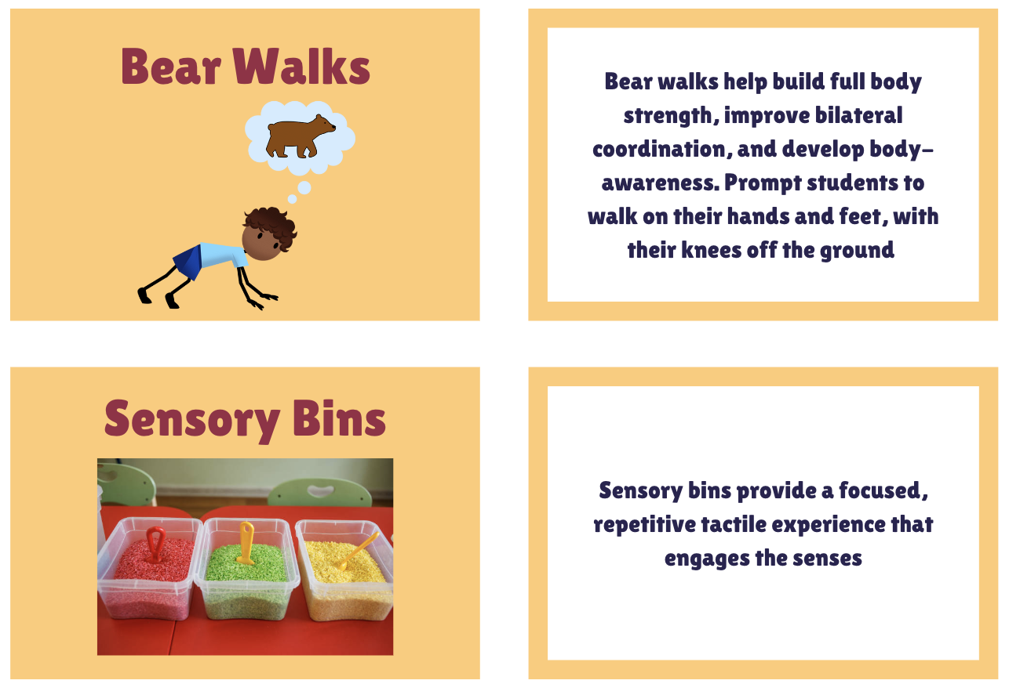
Alerting Activity Examples
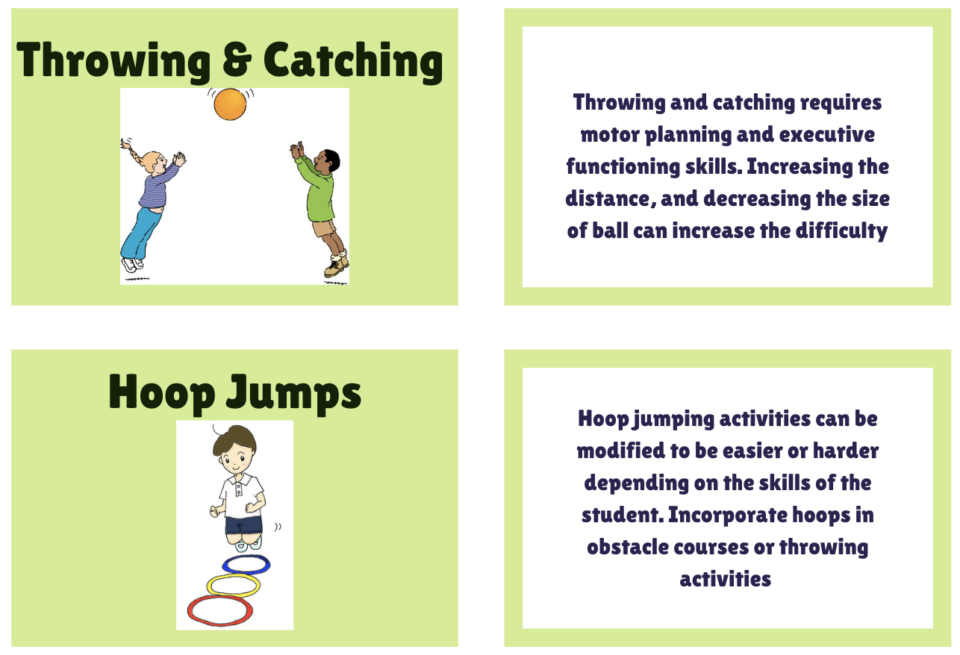
Organizing Activity Examples
Calming Activity Examples
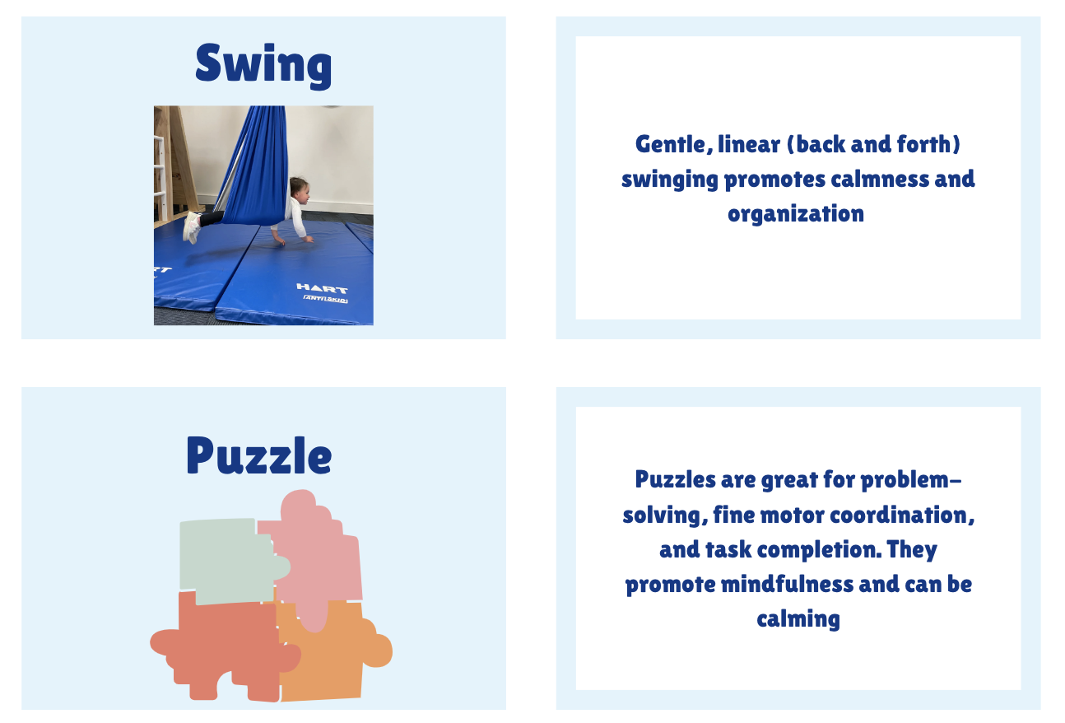

Appendix F: Sensory Activity Overview
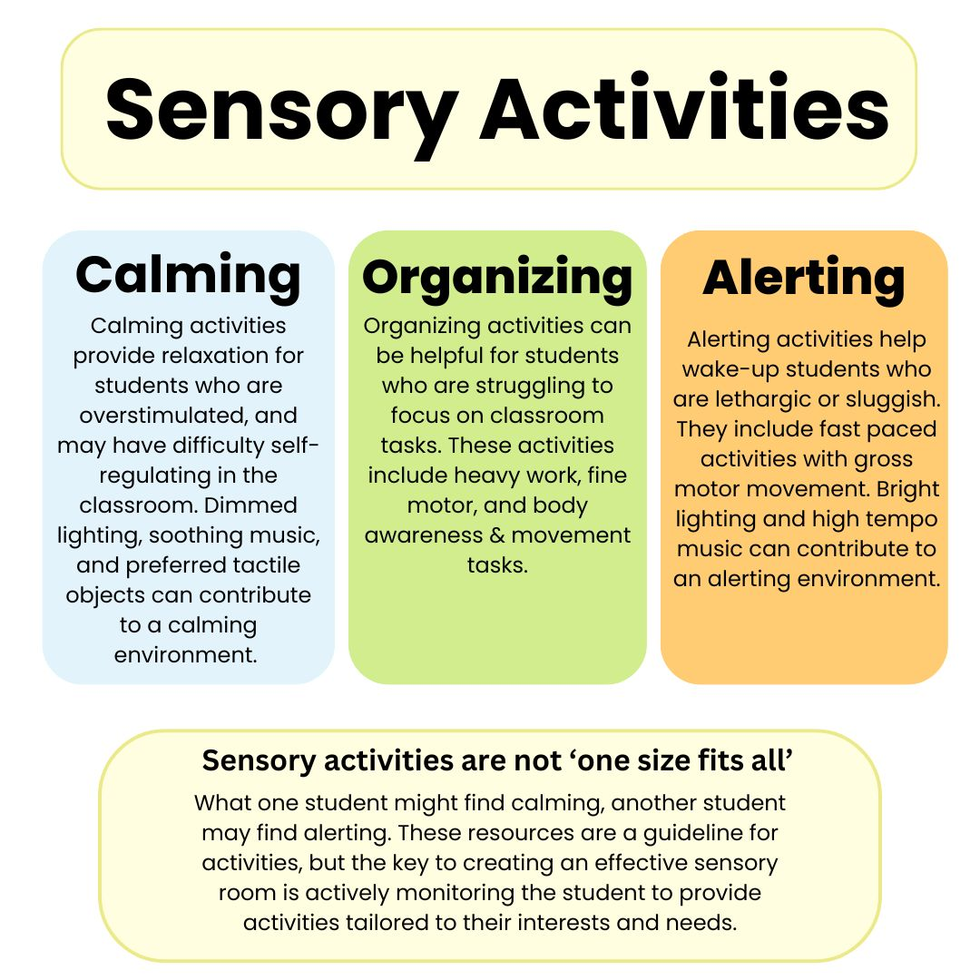

Appendix G: Sensory Circuits Overview
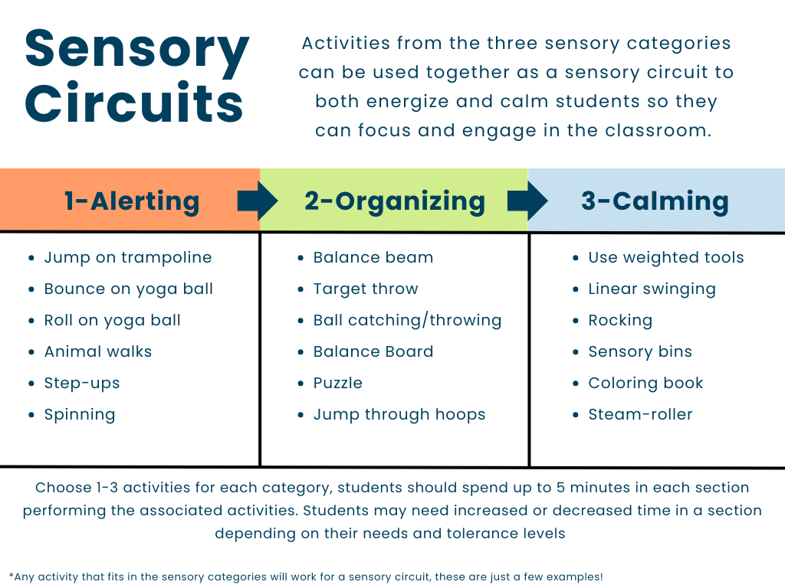

Appendix H: Educator Post-Survey and Results

Survey Question | Participant response
Was the content in the informational session relevant to your role? | Very relevant | Very relevant | Very relevant
How confident do you feel in applying the information shared in the informational session with students in the classroom and in the sensory room? | Very confident | Very confident | Confident
What specific topics from the session were most helpful for you? | The eight sensory systems, Dunn’s four quadrant model, Utilizing the sensory room | The eight sensory systems, Sensory processing difficulties, Dunn’s four quadrant model | Dunn’s four quadrant model, Utilizing the sensory room
Do you feel better equipped to support students with sensory processing challenges after attending the session? | Yes | Yes | Yes
How would you rate the new layout of the room in terms of accessibility and flow? | Excellent | Excellent | Good
Do you feel that the new layout better meets the sensory needs of students? | Yes | Yes | Yes
What changes to the sensory room layout do you think have had the most positive impact? | It is more open and less cluttered so hopefully it will stay more organized | Options for lighting and the flow of the room is more supportive to needs
How useful have the new sensory activity resources been in addressing students’ sensory needs? | Very useful | Very useful | Very useful
Which sensory activity resources do you find most beneficial? (ex. Calming, alerting, organizing) | Calming | Calming | The new swing
Overall, how effective do you believe the changes (informational session, sensory room layout, new resources) have been in supporting students’ sensory needs? | Very effective | Very effective | Very effective
What overall impact do you feel the project has had on student engagement, focus, and behavior? | Positive | Positive
On a scale of 1 to 5, how effective do you find the sensory room in helping students regulate their emotions and sensory needs? | 5. Very effective | 5. Very effective | 4. Effective

