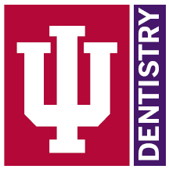 | Dental Hygiene Clinic  Faculty Training Manual  Abbey Rieck LDH, B.S., M.S.Ed.  Twyla Rader LDH, B.S., M.Ed  - Lindsey Billing LDH, B.S., M.Ed  - 2023

Purpose
The purpose of this manual is to assist new dental hygiene faculty in learning clinical procedures and provide as a resource for Axium grading. This should serve as a supplemental tool to the DH student clinic manual which faculty should also read to understand clinical procedures. Additional resources are also posted on Canvas under Faculty Calibration and Resources.
Table of Contents
Purpose 1
Before Clinic Information 2
Clinic Start Times 2
Clinic Preparation 2
Faculty and Student Huddle 3
Medical History Check 3
Guidelines for Determining Need for Premedication 7
Patient Assessment 10
Periodontal Descriptions 12
Periodontal Charting in Axium 15
Comparing Perio Charts in Axium 15
View Periodontal Chart History in Axium 19
Plaque/Bleeding Score in Axium 20
Treatment Planning and Approval 23
Creating a NEW DH Treatment Plan and How to Add Forms: 23
Informed Consent, Plaque Score, OHI, Pt Education 26
Debridement and Scale Checks 26
Polish Check 28
End of Appointment - Axium Swiping 28
Input Student Grade 35
Treatment Note 38
Entrustment Score 40
Paper Grade Sheets 41
Student Achievement Binders 50
Competencies 50
Radiology 52
Panoramic Images 54
Taking Radiographic Images 56
Approving Images 64
Viewing Images 65
Measuring Bone Levels 67

Before Clinic Information

Clinic Start Times
- AM clinic hours are 9am-12:00pm, with a goal to have patients leaving their chairs by 11:45am
- PM clinic hours are 1:30pm-4:30pm, with a goal to have patients leaving their chairs by 4:15 pm
- Students expecting to need an examination should inform DH faculty and dentist no later than 30 minutes prior to the end of that clinic session

Clinic Preparation
- Clinical faculty should arrive to clinic fifteen minutes before clinic start time
- Please take this time to find out what students you will be working with
- There is a 1:5 faculty to student ratio
- PPE can be found in our clinical supply area
- Required PPE: N95 masks, gowns, safety glasses/loupes with side shields
  - Optional PPE: face shields (required when working directly with aerosol procedures), scrub caps or hair nets, shoe covers
- Faculty should be prepared to huddle with students 10 minutes prior to clinic start time.

Faculty and Student Huddle
Clinical faculty will huddle with their assigned five students. Students will brief faculty on their patients for the clinic session. Students should include in their discussion:
- Patient demographics
- Pertinent health history information
- Need for radiographs or full periodontal charting
- Need for DH Tx Plan
- Goals for that clinic session
- Competencies
- Potential barriers

Medical History Check
The first faculty check will be after medical history. This is done on every patient, for every visit, for every student regardless of their year in the program (DH1, DH2, DH3). No student may progress to the next phase of the appointment until their supervising DH faculty has approved the Medical History. Please make sure the medical history is filled out and all prompts are answered Y or N with a reason. Clinical faculty should refer to the student clinic manual to understand the information required for medical history collection. Below are some highlights:

Medical Consult: Many medical conditions require a medical consult on file. Please refer to the Medically Compromised Patient Manual for more information on required medical consults.

All reported systemic medical conditions should be followed up with the following information:
- When was the condition diagnosed?
- How is the condition managed?

Diabetes
All patients with diabetes require a medical consult on file. Include in the medical history:
- Last blood sugar reading: 130 or less is goal for treatment, anything about 200 should be referred for medical evaluation
- A1C: <7% is considered controlled diabetes
- When and what they last ate/drank

Blood Thinner
For patients taking a blood thinner that requires regular INR checks (coumadin, warfarin) include the patient’s last INR reading. INR of 1.1 or below is considered normal. INR range of 2.0 to 3.0 is an effective therapeutic range for those on blood thinner medications.

HIV
- Require medical consult on file
- Record all medications
- Record last CD4 count and viral load

Hypertension
- Blood pressure readings exceeding 180 systolic and 120 diastolic are indication for dismissal from clinic and immediate referral to physician, and or determine need to call 911
- Consultation with patient physicians should be requested when readings above 140/90 mmHg on multiple occasions

Blood Pressure Category | Systolic |  | Diastolic
Normal | Less than 120 | And | Less than 80
Elevated | 120-129 | And | Less than 80
Hypertension Stage 1 | 130-139 | Or | 80-89
Hypertension Stage 2 | 140 or higher | Or | 90 or higher
Hypertensive crisis | Higher 180 | and/or | Higher than 120

Primary Care Physician
Students should have the patient’s PCP as well as any other prescribing physicians listed in the medical history with:
- Physician's name
- Address
- Phone number
- Date of the last visit

All prescription medications should be listed including:
- Medication name
- Dosage / How often they take the medication
- Use
- Pharmacological category
- Effects on dental treatment

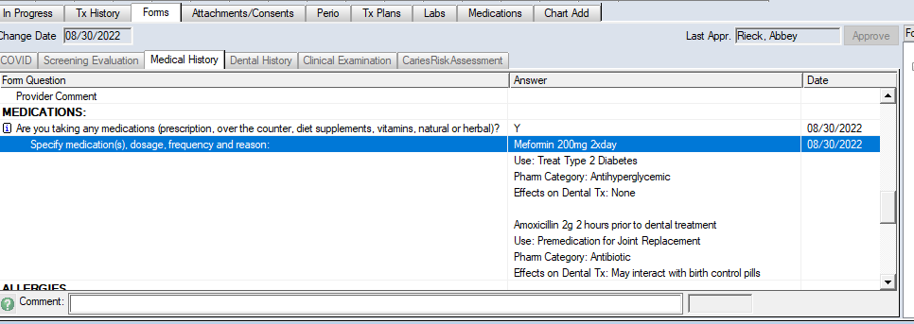

Medical Alerts: The student should list all medical alerts in the circled area below. If any are missing refer to the grade sheet for appropriate point deduction.

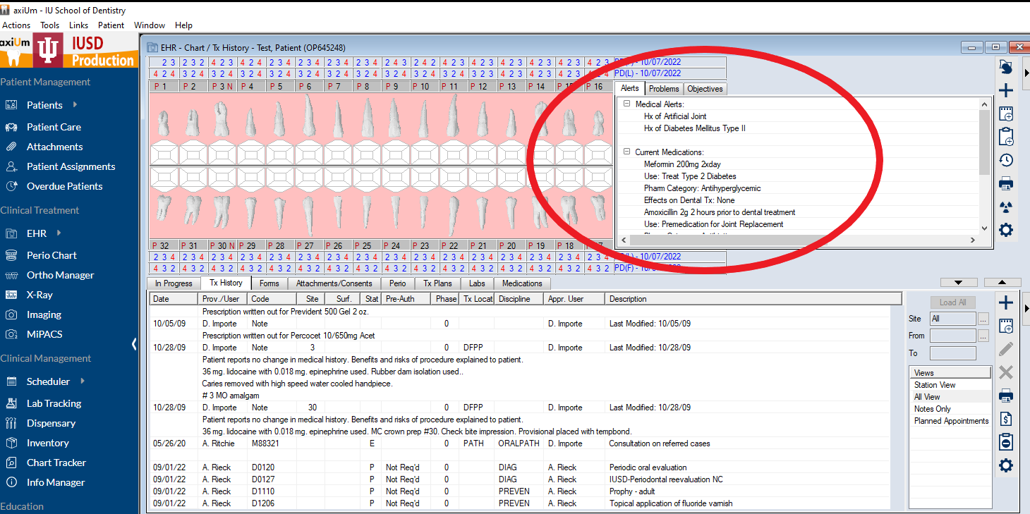
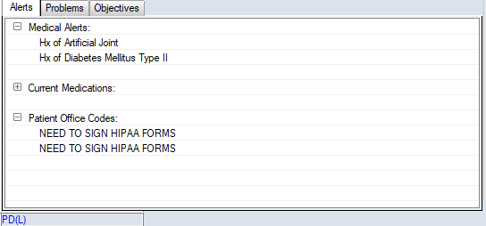
First Swipe! Once you have reviewed the medical history you are ready to swipe it complete.
Medical History Approval – with Covid questionnaire:

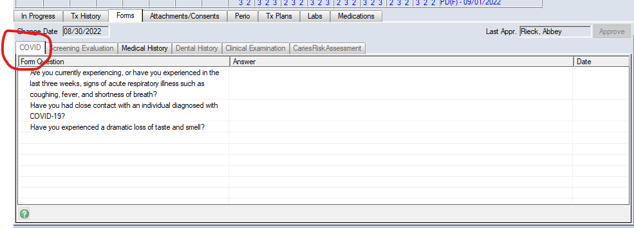
Include Dental Hx form if it is a new patient to the school. See below:
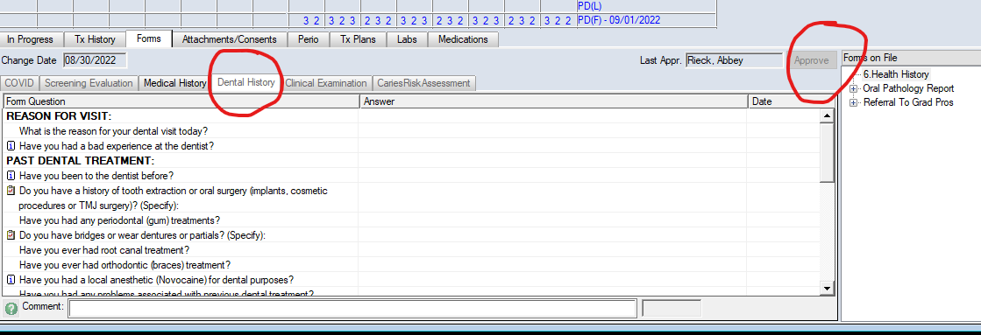
The medical history must be checked and swiped by DH faculty before the student can move on in the appointment, no exceptions, this remains the same for DH1,DH2,DH3 students.

Guidelines for Determining Need for Premedication
High Risk for Endocarditis-Antibiotic Premedication Required
- Artificial heart valve
- Previous history of endocarditis
- Severe congenital heart defects e.g. single ventricle, transposition of great vessels. Tetralogy of Fallot, cyanotic variants. The patient’s physician must always be contacted for diagnosis and appropriate recommendations.
- Surgically constructed systemic-pulmonary shunts for severe pulmonary shunts for severe congenital and other cardiovascular defects.
Moderate Risk for Endocarditis- Antibiotic Prophylaxis Generally Not Required
- Most. Less severe, unrepaired, congenital heart defects-other than those above. The patient’s physician must always be contacted for diagnosis and appropriate recommendations.
- Acquired valvular disease or conditions. E.g. rheumatic heart disease, valvular stenosis, or insufficiency
- Cardiomyopathy
- Mitral Valve prolapse with regurgitation or thickened leaflets
Negligible Risk for Endocarditis Prophylaxis Not Recommended
- Mitral valve prolapse without regurgitation
- Physiologic, functional, innocent, or non-pathologic heart murmurs
- History of rheumatic fever without the development of a murmur or valvular damage
- Kawasaki disease without the development of valvular damage
- Congenital defects such as isolated secundum atrial septal defects
- Repaired congenital defects e.g. atrial septal defects, ventricular septal defects, or patent ductus arteriosus
- Permanently impaired cardiac pacemakers and defibrillators
- Previous coronary artery bypass surgery or transluminal coronal angioplasty.
Dental Procedures that Require Prophylaxis Antibiotics
- Dental extractions
- Periodontal therapy: surgery, probing, root planing, dental prophylaxis, placement of antibiotic fibers and strips to treat periodontal disease
- Placement of dental implants
- Replantation of avulsed or extracted teeth
- Endodontics-surgery and instrumentation beyond the apex
- Initial placement of orthodontic bands
- Intraligamentary injections, e.g. local anesthetic
Antibiotic Prophylaxis Not Recommended
- Restorative dentistry not accompanied by significant bleeding due to instrumentation, gingival caries extent, or use gingival retraction cord
- Local anesthetic injections- blocks and infiltration
- Endodontics-intracanal treatments
- Use of rubber dam clamps in a non-traumatic manner
- Suture removal
- Placement of prosthodontic or orthodontic appliances
- Taking impressions
- Taking conventional dental radiographs
- Spontaneous shedding of primary teeth
- Orthodontic appliance adjustment
- Fluoride treatments
- Soft/Hard tissue examinations that do not cause bleeding
Antibiotic Premedication for Joint Replacement in IUSD Dental Hygiene Clinic:
Since there are many factors used in determining if an antibiotic is needed, it is difficult for anyone to tell you for certain if one is needed or not. It seems that the criteria for making these determinations are always in a constant state of debate. But, as a general rule, if the patient presents with no “high risk” factors, then the current information suggests that they would not likely need an antibiotic. If a joint has been placed (or replaced) within the past two years, then that is nearly always an indication for an antibiotic. If the patient is undergoing immunosuppressive therapy this is always an indication for an antibiotic.
The proper course of action whenever there is even a possibility that a patient may require antibiotic premedication, is to request a medical consult from a physician. It is imperative that we have proper documentation in our charts to back up our decisions regarding prophylaxis. It is appropriate to convey to the physician our planned course of treatment, and also remind them of the current AAOS recommendations listed above.

Patient Assessment
After the medical history has been approved, the student will need to have the supervising dentist order radiographs if necessary. After radiographs have been ordered, the student may take appropriate radiographs if a radiology chair is available or start their assessment while they wait. See the Radiology section at the end of this manual for additional information regarding the process of taking/viewing radiographs. Students can start with the patient assessment if no radiographs are needed.

If the student takes radiographs, they MUST be approved by DDS for diagnostic quality. Once the DDS has approved the images, the student may seat the patient back to their clinic chair and clean their radiology unit.

All students should be observed by DDS or clinical faculty when taking radiographs. First year students will need more assistance in taking radiographs.

Patient assessment includes the following:
- Extra-oral examination (head and neck examination)
- Intra-oral examination (soft tissues, hard tissue, occlusion)
- Radiographic Interpretation
- Dental Charting (restorations, possible decay)
- Periodontal Charting
- Periodontal Descriptions (Gingival, Periodontal and Radiographic)
- Patient Background
- Caries Risk Assessment
A detailed description of these areas and what findings that should be recorded can be found in the Clinic Manual.

Guidelines for assessment checks, clinical expectations, and grading debridement depending on DH student year:

DH1
- H219 (Spring) - First semester in clinic
- Typically have their second check (first check med hx) after the Extra and Intra oral assessment and dental charting
- The students start dental materials the same semester they start clinic (spring semester of their first year). They will be unfamiliar with dental charting and dental materials at the beginning of this semester. Dental charting is not graded, however, they are expected to attempt it. During clinic is the main time students can really learn dental charting as there is only so much you can teach from a classroom. They need real-life, hands-on experience. Try to help them during the Spring semester.
- As they progress and gain more experience in the H219 semester, you may have them progress through dental charting to periodontal charting/calc detection, and periodontal descriptions, eventually letting them complete their entire assessment
  - Always stop for assessment check before disclosing for plaque score (dyed tissues make it difficult to determine color in gingival description)
- Scaling is also not graded during this semester – use it as learning experiences
- First years can start seeing class 3 patients after they have completed 5 patients. CANNOT see class 4 patients in their first semester.
- IMPORTANT: the classification of the patient MUST be checked before the patient leaves the first appointment! At the beginning of the semester the students may not finish the full assessment in the first appointment. If this happens and the student has not completed 5 patients yet, the classification of that patient MUST be checked prior to them leaving to determine if it is a class 3-4 and will need to be transferred to the students mentor to complete treatment. This avoids the patient coming back for a second appointment just to find out they will need to be transferred to another student and rescheduled.
  - If the patient is a family member/friend and a class 3 or 4, the patient does not need to be transferred to the student's mentor and can wait to complete treatment until the student is allowed.

DH2
- H301 (Summer), H302 (Fall), H411 (Spring)
- Typically do an entire patient assessment before requiring a faculty check
- As they progress through the program, they may even begin to treat their recall patients without any check between medical history and final scale/polish check - depends on the ability of the students.
- Typically, after a D2 student has completed their Class 2 competency they are considered eligible to treat their recall patients without any faculty check (after med hx check) until the end of the appointment. However, it may be necessary for faculty to do assessment checks to manage their own time. See more on this below
- Expectations: by now all DH2 should be able to complete a medical history and perform a patient assessment with no errors. If a student misses' important information on the patient’s medical history and/or the patient assessment, points should be deducted accordingly.

DH3
- H420 (Fall)
- Should have as limited faculty intervention as possible
- They should be working on their time management and able to treat their patients to completion after the medical history has been checked
- Please challenge the students on their time management this semester
- Students at this stage in their education should not be missing medical history information or making assessment errors; points should be deducted accordingly.

Notes about checks: Clinical faculty must manage their time. It may be necessary to interrupt a student and check their assessment in order for faculty to manage their time. Faculty will run out of time to do 5 (students) full assessment and scale checks at the very end of a clinic session. Therefore, there may be cases where faculty will ask to do an assessment check on DH2, or DH3 student in order to manage their time. Communication between instructor and student is key.

IMPORTANT: Any time a patient requires a new DH treatment plan the student MUST stop and get the assessment and treatment plan checked by their instructor. This must be done BEFORE the treatment plan is approved by the DDS (see Treatment Planning and Approval)

Periodontal Descriptions
Below is a chart to assist you in clinic. You must review chapters 6-7 from the periodontics textbook. PowerPoints over the chapters can be found on canvas under modules in the Faculty Calibration and Resources page. You will need a gingival description and a periodontal description. The radiographic description of bone levels is included as part of the periodontal description.

Below are some general guidelines for gingival descriptions:
- Describe as color, contour, consistency
- Example description for healthy gingiva:
  - Patient presents with generalized healthy gingiva as evidenced by light pink, stippled, knife-edge tissue and 5% BOP.
- Gingivitis
  - INCLUDE ALL OF THE FOLLOWING
    - Extent (localized or generalized)
    - Distribution (papillary, marginal or diffuse)
    - Cause (plaque/nonplaque induced)
    - Descriptors (color, contour, consistency)
    - BOP score
  - Example description for gingivitis:
    - Patient presents with generalized marginal plaque-induced gingivitis as evidenced by red, bulbous, shiny gingiva with 35% BOP.

Below are some general guidelines for completing your periodontal descriptions (keep in mind, your periodontal descriptions are separate from your gingival descriptions):

Intact Periodontium
- There is NO radiographic bone loss
- Healthy bone levels are measured as 1-2mm from CEJ to crest of bone
- A patient can be classified as health or gingivitis on an intact periodontium
- Example description of a patient with health on an intact periodontium:
  - Patient presents with a healthy periodontium as evidenced by 1-3mm CAL (level) and healthy radiographic bone levels as evidenced by 1-2mm from CEJ to crest of bone.
- Example description of a patient with gingivitis on an intact periodontium:
  - Patient presents with gingivitis on an intact periodontium as evidenced by 1-3mm CAL (levels) with 4mm probing depths due to inflammation and healthy radiographic bone levels as evidenced by 1-2mm from CEJ to crest of bone.

Reduced Periodontium
- A patient falls under the reduced periodontium classification if they have radiographic bone loss but do not have active signs of periodontitis
- Can be non-periodontitis patients or successfully treated stable periodontitis patients
- Can have health or gingivitis on a reduced periodontium
- Radiographic bone loss is described as % of bone loss in relationship to the length of the tooth root. (NO LONGER described in mm!)
- Example description of a patient with health on a reduced periodontium:
  - Patient presents with health on a reduced periodontium in a non-periodontitis patient as evidenced by 1-3mm CAL (level) with 4mm CAL (level) due to recession and horizontal radiographic bone loss extending to the coronal third of root. (Reminder, the healthy gingival description is separate)
- Example description of a patient with gingivitis on a reduced periodontium:
  - Patient presents with gingivitis on a reduced periodontium in a successfully treated stable periodontitis patient as evidenced by 1-3mm CAL (level) with 4mm probing depths due to inflammation and horizontal radiographic bone loss extending to the coronal third of root. (Reminder, the gingivitis gingival description is separate)

Periodontitis – Staging and Grading
- If the patient has active periodontitis – you must stage and grade the patient (REVIEW perio chapters!!!)
- Stage is defined by the disease severity and the complexity of management
  - Described by interdental loss, radiographic loss in %, tooth loss due to periodontitis and complexity factors (include ALL of these in your description – see chart)
- Grade is the indicator of rate of progression
  - Described by direct OR indirect evidence (see chart) and modifiers (diabetes/smoking)
- Example: Patient presents with generalized Stage 2 Grade B periodontitis as evidenced by 1-2mm interdental loss, horizontal radiographic bone loss extending to the coronal third of root, no tooth loss due to periodontitis, up to 5mm probing depths, non smoker/diabetic with an indirect evidenced score of .5.
Health/Gingival Diseases & Cond. on Intact Periodontium |  |  | Periodontitis |  |  |  |  | Other Conditions |  | Peri-implant diseases and Cond.
-Periodontal & Gingival Health |  |  | -Periodontitis |  |  |  |  | -Systemic Diseases |  | -Peri-implant Health
-Gingivitis: Biofilm Induced |  |  | -Necrotizing Periodontal Diseases |  |  |  |  | -Periodontal/Endo Lesions |  | -Peri-implant Mucositis
-Gingival Disease: Non-Biofilm (Indicate cause) |  |  | -Manifestation of Systemic Disease |  |  |  |  | -Mucogingival Deformities |  | -Peri-implantitis
 |  |  |  |  |  |  |  | -Traumatic Occlusal Forces |  | -Peri-implant deficiencies
Gingival Health |  |  |  | Localized Gingivitis |  |  |  |  | Generalized Gingivitis
BOP < 10% |  |  |  | BOP 10% to 30% |  |  |  |  | BOP >30%
Intact Periodontium: No bone loss = 1-2mm from CEJ to crest of bone
Health (gingival health on an intact periodontium) |  |  |  |  |  |  | Gingivitis on an intact periodontium
Health on Reduced Periodontium
Periodontal health on a reduced periodontium in a non-periodontitis patient |  |  |  |  |  | Periodontal health on a reduced periodontium in a successfully treated stable periodontitis patient
Gingivitis on Reduced Periodontium
Gingivitis on a reduced periodontium in a non-periodontitis patient |  |  |  |  |  | Gingivitis on a reduced periodontium in a successfully treated stable periodontitis patient
If there is ACTIVE periodontitis infection – Stage and Grade
Radiographic Assessment/Periodontal Charting
Stage | Stage 1 Initial Attachment Loss | Stage 2 Established Periodontitis |  |  | Stage 3 Severe Destruction |  |  |  |  | Stage 4 Advanced
Interdental Loss | 1-2mm | 3-4mm |  |  | >5mm |  |  |  |  | > 5mm
Radiographic Bone loss | Coronal Third < 15% | Coronal Third |  |  | Mid-third of root and beyond |  |  |  |  | Mid- third of root and beyond
Tooth loss due to Perio | No Tooth Loss | No Tooth Loss |  |  | <4 teeth |  |  |  |  | > 5 teeth
Complexity Factors | - Maximum probing depth 4mm  - Mostly Horizontal Bone Loss | - Maximum Probing Depth 5mm  - Mostly Horizontal Bone Loss |  |  | - Probing Depth > 6mm  - Vertical loss > 3mm  - Furcation Class 2 or 3  - Moderate Ridge Defect (that would complicate implant placement) |  |  |  |  | Stage 3 complexity PLUS one or more of the following:  - Mobility > 2 mm  - 10 pairs of opposing teeth  - Less than 20 remaining teeth

Grade = Estimate of Future Rate of Progression of Periodontitis Based on Direct or Indirect Evidence of Disease Progression
Direct = Longitudinal Observation through older radiographs/perio charts Indirect = Assessment of bone loss relevant to age

Periodontitis Grade | Grade A Slow | Grade B Moderate | Grade C Rapid
Direct Evidence  (CAL(loss)/Radiographic Bone Loss) | Evidence of No CAL/Radiographic Bone Loss Over 5 Years | Evidence of < 2mm CAL/Radiographic Bone Loss Over 5 Years | Evidence of > 2mm CAL/Radiographic Bone Loss Over 5 Years
Indirect Evidence  - % Bone Loss/Age  - Case Phenotype | - < .25  - Heavy Biofilm with Low Level Destruction | .25 to 1.0  Destruction In-line with Biofilm | > 1  Destruction Exceeds Expectations based on Biofilm
Modifiers  - Smoking  - Diabetes | - Non-smoker  - Non- Diabetic | - Smoke < 10 Cigarettes/day  - HbA1c < 7 | - Smoke > 10 Cigarettes/day  - HbA1c > 7

Periodontal Charting in Axium

Comparing Perio Charts in Axium
To easily compare a periodontal charting from one date to another, go to the patients Perio Chart and click on the icon at the top that has two arrows pointing towards each other “Compare Form”
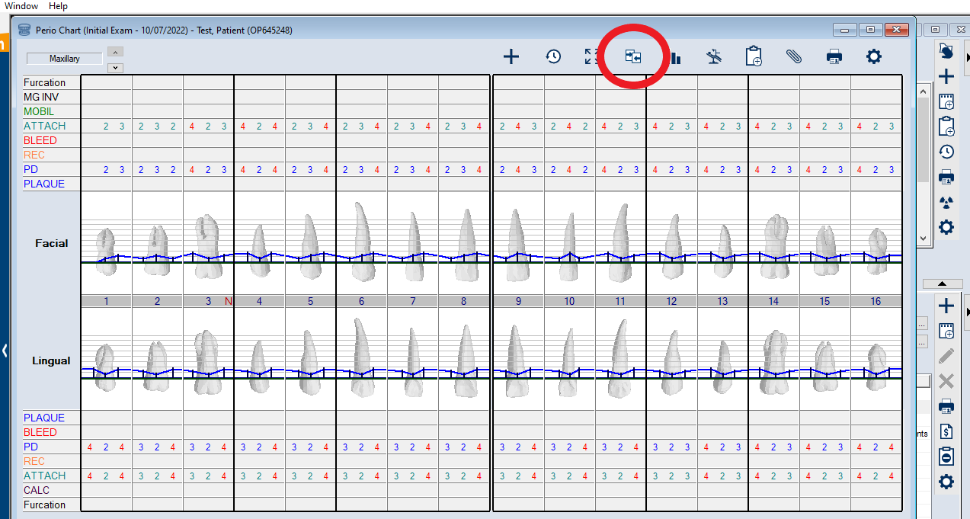
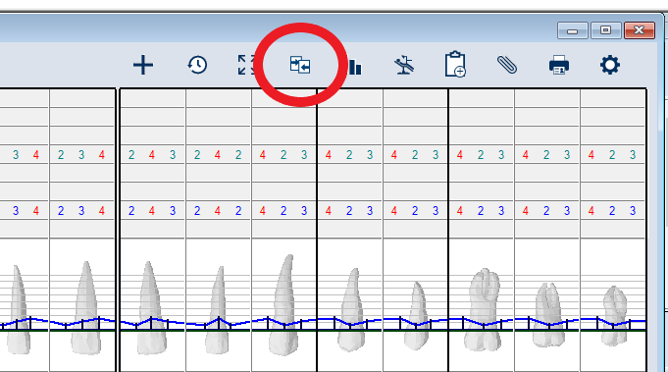
The following box will pop up, and you can select from the drop-down menu what condition you would like to compare:
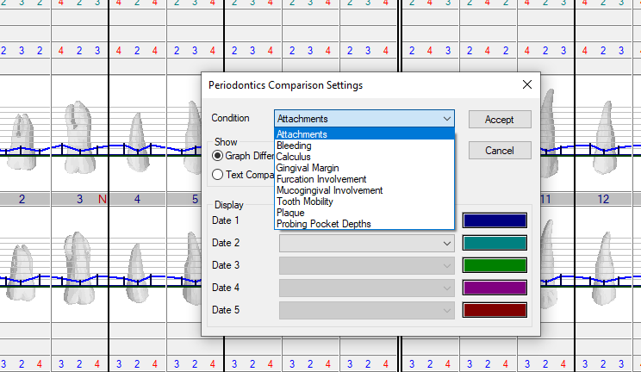

Then you will select the charting from the two (or more) dates that you wish to compare:
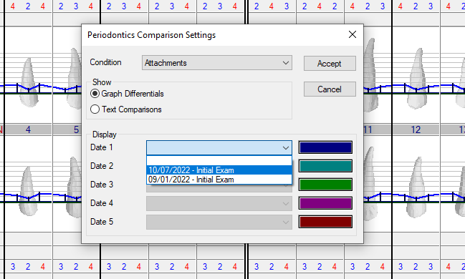
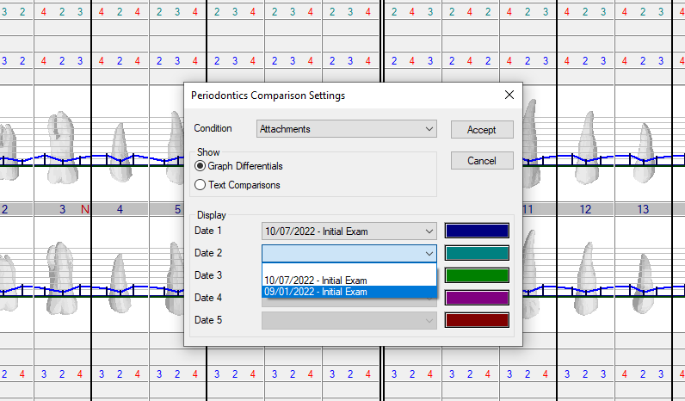
Click Accept, the following comparison of dates selected will appear:
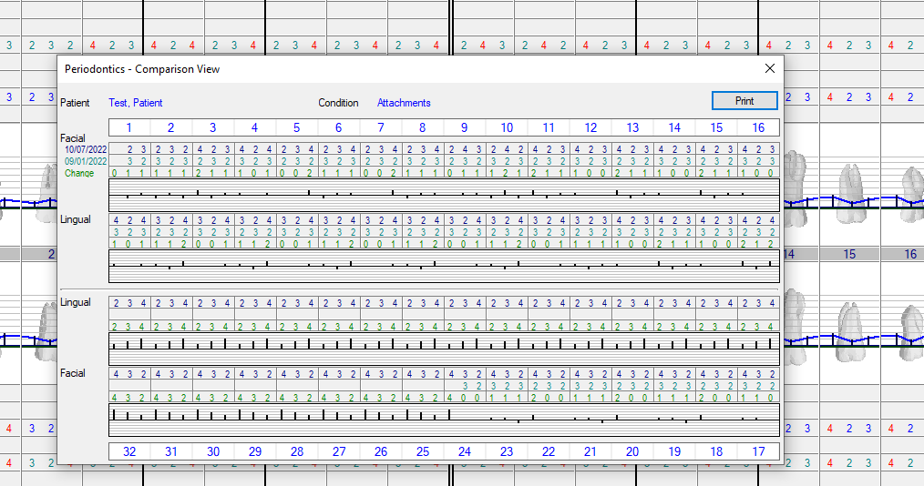

View Periodontal Chart History in Axium
To review all periodontal charts recorded for that patient, click on Perio Chart, then click on the icon that looks like a clock “View Form History” at the top:
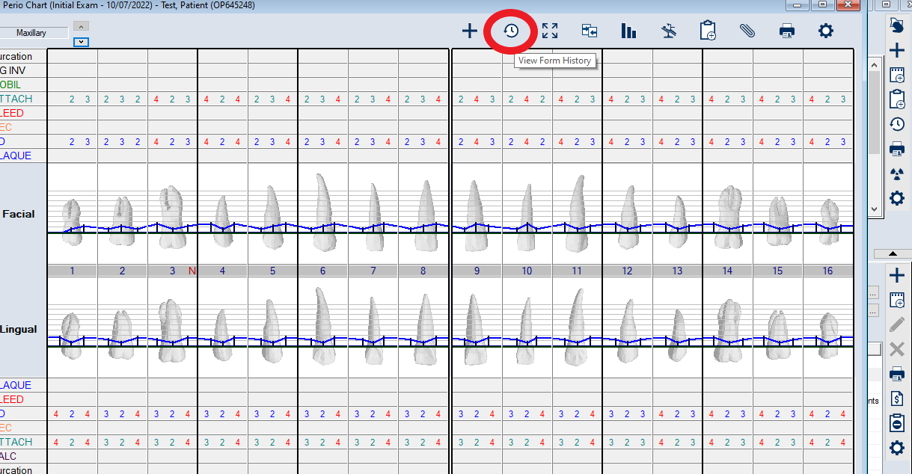
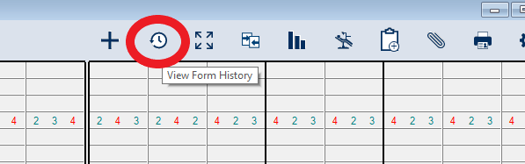
The following will appear, and you can select which date you would like to view:
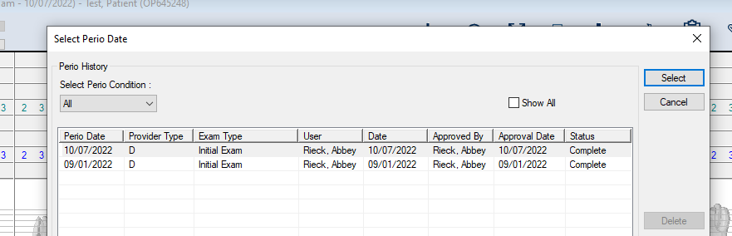

Plaque/Bleeding Score in Axium
To view the plaque and bleeding scores, click on the icon at the top that looks like a clip board “EPR Forms”:
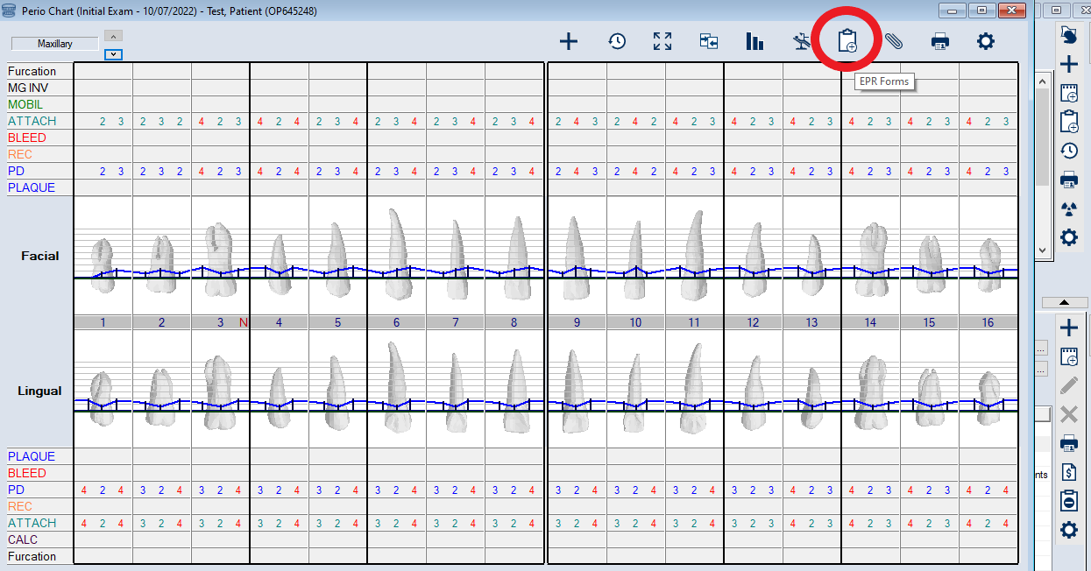
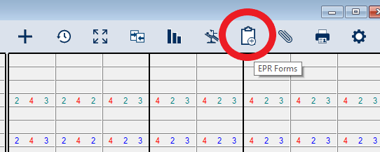The following will appear:
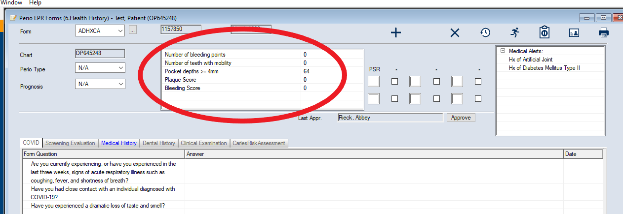

Treatment Planning and Approval
After the assessment has been checked, student and faculty must compare assessment findings with current DH Tx Plan. ALL patients MUST have a DH Dentist Screen & Tx Plan form in axium. This is found under forms. If findings are consistent with existing treatment plan then the student can move onto informed consent, plaque score, OHI, patient education. If the patient is new to the school or the hygiene clinic then a DH Tx plan must be created. Students must have their DH faculty approve the new DH Tx plan BEFORE DSS swipes it complete.

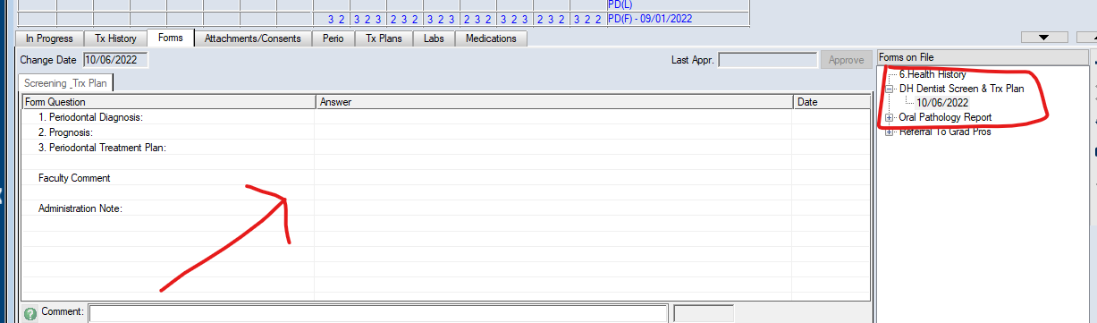Dental Hygiene Codes are the following:
Adult Prophy | 1110
Scaling and Root Planning 1-3 teeth | 4342
Scaling and Root Planning 4 or more teeth | 4341
Perio Maintenance | 4910
Scaling in the presence of gingivitis | 4346
Tissue Re-evaluation | 0127

Creating a NEW DH Treatment Plan and How to Add Forms:
Add a new “DH Dentist Screen & Tx Plan” form by clicking on the + under the “Forms” tab.
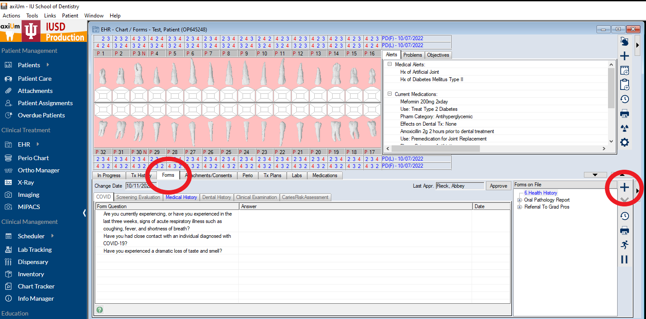
A box will appear with a drop-down menu under “Forms”. This is how you add any form you may need (DH Tx plan, Caries Risk/Management, Referrals, Med consults, etc.)
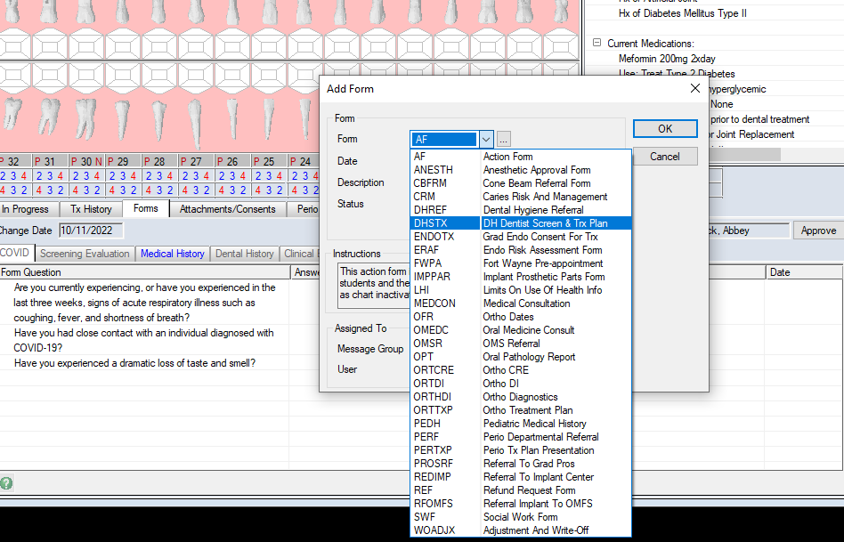
The patients gingival and periodontal descriptions will be entered under “Periodontal Diagnosis.” The treatment code/codes will be entered under “Periodontal Treatment Plan.”
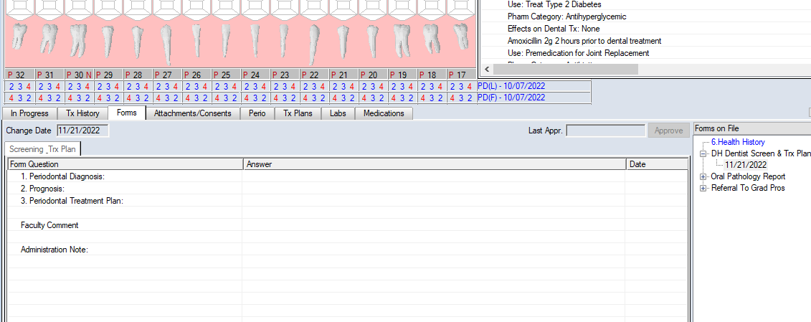
SRP Example:
4341 Scaling and Root Planning 4 or more teeth UR - #2-8
4341 Scaling and Root Planning 4 or more teeth UL - #9-15
4341 Scaling and Root Planning 4 or more teeth LL - #18-24
4341 Scaling and Root Planning 4 or more teeth LL - #25-31
0127 - Tissue Re-eval
Note: all teeth being treated, the quadrant and the code must be listed.

Adult Prophy Example:
Adult Prophy - 1110
If a tissue re-eval is indicated, that code must be listed as well. The dental faculty must swipe the treatment plan and the DH Tx code complete before moving on

Informed Consent, Plaque Score, OHI, Pt Education
After the assessment has been completed and tx plan approved by DH faculty and DDS faculty (if applicable) then the student will move on to informed consent, plaque score, oral hygiene instruction and patient education.
DH1- Student should inform the faculty of the plaque score and review with the faculty the oral hygiene instructions they plan to review with the patient. The student should include what products they would like to recommend to the patient, what type of toothbrush and paste, and floss they are selecting and why.
DH2, and DH3- the above information should still be reviewed with these students but may happen during the final scale and polish check.

Debridement and Scale Checks
Now it is time for the student to begin debridement. Depending on the year of the student and the difficulty of the patient “scale checks” by instructors will vary.
The following are guidelines by class….
DH1- H219 and H221
- At the beginning of H219, students should only work on a sextant at a time.
- As they progress through the semester they may start working by quadrants, and possibly by an arch at a time if it’s a class 1 patient.
- Calculus removal is not graded in H219, at this time it is a teaching opportunity between instructor and student
- In H221 (summer) – students will begin to be graded on calculus removal on Class 1 and Class 2 patients
- H221- Class 3, 4 will likely have limited calculus deductions as these students are just beginning to see these difficult cases, if a student has been given many opportunities to remove a piece of calculus and has had help from instructor but still unable to remove the calculus an instructor may decide to deduct points.
DH2- H301, H302 and H411 –
- H301 Class 1 and Class 2: scale an arch. By H302/H411 may scale entire dentition
- Class 2 competency (due in H301): if a student has completed their class 2 competency, they can scale entire mouth before having a scale check
- Class 3 and 4 patients: students should be debriding by sextants and or quadrants. As the student becomes more proficient the instructor may entrust the student to debride an arch at a time.
- Debridement- the second year is the “meat and potatoes” of the program, these students are finally making connections from everything they have learned in their text and beginning to feel more comfortable in clinic and starting to demonstrate some independence. Students should be debriding class 1, and class 2 patients without much difficulty. If a student misses several areas of calculus on these patients, points should be deducted.

DH3 - H420
- Class 1 and 2: students may scale the entire mouth
- Class 3: Student may work on a quadrant at a time, or an entire arch if they feel competent enough
- Class 4: Student should work by quadrant.
- Please keep in mind this is the students LAST SEMESTER. We need their clinic grades to be reflective of the work they are doing.
- If they are leaving supra calculus on class 1 and 2 patients – this should be an automatic scale deduction
- You can allow progress checks for class 3 and 4 patients, however, if there are areas they have not been able to get after a scale check, especially if they were not able to tell you that calculus was still there, points should be deducted
- If you have to remove any piece of calculus for the student – points should be deducted
- We do not want to get to the end of this semester and the student is still unable to scale without numerous scale checks/help from faculty – yet they have close to 100% in clinic.
- Remember, their grade gets entered into axium out of 40 but this is still out of 100%! So, even if you take 10 total points off, the student gets a 30 in axium – this is still a 90%! We need to have a record of students who are struggling! We can’t intervene if their clinic grade tells us they are excelling.

“Progress check”- At any time a student can ask for a “progress check”. This is an opportunity for students to have faculty check their progress when the student is not confident that they have removed all the calculus deposits. Students should tell their instructor what specific areas they are concerned with or have questions about. For example, do not progress check the entire mouth. Calculus removal is not graded in H219, at this time it is a teaching opportunity between instructor and student. It is at the discretion of the instructor how many progress checks will be allowed and when they will take off points for missed calculus.
The above are merely guidelines, some students may need more checks than others, and it is okay to have a student who is struggling with debridement to work in smaller increments of the mouth at a time until the instructor feels the student can work on more teeth at a time.

Polish Check
After the student completes debridement, they continue with polishing. If it is a DH2, or DH3 student this may be already completed with their scaling but a DH1 student will typically have a separate polish check. DH1 students must redisclose their patients after polishing to check their work. All plaque and stain should be removed by the end of polishing
DH 1 – H219 – if they are expecting to complete their patient in that clinic session, they must start polishing no later than 11:15am and 3:45pm.
REMINDER: It is the student's responsibility for managing their time appropriately. If they require an examination, they MUST let the DSS know no less than 30 minutes prior to the end of that clinic session. Deductions for time management can be taken for students failing to request a dental exam in time, going over clinic time, not having clinic notes entered in a timely manner, etc.

End of Appointment - Axium Swiping
Horary! The student has completed the patient now all you need to do is properly “swipe” the patient out. This can be done a few different ways. You can swipe your ID card and unapproved treatment may pop up. If this does not happen you will need to click on the bottom of the chart on the chart number (double click, typically this will show up blue).
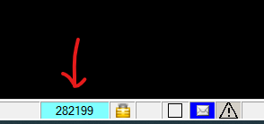

When you double click the chart number a screen of unevaluated treatment will come up, you can click what you want to approve, note that not all unevaluated treatment may be from the current dates, only approve current date and entries related to hygiene, as you can see below the caries risk and management and the initial exam (perio chart) still need to be approved.
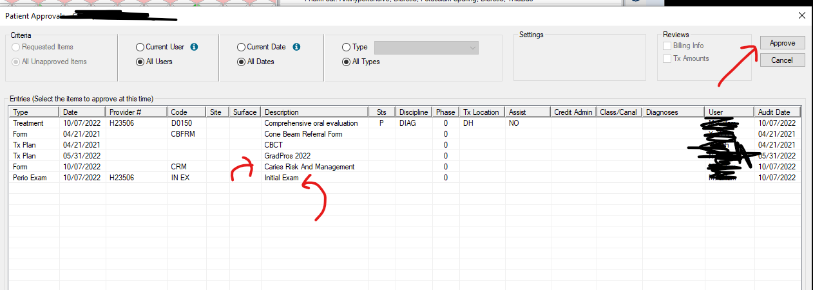
Initial Exam is the periodontal chart - click to approve:
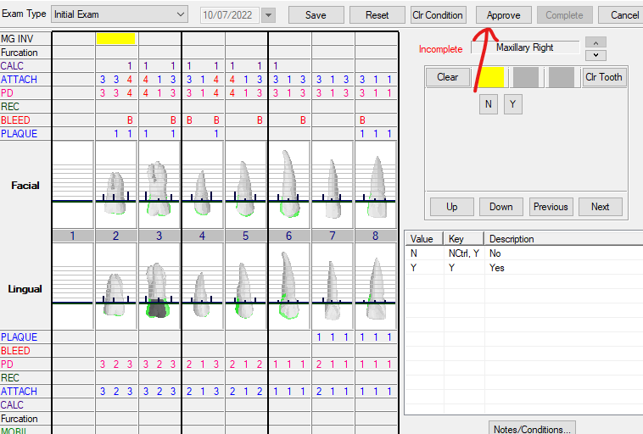
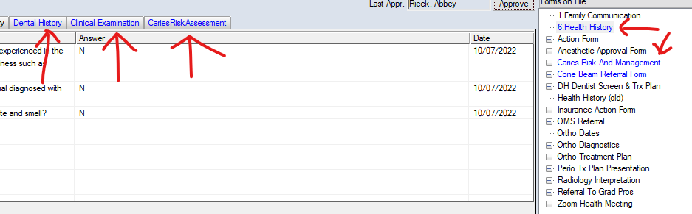
As you can see here all the blue tabs are forms that need to be swipe approved by faculty. On the right-hand side click health history and there are 6 tabs under this form. They are the following COVID, Screening Evaluation, Medical History, Dental History, Clinical Examination, and Caries Risk Assessment. You will click on each tab, review the information then hit approve.
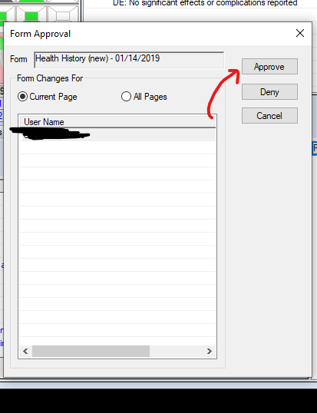

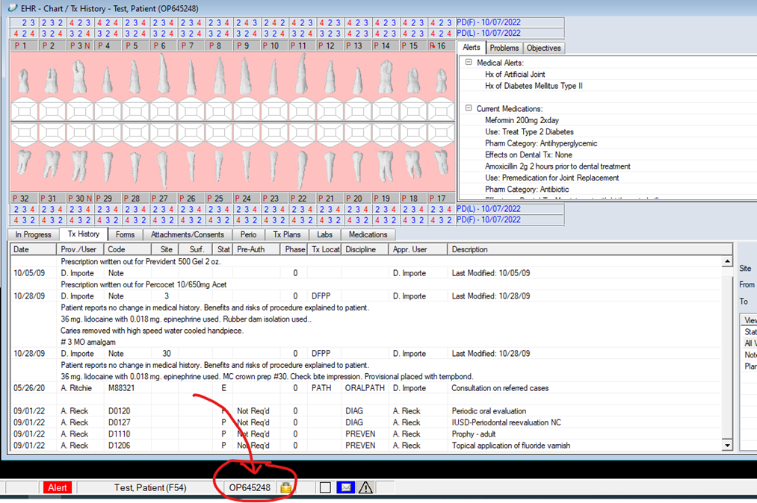
When codes, and notes are added into Axium they show up as blue, this allows them to be edited. Faculty will be checking everything that goes into Axium, once it has been checked and verified that what is written in the chart by the student is correct, faculty will be swiping to change blue codes and notes to black.
Goal for end of the appointment- all codes should be completed from a “P” planned treatment to a “C” completed treatment. As faculty/students you can change these however ONLY DENTAL faculty can swipe these codes completed as they are billable codes. Again, only a dentist should be swiping these codes completely completed. That means approving them from a blue “C” to a black “C”.
See below image you can see that all these codes have been planned and have a black P
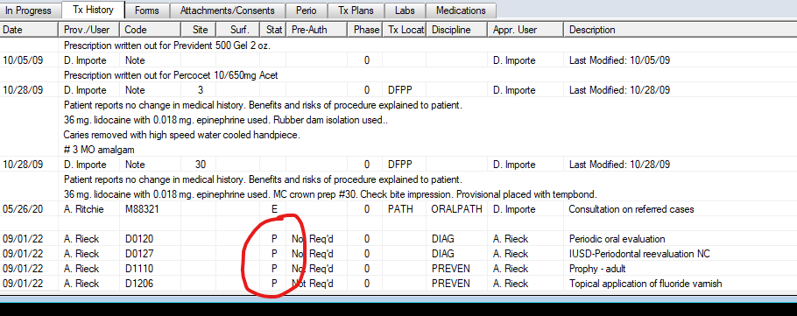
Double click the code and a box will pop up that will allow you to change these codes from planned to complete. See image below
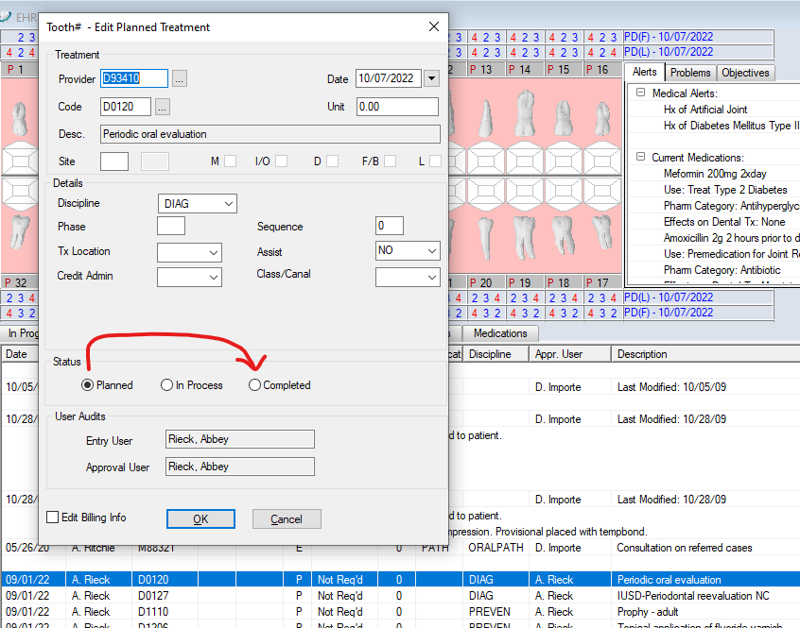
Furthermore, you will need to make sure the Class and Tx location are in under the students prophy/perio maint/SRP code. You can pull up this box by double clicking on the code. Failing to add the classification will mess up the students achievement report and the patient will not count in Axium
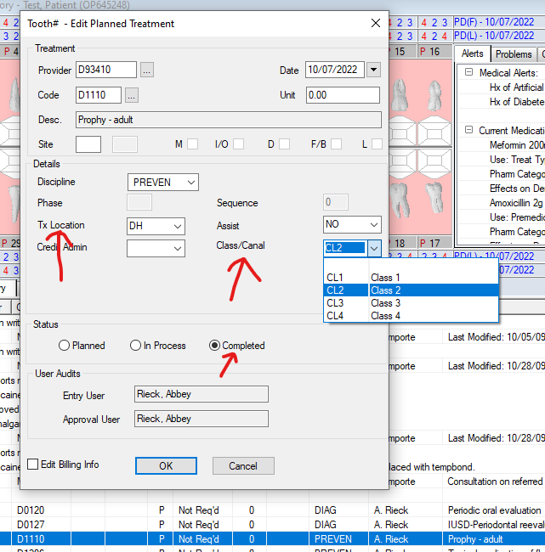
Initially when you change to complete the code is going to again show up as blue in Axium, once it is swiped completed by DDS faculty it will be a black “C” like below
Caries Risk assess + documentation codes
These can and should be swiped complete by hygiene faculty, it is not a billable code so this is the only code that can be swiped to a black “C” by hygiene faculty

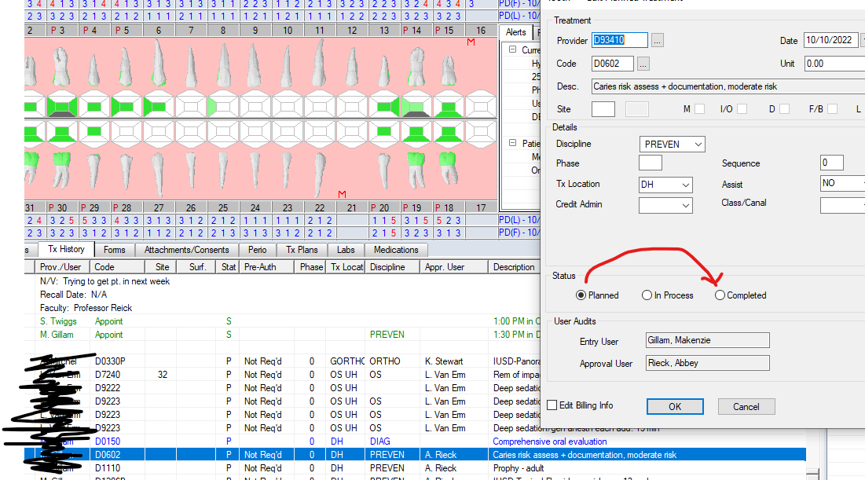
Note: If the student does NOT finish the planned treatment during that clinic session and the patient is to return for another appointment, DO NOT swipe treatment codes complete or input grade. The only things you will swipe complete are the things you finished in that clinic session - periodontal charting, forms (dental history, clinical assessment, caries risk and management) caries risk assessment code and the treatment note. Or essentially only approve those items that were checked by faculty.

To review: If a student has completed the patient treatment that day: faculty need to approve all caries risk and management forms, clinical assessment form, periodontal charting, and treatment notes. The only code a faculty can swipe complete is the CR assessment and documentation code, the other codes must be swiped complete by DDS. The grade for student goes under the treatment code.

Input Student Grade
To input a student's clinic grade - right click on their treatment code, the grade goes with one of the following (prophy, periodontal maintenance, or SRP codes). It does not go on the exam code or radiographs (if there are multiple SRP codes – input grade for only one of them, does not matter which). When you right click a box with pop up, click “Add Student Eval”
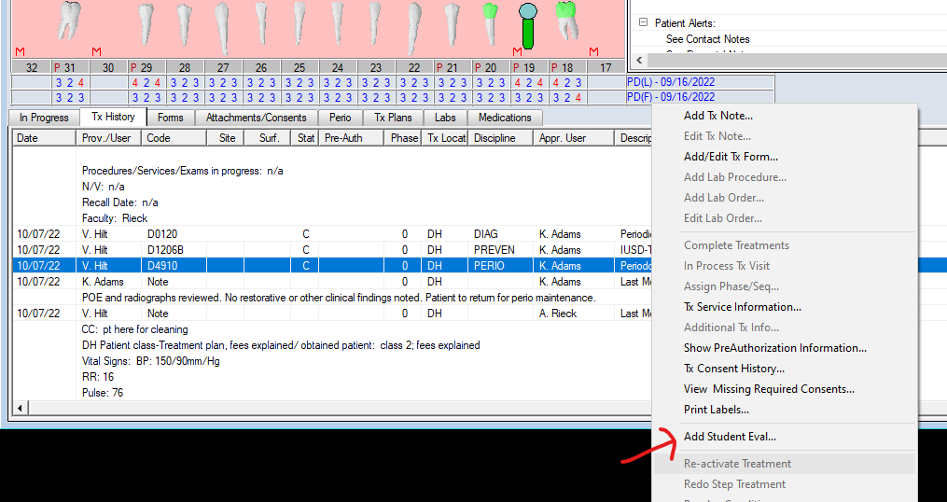
Then a box will come up in which you will be filling out the “provider” (student) eval. You need to answer Y or N for infection control expectations met, professionalism expectations met, procedure independence which is the students entrustment score (the entrustment score the student gives themselves) and appropriate progress note template use Y or N. Typically these should all be “Y”. Do not put a grade in yet…..after you have filled this out hit “Ok” and swipe…the same box will appear but now you will see the “Instructor” indicated. See image below
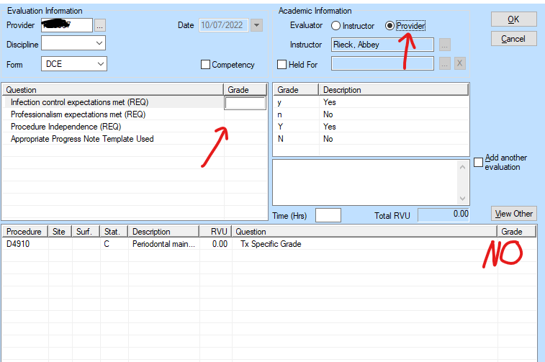

Now you will need to do the same thing again but now will be under evaluator as the instructor. You need to answer Y or N for infection control expectations met, professionalism expectations met, procedure independence which is the student's entrustment score (the entrustment score that you as an instructor give the student, see more under Entrustment Score), and appropriate progress note template use Y or N. Typically these should all be “Y”. You will also put in the students grade out of 40. 100% is 40 in Axium. See image below
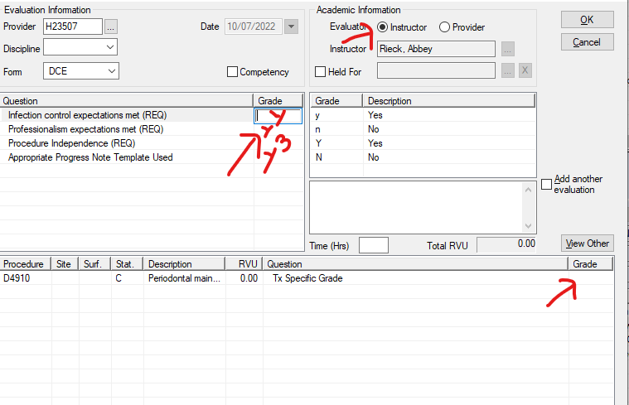

Treatment Note
The student is to complete the treatment note after each clinic session. The note is to be checked and swiped by their faculty. Below is the template that is used with a description of what is to be included in each area (bold is the template, italic is what should be included for each section):

CC: Patient’s chief complaint
DH Patient class-Treatment plan, fees explained/obtained patient consent: Include DH class (1,2,3,4) and confirm that fees were explained, and consent obtained
Vitals: Include BP, Pulse, RR and Temp
PMH reviewed: Yes/No
PMH Form Updated: Yes/No
Allergies Reviewed: Yes/No
Allergies on form updated: Yes/No - only say yes if allergies were changed
Medications reviewed: Yes/No
Medications on form updated: Yes/No - only say yes if medications were changed/altered
Dental HX reviewed: Yes/No
Dental HX on form updated: Yes/No - only say yes if changes were made
Dental Exam performed by: Enter the DDS name who performed exam
Gingival Description: Enter gingival description from assessment. If the student has not had assessment/descriptions checked, put NV.
Periodontal Description: Enter periodontal description from assessment. If the student has not had assessment/descriptions checked, put NV.
Other significant Findings: Include any findings – restorative needs, intra/extra oral findings, abnormalities, etc.
DH Care Plan: Indicate # of appointments and what all is anticipated to be done for each appointment (OHI, smoking cessation, fluoride needs, LA needs, use of hand scalers/USS, polishing agent/air polishing, need for dental exam, etc.)
Radiographs: List the date of the radiographs reviewed and what type. Example: BWX-4 from 8/8/2022 and FMX from 6/3/2020.
Radiograph Findings: include any radiographic findings
Radiographs interpreted/reviewed by: List name of DDS radiographs were reviewed by
Plaque score: enter P.S.
Caries risk Assessment: enter patient’s caries risk
CRA From Completed or In Progress: indicate if forms were completed or in progress
Detailed Treatment Provided/Task Accomplished: Include all treatment/tasks provided THAT day. Med hx, radiographs, assessment, PS, OHI, indicate what areas were scaled and what type of instrumentation (hand scalers/USS), polished (indicate grit, what type of paste and flavor), floss, exam, fluoride (what type), anesthetic, etc.
Patient Educations: What was included in OHI, smoking cessation, dietary recommendations, fl recommendations, re-care recommendations, etc.
Patient goals: what goals were set for the patient prior to next appointment/recall. Example: will brush 2xday, will decrease snacking to 1 time a day between meals, will floss 2xweek
PT involvement/questions/disposition: Include how involved/receptive the patient was throughout the appointment
Procedures/Services/Exams in progress: List any treatment that is still in progress, or n/a if all treatment has been completed
N/V: list what the next visit should be
Recall Date: list the patients recall date if the patient’s treatment was completed
Faculty: the faculty name

Entrustment Score
At the end of each clinic session, the student will give you an entrustment score of how independent they felt they were that clinic session. You will also give the student an entrustment score based on how independent you felt they were that session. This is a score of 1-5 and below is the rubric you should be following when determining entrustment. See “Input Grade” for how to enter these scores into Axium.
Scale |  | Student
5 | Independent Practitioner (Mastery) | No guidance “I was there just in case”  Demonstrated virtually complete independence, Performed in a safe manner without instructor assistance
4 | Early Practitioner (Emerging Mastery) | Minimal of infrequent guidance “I directed from time to time” Demonstrated modest independence, required occasional prompting, assistance, or supervisions for safe practice
3 | Advanced Learner (Progressing) | Modest or frequent guidance “I talked them through it”  Demonstrated minimal independence, Able to perform some tasks but required intermittent direction/help (faculty did less than half of it for them)
2 | Beginning Learner (Emerging) | Complete or extensive guidance “I did more than half for the student” Demonstrated total or significant dependance on faculty. Required persistent direct supervision and direction.
1 | Critical Deficiency | Failed to seek appropriate guidance from the faculty or operated with an inappropriate level of independence, leading to unacceptable protentional harm. Unacceptable preparation or lack of essential knowledge and understanding of the patient procedure

Paper Grade Sheets
Students receive clinical feedback from faculty in two ways, they will receive a grade that is inputted into Axium as well as a paper grade sheet. There is a grade sheet for each semester H219, H221, H301, H302, H411and H420. The student should have their class grade sheet as well as the blank grade sheet for faculty to write feedback. The student is responsible for having both papers in clinic and filled out for the hygiene faculty. The first page is the clinical grade sheet the second page is for written feedback. Point deductions for each section are weighted differently for each class – see all class grade sheets below. The second page should be dated at each appointment with faculty name. This is where you give a written description of what happened during the appointment. Information such as if the patient is new to IUSD, a recall, new to the hygiene clinic, needs radiographic planning or new treatment plan. It is also where you will give student feedback, notes about what you and the student worked on that day. Document where the student missed points and why. Please provide both positive feedback and constructive criticism and/or areas of improvement. If the patient is to return for another appointment, provide any necessary information for the next faculty member to know (how far they got today, what is left to complete, etc.). There is also a line item for the entrustment score the student received that appointment session. Students receive an entrustment score at each appointment, so if the student takes three visits for one patient, they will have three entrustment scores.

Calculating Scaling Deductions: scaling deductions are weighted differently for every semester and what type of patient they are working on (Class 1,2,3,4). Please refer to the Faculty Calibration and Resources page in canvas for detailed information on how to calculate scaling deductions and get help from other attending faculty. It seems daunting at first, but once you get the hang of it, it’s simple! Remember: taking scaling deductions is important so we know how the students are progressing!

Clinic Grade Sheet – H 219 (Spring)
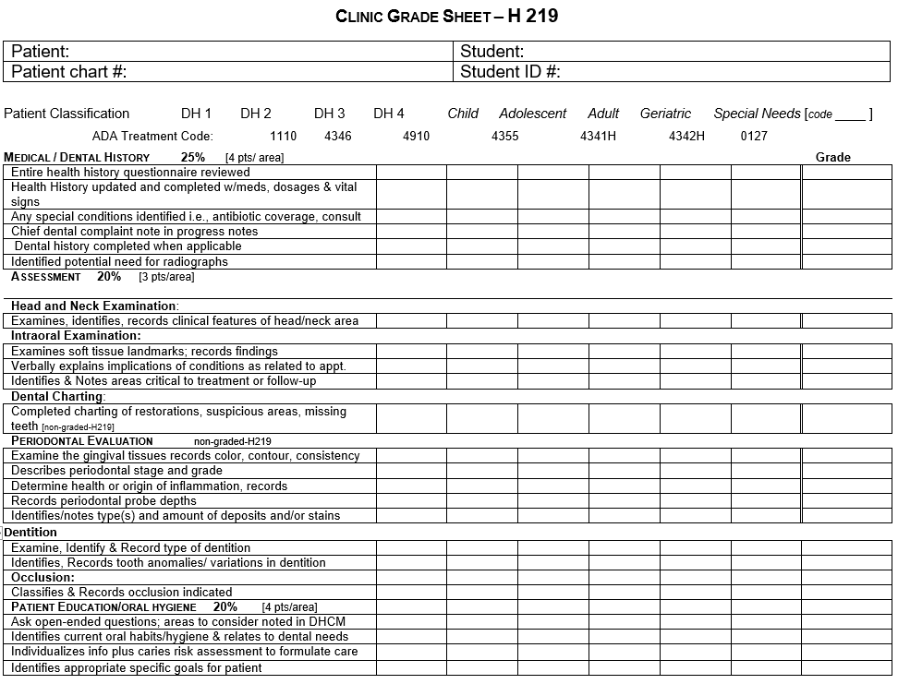
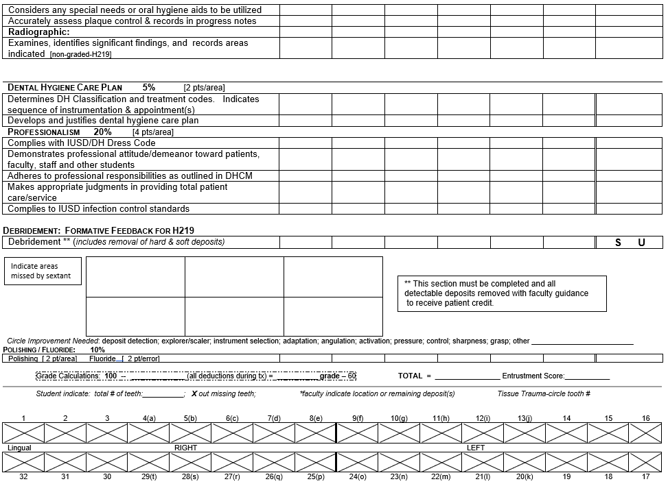
Clinic Grade Sheet – H 221 (Summer)
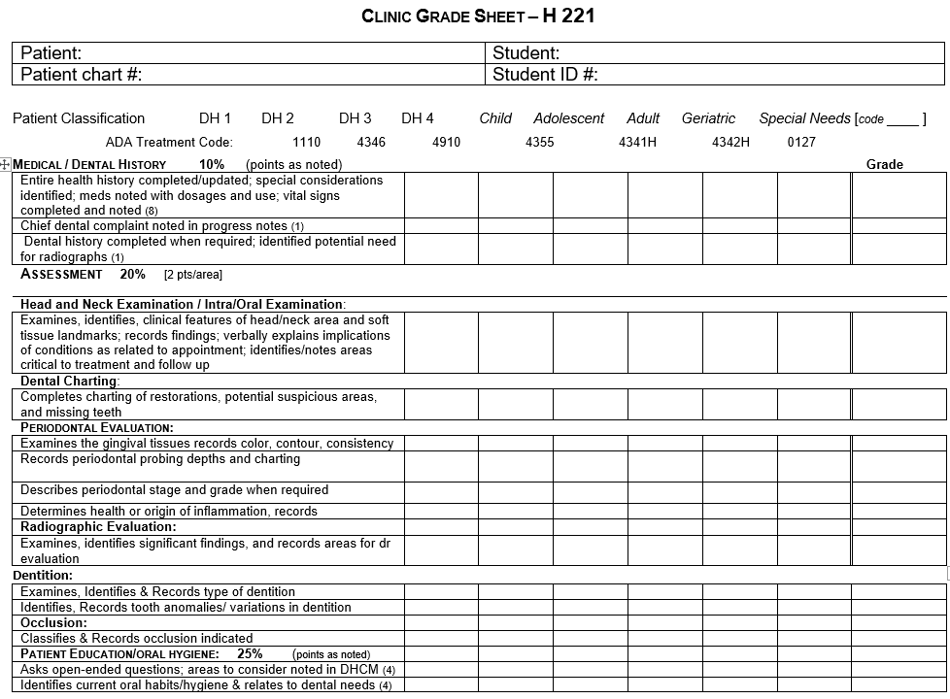
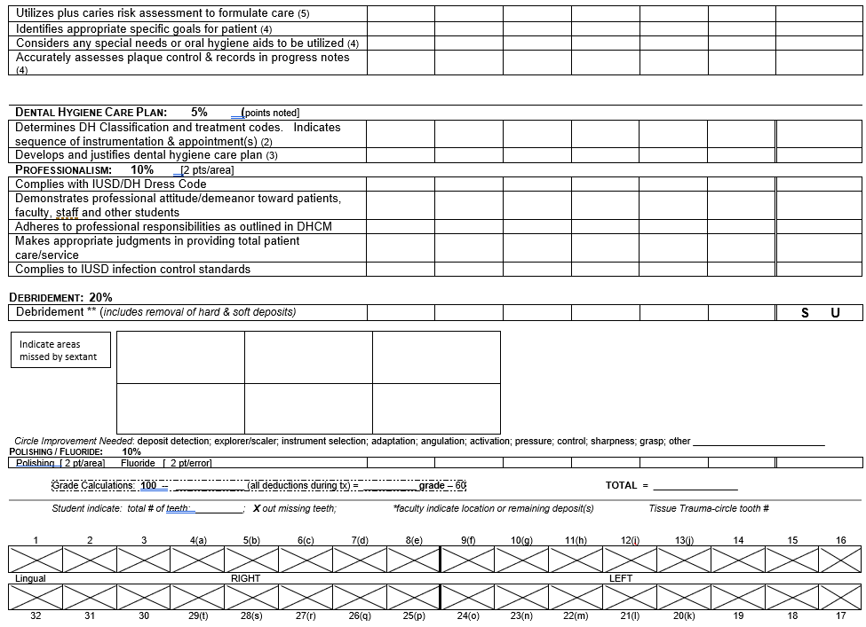
Clinic Grade Sheet – H301 (Fall)
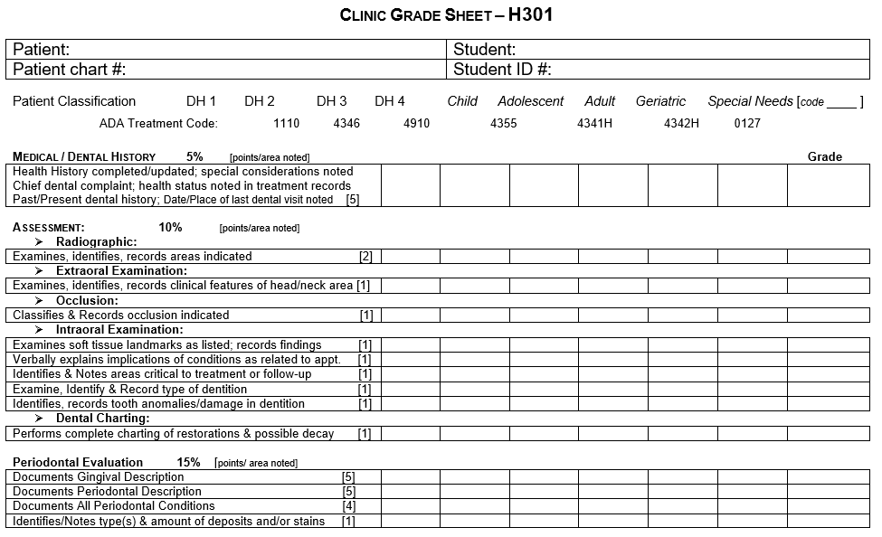
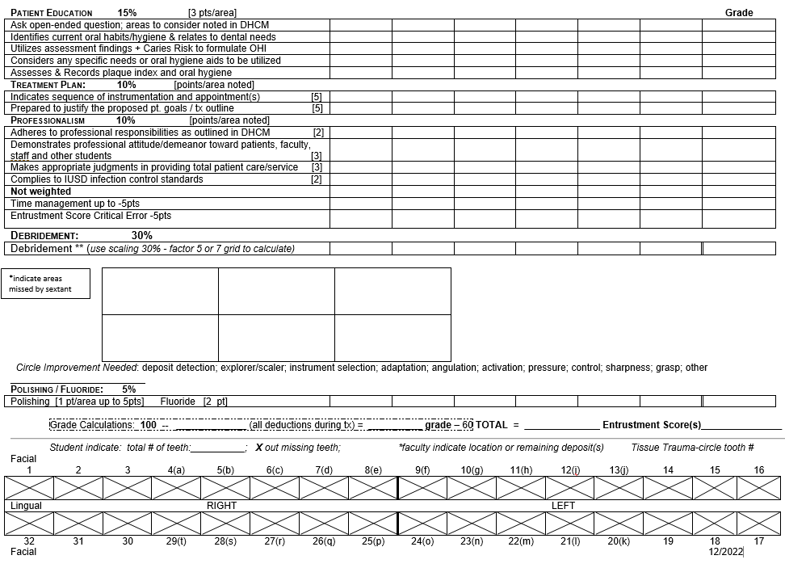

Clinic Grade Sheet – H302 (Spring)
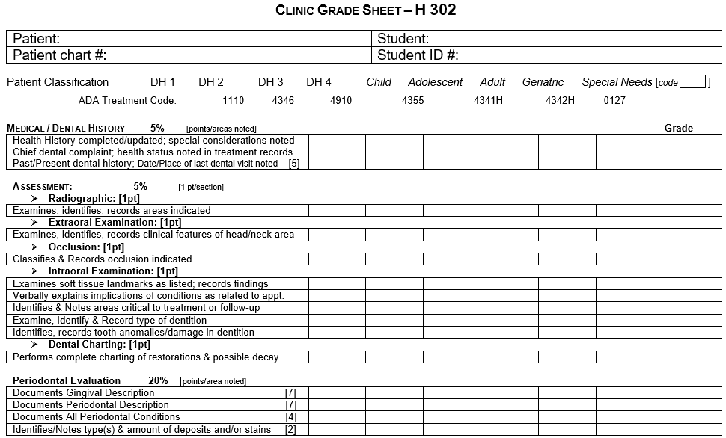
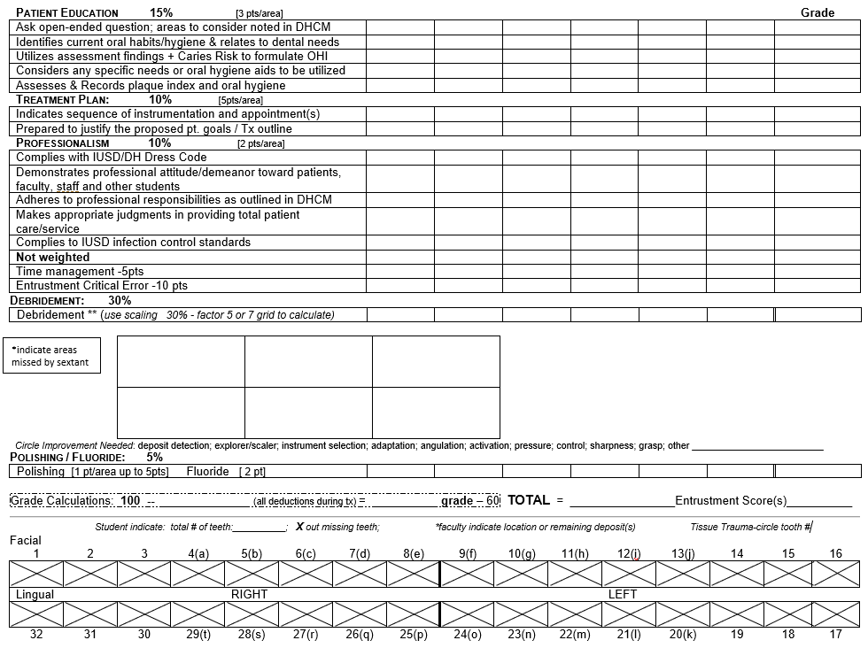
Clinic Grade Sheet – H420 (Fall)
COMING SOON – currently being revised

Student Achievement Binders
Each student has a binder given to them when they start seeing patients. This binder is the student’s record of their achievement through the program. It logs their competency completions, completed patients, grades received, types of patients they have seen, class 3 and class 4 requirements as well as anesthesia injections given, and sealants placed. These are placed in a locked cabinet in the clinic and should NEVER LEAVE THE BUILDING. Students require faculty sign offs in the binders for the following:

- Completed patients: students must date, add chart number, patient classification, grade, any special needs codes and patient demographics. Faculty will sign off, please DO NOT SIGN THE BINDER UNTIL ALL THIS INFORMATION IS IN (think of it as signing a blank check). Make sure the student has filled out the binder entirely. This is just one way we log the student's achievement, but is an important part of our “check and balances” and necessary for CODA

- Completed competencies: sign off when the student successfully passes a competency, add date of attempt if patient fails competency. Faculty will fill out the individual competency form and the column for the competency completed/attempted on the front pages of the binder.

- Completed Sealants: if a student places a sealant, these are recorded in the binder and signed off by faculty. Students are required to place at least 8 sealants.

- Completed Class 4 teeth: Every time a patient is working on a class 4 patient, the teeth numbers need to be recorded in the binder as they are completed and signed off by faculty. The students are required to scale at least 56 class 4 teeth. If you check off on scaling ANY class 4 teeth, you need to sign the student's binder indicating which teeth.

- Local Anesthesia- the student records the anesthesia injections given; DDS signs off

Competencies
Students have competencies they have to complete each semester.
- If a student wishes to attempt a competency during that clinic session, they are to inform faculty during the huddle and have the competency sheet out and ready for you to review
- Each competency sheet has detailed information as to what the student is expected to demonstrate, what type of patient it can be attempted on, and which semester they are allowed to attempt the competency
- All competencies are posted on the Faculty Calibration Canvas page
- Competencies are pass/fail - they must pass all portions to pass the competency
- If they do not pass, make detailed notes and communicate the issues to the student so they can learn from the experience
- If the student passes the competency, make sure to date and sign your name under that competency on the first few pages of the student's binder

Below is the list of competencies that are to be completed by semester:
H219 Spring  DH1 | H219 Instrumentation Skills Assessment  Health History  H219 Instrumentation Sharpening  Patient Assessment  Vital Signs  Polishing
H221 Summer  DH1 | H221 Instrumentation Assessment  Tray Fluoride  Varnish Fluoride  Cleaning of Removable Prosthesis  Dental Charting  Patient Education Part 1: Plaque Score and OHI  Caries Risk Assessment and Management Comp Part 1 & 2
H301 Fall  DH2 | H301 Instrumentation  Diet Analysis  Patient Education Part 2: Informed Consent and Communication  Patient Education Part 3: Auxiliary Aids  Class 2 Competency
H302 Spring  DH2 | H302 Instrumentation  Autoclave  Caries Risk Assessment and Management Part 3  Special Needs  Powered Instrumentation: Ultrasonics and Piezo  Geriatric  Periodontal Assessment and Evaluation  Air Polisher  Calculus Identification and Removal  Pulp Testing  Smoking Cessation
H411 Summer  DH2 | Tissue Re-evaluation Competency  Adolescent  Pediatric  Sealant
H420 Fall  DH3 | 60 Minute Competency  Double Book Appointments  Periodontal Evaluation Written

Radiology
This information is intended to provide knowledge regarding the performance of dental radiographic procedures, and the criteria used to demonstrate competence in this area. This section also includes important clinic policies to be observed when in the radiology area for which the student will be responsible.

Getting Started in H219 Clinic with Live Patients
Remember: If the student has any questions about procedures OR have difficulty taking radiographs on their patient, they are to GET HELP IMMEDIATELY
The student should allow at least 1 to 1 ½ hours for the first few FMS series they take in clinic. This will permit adequate time for taking images, reviewing with DDS and performing retakes if needed.

Dental Hygiene Clinic Radiology Procedures:
- Students should identify the potential need for radiographs by reviewing the chart prior to the appointment and discuss with faculty during huddle. *New patients, existing patients with BWX that are 18-24 months old, or FMS/Pano is older than 5 years, will more than likely need Radiographic Planning with the DDS. When in doubt check with DH faculty or DDS

- After the medical history is approved, students should sign up for Radiographic Planning on the DDS sign-up sheet.

- Plan all radiographs in the presence of the patient/student/dentist (state the rationale for the selection).

- Specifically, document in the patient treatment notes, which radiographs are needed; indicate specific survey (FMS, BWS by code) or specific location using tooth # and description for PAs (e.g., 2 PAs ordered to evaluate #6, R Max PM and R Max Canine).

- After the dentist enters the procedure code(s) of the selected radiographs in Axium, the student should notify Tuwana/Yvonne and their clinical faculty.

- Tuwana/Yvonne will provide a sensor to the student on a first come basis.

- Prepare the radiology unit by observing infection control procedures

- Seat the patient in radiology unit with the HEADREST SUPPORTING THE BACK OF THEIR HEAD.

- Place the lead apron with thyroid collar on patient properly. Check and adjust exposure setting for areas of interest as needed.

- FMS should take 1- 1 ½ hours and BWX should be completed in 30 minutes. **Student is to complete whatever series has been ordered by the DDS and discuss with DDS/DH Faculty BEFORE any retakes are taken. NO RETAKES SHOULD BE TAKEN UNTIL THE PRESCRIBED SERIES HAS BEEN CAPTURED.

- Once the images have been taken, the student should consult with the DDS to determine diagnostic quality of the images. The final decision on radiographs to be retaken will be made by the dentist, after the prescribed series has been captured.

- Students will then seat the patient back in their clinical operatory while cleaning up radiology unit.

Panoramic Images
Panos will all be taken in the Fritts building. Notify Yvonne that you will need a pano and she will plan. Students must complete the pano competency prior to taking panoramic images on patients and must always have a licensed clinician present.
The last FMS will not start after 10:30/3:30. The last BW will not start after 11:15/4:00.

RADIOGRAPHIC TECHNIQUE WORKSHEET:
- Students are to complete “Radiographic Technique Worksheet” for all images taken and should be completed within 48 hours of taking images. Dentists and faculty are encouraged to write signed comments/requests on the “Radiograph Technique Worksheet” back page if needed.
- If an alternate radiograph plan from the original needs to be requested, this should be documented as an “alternate” plan and give the reason(s) for the change. This information is important for future providers. Please provide enough detail to clarify any adaptations (e.g., Patient had a small mouth and required a FMS with a #1 sensor and pedo bite block. Student was not able to capture Max Molars in FMS due to extreme gagging. BWS were provided and a pano was requested). The reduction in PAs should be reflected in the treatment notes.
- When evaluating the radiographs for approval:
  - Identify exposures that accurately capture anatomy, density/contrast, etc.
  - Identify errors in the image. If the image is diagnostic due to the ability to identify the area in another image in the series explain why a Retake is not required.
  - If the image has a critical error that renders the image not diagnostic and the area is not captured in another area, a retake is required.
- Write on the “worksheet” in ink a capital ‘R” in the corresponding location to indicate retakes. (capital “R” in ink for each)
- If the student did not correctly identify a needed retake with a “pencil” mark “R”, faculty should write and sign a note on the back of the worksheet in faculty comment section explaining the retake was ordered and discussed with the student to improve error identification. If the student marked an “R” but no retake is needed, provide a similar note.
- IF the student has excessive errors (3 or more incorrectly identified retakes) then enter an explanation of the problem on the “worksheet” and the radiology course director will meet with the student to review the retake criteria.
- Completed Radiographic Technique Worksheets should be placed in the folder on the top shelf of the black cabinet that holds Dental Hygiene binders. Prof. Rader will collect and grade. It is the responsibility of the student to complete a technique worksheet for all images in order to receive credit for the images.
MINIMUM ACCEPTABLE CRITERIA FOR A FMS: on a patient consists of being able to see each interproximal space at least once (somewhere) on the FMS without overlapping. Each root apex (2-4 mm visible beyond root apices) should be visible at least once in the series. Retakes will be taken only to the degree that these minimal standards can be achieved. Retakes WILL NOT be taken merely to improve the technical quality of an individual radiograph.

Critical Errors in radiographic procedures will result from the student's inability to apply or perform essential principles of:

- Asepsis and Infection Control
- Acceptable use of lead apron/thyroid collar on patient.
- Unacceptable radiography:
- requires retakes more than 10% of images/films
- incorrectly exposes 2 or more radiographs
- utilizes unauthorized retakes without instructor/technician approval and evaluation.
- failure to record patient's name, chart number, date, retakes in dental log
- inability to demonstrate acceptable professional skills and problem-solving ability.
- failure to properly document radiographic survey taken in patient's chart.
To be considered as an acceptable FMS survey the following criteria are applied:
- Require minimal assistance from instructor/faculty/radiology staff during the FMS procedure.
  - Frist year Spring/Summer semester - require technical assistance on 6 or fewer radiographs
  - Second year Fall/Spring semester - help on 3 or fewer radiographs
  - After March 15th - no help should be necessary except in the most complicated patients. This should be documented in a note on the back of the radiographic technique worksheet and signed by the faculty member/radiology assistant.
- Satisfy criteria for minimal technical and clinical acceptability for each FMS.
- Any FMS/survey earning a score of less than 2.0 does not meet technical or clinical standards of acceptability. Scores less than 2.0 will not count toward satisfying clinic radiology standards or lab competency.
- Complete an evaluation for each radiographic image taken, using appropriate abbreviations as indicated on the radiographic technique worksheet. The evaluation needs to be completed within 48 hours of taking the images and turned into the folder in the black cabinet or given to Prof. Rader.

Taking Radiographic Images

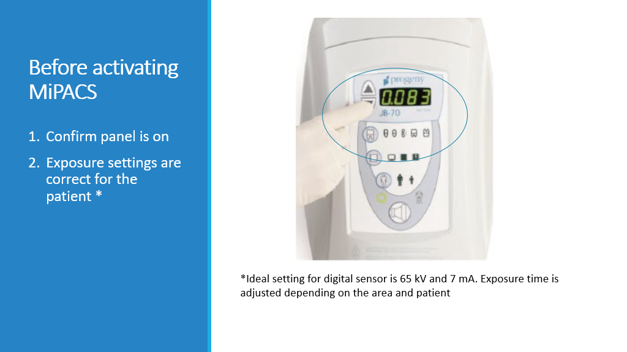
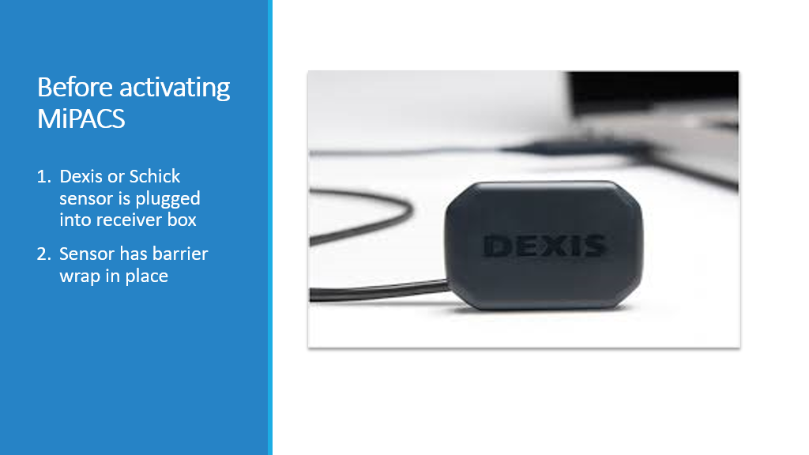
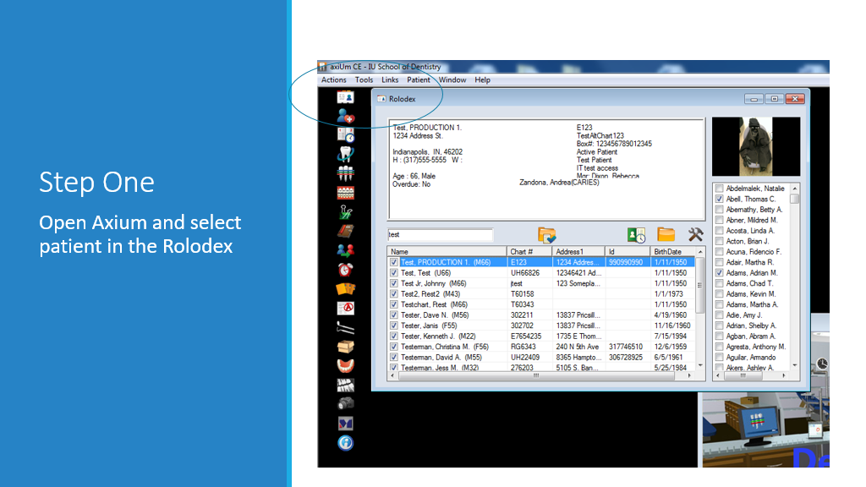

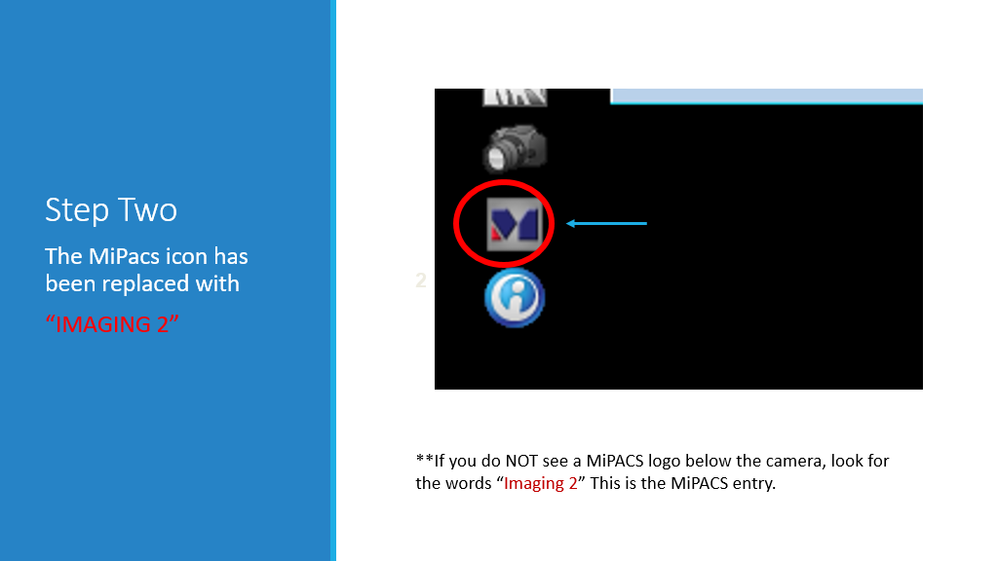

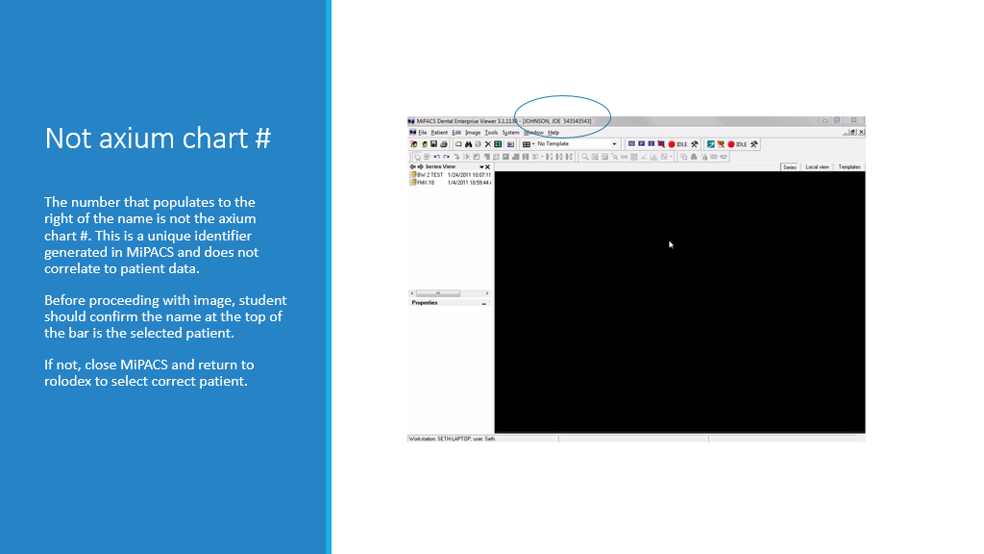
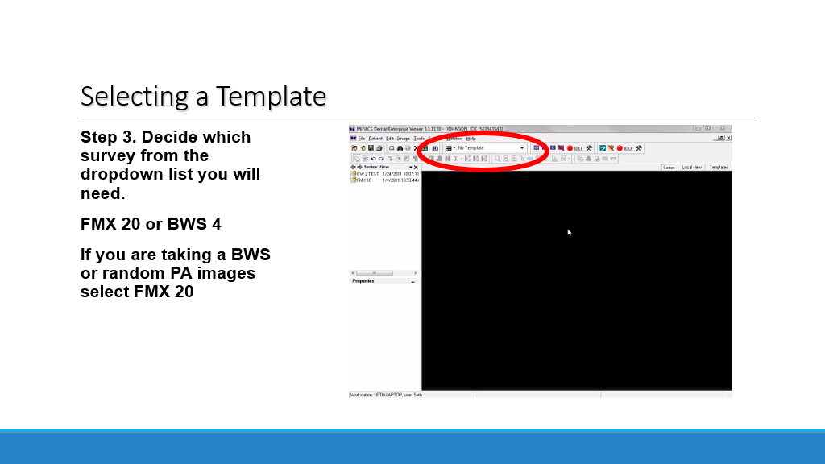

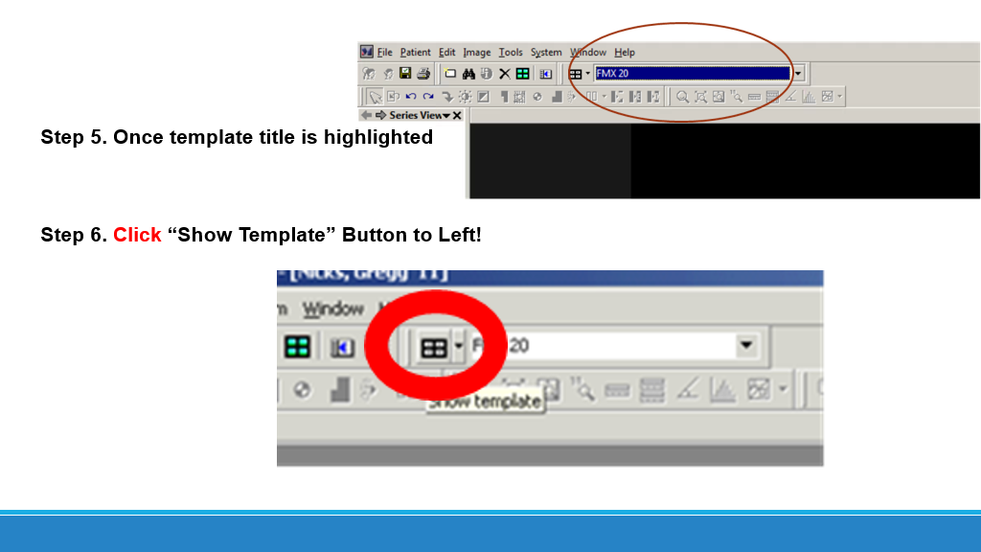

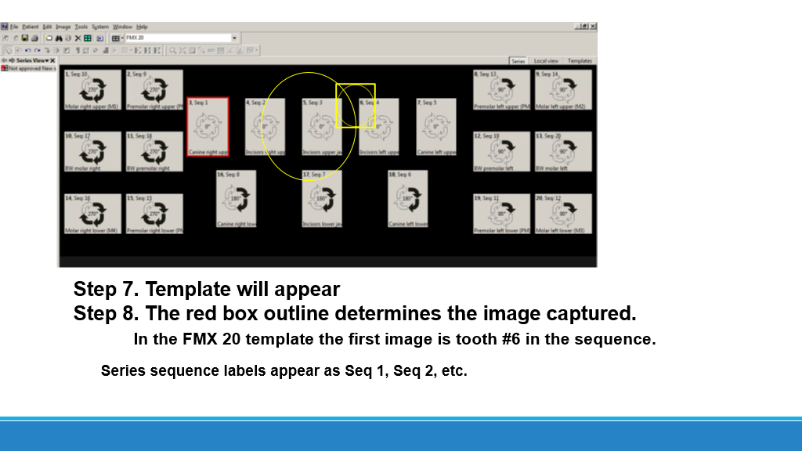

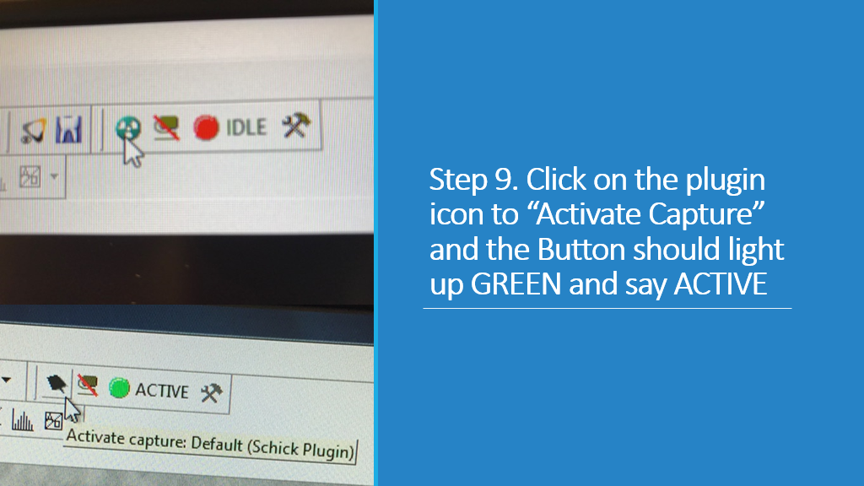

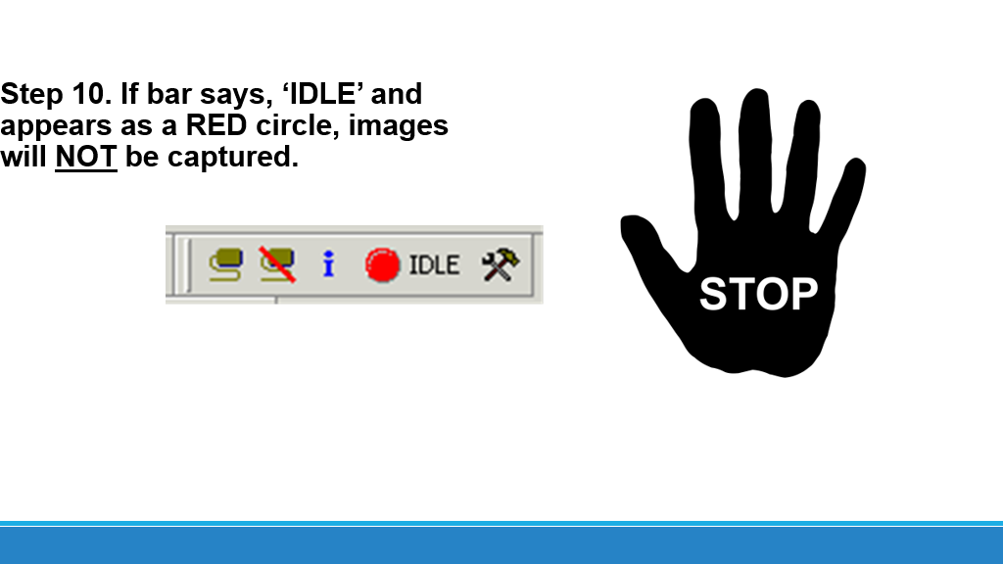

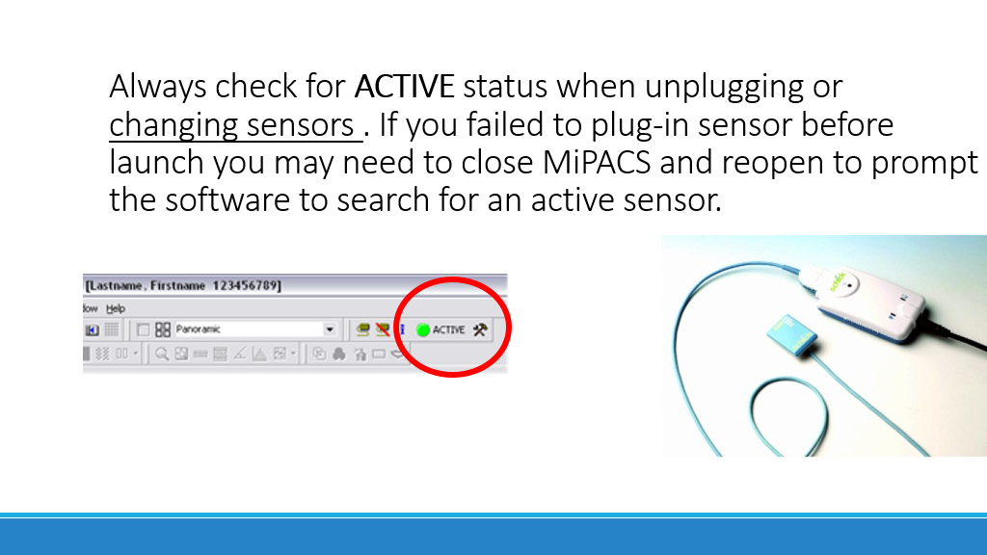
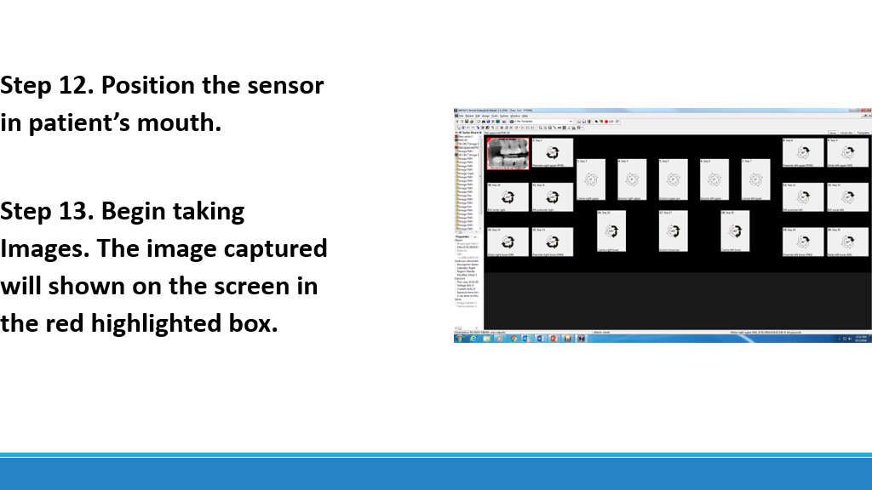

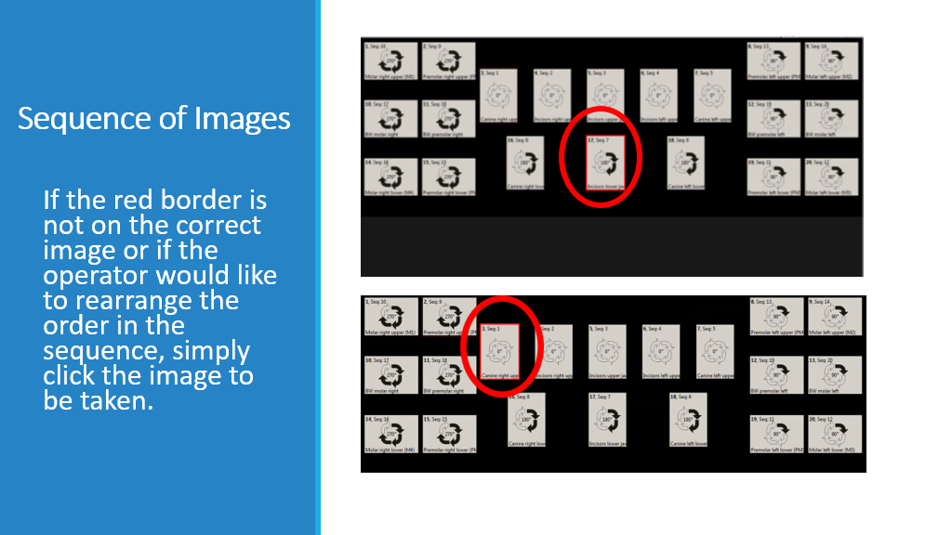

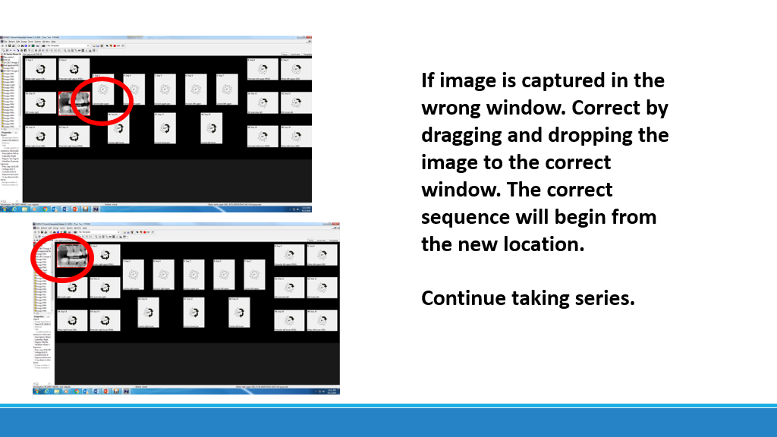

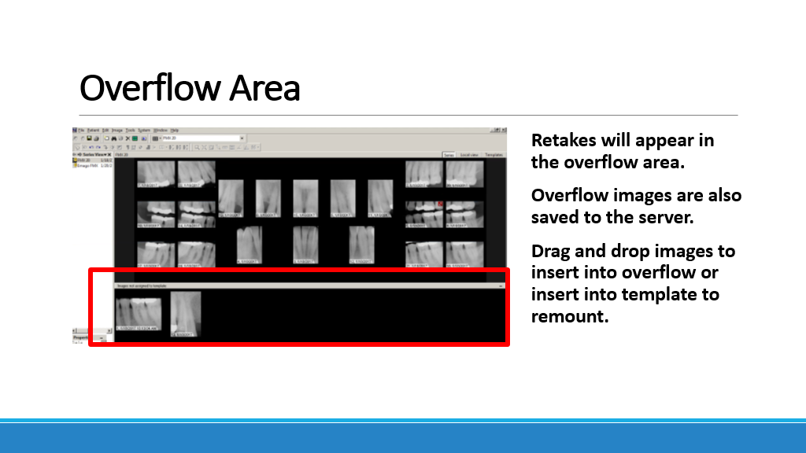

Approving Images
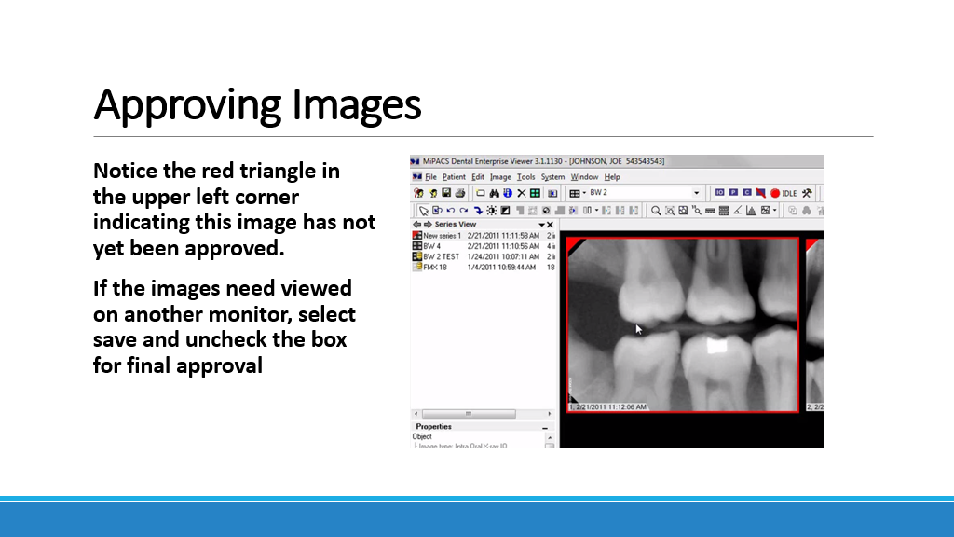

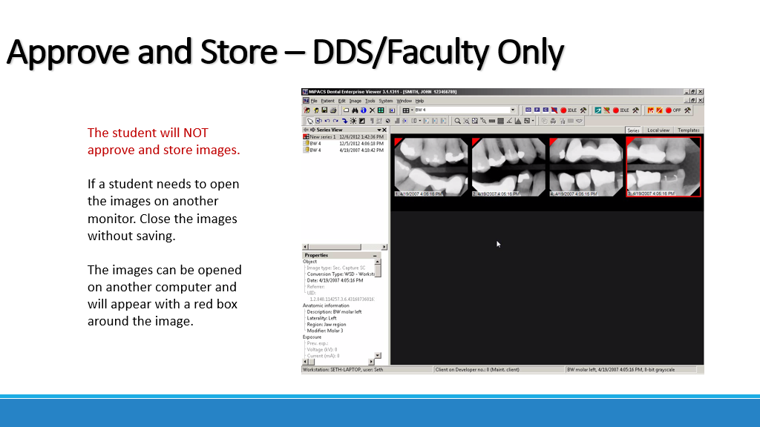

Viewing Images
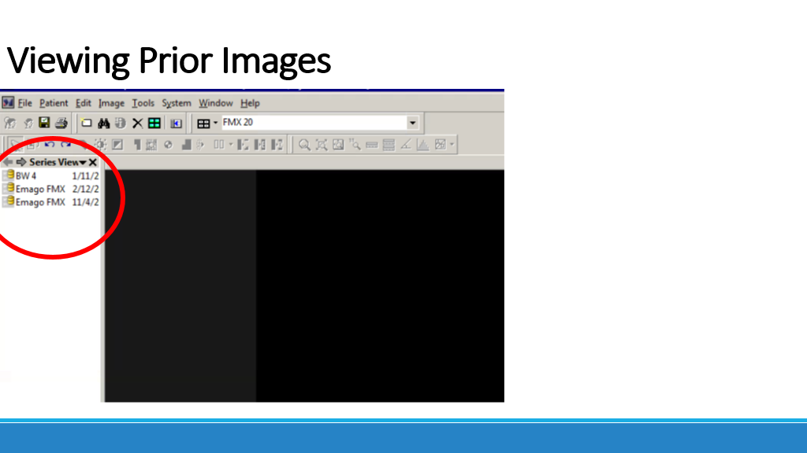
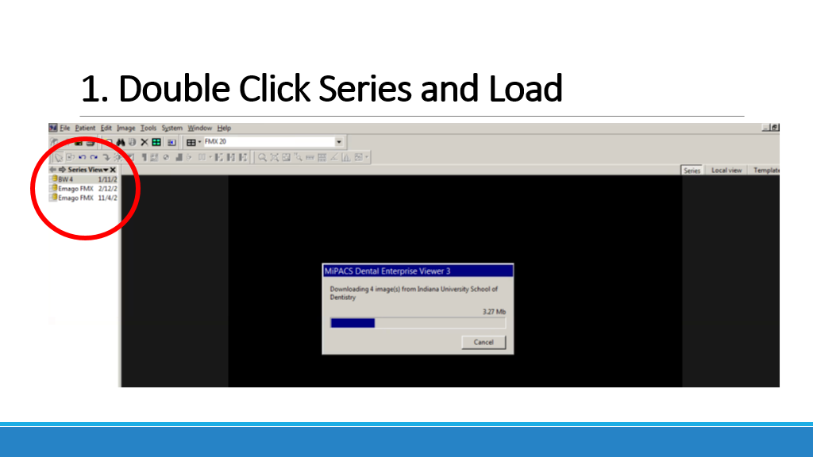
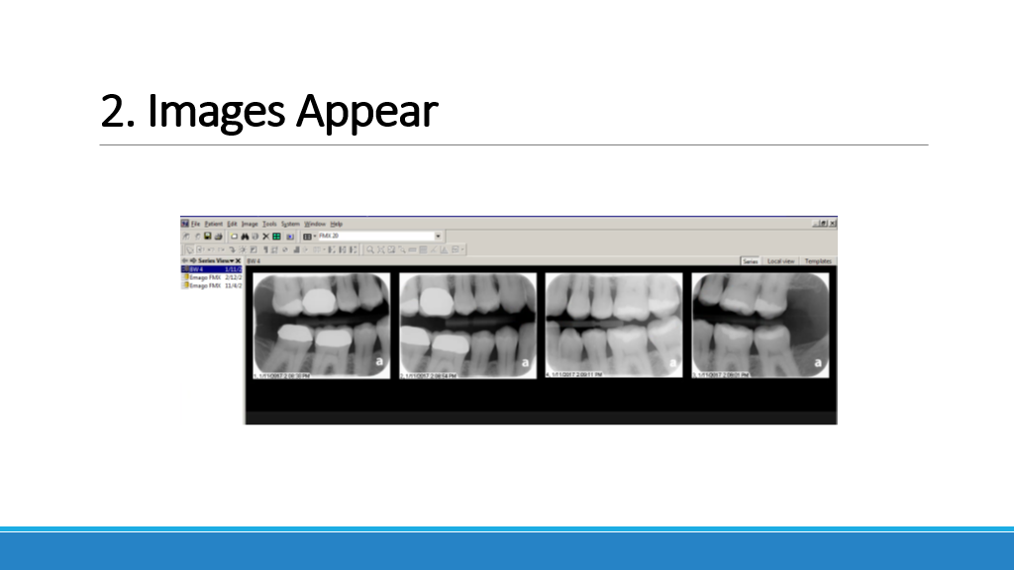

Measuring Bone Levels
